New Public Health Student Convocation
Wednesday, August 22nd, 2018

Hello Public Health Students, Alumni, Faculty, and Friends! Please joins us in welcoming our incoming public health students at our New Student Convocation and Reception on Wednesday, August 22nd, beginning at 5 pm.
We are honored to have Senator Doug McCrory Democratic Deputy President Pro Tempore as our keynote speaker.
Senator Doug McCrory was elected with the continued promise of continued accountability and accessibility as the State Senator for the 2nd Senate district in a special election in February, 2017 to represent parts of Bloomfield, Hartford and Windsor. He was first elected to the General Assembly in 2004 to represent the 7th House district, which he served for six full terms. Even before his service as a legislator, Senator McCrory has been committed to strengthening neighborhoods through education, development and civic engagement. He is currently chair of the CT Aging Committee, Vice Chair of the Banking Committee and Committee on Children, and is a member of the Finance, Revenue, and Bonding Committee and the Joint Committee on Judiciary. A vice principal for the Capitol Region Education Council (CREC), Senator McCrory has been an educator for over 20 years. Beginning as a teacher at Sarah J. Rawson Elementary School, he has also taught at and served as vice principal at Lewis Fox Middle School. Recognizing the importance of strong role models and education asthe keysto positive development, Senator McCrory worked with fellow teacher Sadiq Ali to found the Benjamin E. Mays Institute, which emphasizes positive self‐ esteem through the use of a curriculum infused with African American history and themes. His remarks on public health policy issues currently on the Committee’s agenda will undoubtedly be of interest to all of us.
Katherine Kuzmeskas, MPH, will be our featured alumni speaker.
In late April 2017 Kat was recognized by Fortune among the 34 Leaders Who Are Changing Health Care. Kat left Yale New Haven Health in December 2016 to launch SimplyVital (SV) because she sought to solve an actual problem she had as a hospital administrator - she needed the platform she now sells. As the program manager of the Yale New Haven Hospital Center for Musculoskeletal Care (CMC), she managed the Lower Joint Replacement Bundled Program (a type of Value Based Care program) which included everything from general operations to supporting the clinical and financial analytics of the program. It was in this role that she needed the SimplyVital Health platform and saw the gap in existing solutions for Post-Acute Care follow up and the opportunity to transform Value Based Care with a technology that makes coordination and data sharing frictionless.
Prior to her role at the CMC, she served as a Strategic Planner for the Medicine and Surgery service lines for the entire Health System, which included providing guidance on the opportunities within and the future of Value Based Care. The majority of her analyses provided business opportunity and market expansion intelligence to Yale New Haven Hospital, the nation’s 6th largest hospital, and her analyses gained national recognition. In less than 6 months, Kat mastered all department analytics and technology tools, advancing to super user and the department resource for new and tenured co-workers. She also automated her medicine and surgery service line reports, and taught co-workers to develop similar dashboards. Serving as the technical trainer and liaison between the database developer and strategic planners she co-designed a four state physician database and designed a sustainable process for physician list maintenance.
Before her career at Yale New Haven Health, Kat designed and led the development of a care management platform for Connecticut’s largest community health network that gained national recognition. At the same community health network, Kat improved their quality metrics by 39% in 3 months by designing and leading a quality improvement initiative with all state-wide clinicians and the Business Intelligence team.
She received a full ride and attained a 4.0 in her Master of Public Health program with a certificate in leadership. Kat is a 2007 Rio Grande Valley Teach For America Alumna, a program that is more selective than Harvard Law. As a Corps Member, she lead >350 7th grade students in the nation’s 5th poorest region to the highest science exam scores in their districts.
Fun fact: It was 2007 during her 2 months of clinical rotations in Quito and the rain forest of Ecuador that Kat decided she wanted to pursue transformational change in healthcare administration instead of going to medical school.
Student Speaker, Dr. Natalie Moore
After graduating from Elon University, Magna Cum Laude, Dr. Natalie Moore completed her Doctor of Medicine at the University of Connecticut in 2014. She subsequently completed her Emergency Medicine Residency at Baystate Medical Center/Tufts University School of Medicine in Springfield, MA and currently serves as UConn Health’s first International Disaster Emergency Medicine Fellow and a UConn Master of Public Health candidate. This past year, Dr. Moore went to the U.S.Virgin Islands after Hurricane Irma. She treated patients at a temporary triage clinic in St. John before working at a hospital in St. Croix, where she hunkered down for Hurricane Maria. It was the only hospital open in the area, as the hospital in St. Thomas was destroyed. Natalie is quite the international traveler. In 2013, she volunteered in the St. Lucia ER as a medical student in St. Jude’s Hospital.
Dr. Moore volunteers every moment she gets, including at South Park Clinic, a homeless shelter served by the medical school in Hartford. From 2011-2014, she designed a quality improvement project around the Malta House of Care in Hartford. It involved an easy-to-use history and physical form which allows patients to be seen fasters with better documentation. She also designed a pre-visit questionnaire in English and Spanish to save time during the visit. The system has yet to be implemented but has been presented to the directors of the program. From 2011-2014, she volunteering at the Cornerstone Soup Kitchen in Rockville, CT. She is both a volunteer firefighter and an EMT. She even received the Firefighter of the Year Award in 2006, then in 2010 Hartford Hospital awarded her the Dedicated to Caring Award. During the summers of 2008, 2009, 2010 and 2011, she worked at Camp Horizons, a special needs camp, in South Windsor, CT, as an infirmary assistant. The list goes on and on. Dr. Moore is most deserving of this award. In all my time with the program, I have never seen a student as giving as Natalie. She is one incredible young woman.
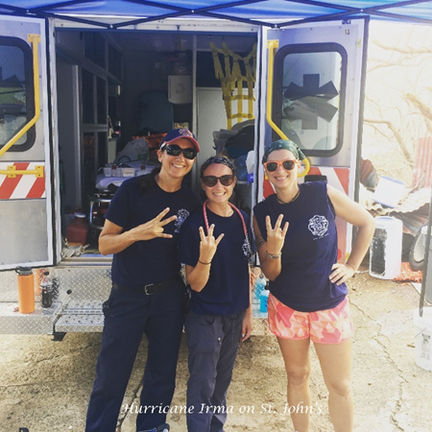
Dr. Natalie Moore (middle) is providing relief work on St. John after Hurricane Irma.

