PROTOCOL: Aminoglycoside Collaborative Practice Dosing Protocol
CATEGORY: Clinical | Date Originated: 1/9/19
Page 1 of 22 | Last Reviewed:
Owner: Dept. of Pharmacy, Dept. of Infectious Diseases | Last Revised:
Approved by: | Retired:

Collaborative Practice Agreement for Intravenous (IV) Aminoglycoside drug management, dosing, and monitoring
1.) SCOPE:
- Licensed Prescribers, Pharmacists, Nurses. All Pharmacists who have received, completed, and passed the internal competency certification on IV Aminoglycoside clinical management
- IV Aminoglycoside therapy defined as use of gentamicin, tobramycin, and amikacin. IV tobramycin and amikacin are restricted antimicrobials. Tobramycin drug levels require a laboratory send out minimizing timely pharmacokinetic tobramycin level monitoring abilities.
- Population: Adult Patients with orders for an IV Aminoglycoside initiated either in the Emergency Department or Inpatient Care Units
- Outcome: Pharmacists will independently manage IV Aminoglycoside therapy according to the guidelines detailed in this protocol

2.) COLLABORATIVE PRACTICE AGREEMENT:
- Under this collaborative practice agreement, UConn Health – John Dempsey Hospital (UCH/JDH) Pharmacists, according to and in compliance with Section 91 of Public Act 10-7 and Connecticut General Statutes sec 20-631 “An Act Concerning Collaborative Practice Between Physicians and Pharmacists”, may design, implement, and monitor a therapeutic drug plan intended to manage IV Aminoglycoside therapy upon receipt of an order from the licensed provider to the Pharmacist for IV Aminoglycoside dosing.
- The specific services provided by the Pharmacists and the methods for providing these services are described in detail in this protocol document

3.) PURPOSE:
- To establish evidence-based guidelines for the dosing and monitoring of IV Aminoglycoside therapy based on current peer-reviewed literature.
- To provide a detailed and standardized protocol that allows Pharmacists to manage IV Aminoglycoside therapy in collaboration with practitioners.
- To maximize the probability that patients will receive optimized IV Aminoglycoside therapy, which maximizes efficacy and minimizes risk of toxicity.

4.) BACKGROUND: CONTEMPORARY CLINICAL USE OF IV AMINOGLYCOSIDES:

The purpose of aminoglycoside pharmacokinetic monitoring is to assure maximal efficacy and to prevent unnecessary physiological complications, especially nephrotoxicity, in patients receiving this group of pharmacological agents. The Department of Pharmacy routinely monitors all patients to prospectively assess the patient’s ability to eliminate aminoglycosides given a specified dose and frequency of administration. The pharmacist will assist with recommendations for dosing and monitoring of patients requiring aminoglycoside treatment utilizing the following procedure as a guideline. NOTE: Gentamicin is the aminoglycoside of choice. Both IV tobramycin and amikacin are restricted antimicrobials. Inhaled tobramycin is without restriction.

Gentamicin was discovered in 1963 in New Jersey. It is currently approved for a wide gamut of infections, but its use is best seen when in combination with other antimicrobial agents to achieve synergy. Aminoglycosides primarily have good bactericidal activity against gram-negative organisms. They are sometimes given in combination with other antibiotics, both empirically and definitively, for the treatment of severe infections caused by Pseudomonas aeruginosa and other multidrug-resistant gram-negative organisms. Gentamicin can be used in combination with a beta-lactam or vancomycin to provide synergistic effect against gram-positive pathogens, such as Enterococcus spp., which cause infective endocarditis. . (Deck D.H., et al. 2019)

Traditionally, aminoglycoside dosing uses small doses with frequent dosing intervals, however, a single large dose at intervals greater than or equal to 24 hours can optimize pharmacokinetic (PK) and pharmacodynamic parameters and C_{MAX}:MIC ratio for concentration dependent bactericidal activity versus gram-negative bacterial pathogens. Extended-interval of once daily dosing can reduce the drug trough concentration and duration of renal and otic tissue exposure to potentially minimize the risk of toxicity without compromising efficacy by taking advantage of the post antibiotic effect. Clinical studies have shown that extended-interval dosing is as efficacious and safe, or superior to, traditional dosing; caution must be taken however in populations with significant alterations in aminoglycoside PK parameters (i.e. volume of distribution, drug clearance, elderly patients, any drug interactions, etc.).

Current Status of Therapeutic Monitoring of IV Aminoglycoside Therapy:
Physicians have accomplished dosing of IV aminoglycoside therapy with monitoring by pharmacists. Current therapeutic monitoring recommendations vary based on dosing regimen:
- For high-dose extended-interval regimen monitoring, see APPENDIX 1
- For traditional regimen monitoring, see APPENDIX 2
- For indication specific dosing, see APPENDIX 3

Justification for the Implementation of an Aminoglycoside Collaborative Practice Protocol
Achievement of maximally-effective and maximally-safe aminoglycoside therapy in our patients at UCH/JDH is a standard that we strive for. The investigational study by Bond, et al. explored the impact of pharmacist managed aminoglycoside and vancomycin therapy as it pertains to major health care outcomes: rate of death, length of stay, financial impact, hearing loss, and renal impairment. Bond et al. found that in hospitals without these collaborative practice protocols death rates were 6.71% higher, length of stay was 12.28% higher, total Medicare charges, drug charges, and laboratory charges were higher by 6.30%, 8.15%, and 7.80% respectively. In these hospitals rates of therapy related hearing loss was 46.42% higher, renal impairment was 33.95% higher, and the death rate in patients who developed complications was 10.15% higher compared to hospitals that have these collaborative protocols that enable pharmacists to manage these medications. All findings were determined to be significant.

The evidence supporting pharmacist-managed aminoglycoside therapy is associated with significant improvement in health care and economic outcomes. We propose a highly-detailed, evidence-based, and rigorously-structured Collaborative Practice Protocol to guide Pharmacist-led dosing and therapeutic monitoring of aminoglycoside therapy for JDH/UCH patients.

5.) COST-JUSTIFICATION, INCLUSION, AND EXCLUSION CRITERIA:
5.1.) Cost of Services Provided under the Aminoglycoside Collaborative Practice Agreement:
- The services provided by UCH/JDH Pharmacists under the Aminoglycoside Collaborative Practice Agreement will be provided at no additional charge to the patients. The service will be justified based on cost avoidance through such measurable outcomes as:
(1) Reduced risks of aminoglycoside toxicities,
(2) Reduced numbers of blood draws for determinations of aminoglycoside serum concentrations,
(3) Quicker therapeutic dosage standardization, and/or
(4) Reduced duration of hospitalization

5.2.) Inclusion Criteria:
- All adult inpatients > 16 years old who are admitted to UCH/JDH adult inpatient treatment units who are prescribed IV aminoglycoside therapy

5.3.) Exclusion Criteria:
- All patients under the age of 16 years
- All patients receiving IV aminoglycosides for surgical prophylaxis or patients ordered topical aminoglycosides for non-systemic infections and/or inhaled aminoglycosides for lung infections.

6.) PROCEDURES FOR THE AMINOGLYCOSIDE COLLABORATIVE PRACTICE AGREEMENT:
6.1.) Patients Initiated on IV Aminoglycoside Therapy Dosed by Pharmacy
6.1.1.) Providers will initiate aminoglycoside use by order, either as “provider-dosed” or “pharmacy-dosed.” If the Provider orders pharmacist guided dosing, the Provider will first determine if the patient is a candidate for high-dose extended-interval dosing, traditional dosing, or special-indication dosing (e.g. synergistic agent for a gram-positive infection). High-dose extended interval dosing will be the default strategy for all documented/suspected gram-negative bacterial infections unless any of the contraindications apply listed in section 6.1.1.1. If a patient has a contraindication to high-dose extended-interval dosing, traditional dosing will be used, with the exception of cases requiring special-indication dosing (e.g. synergistic agent for a gram-positive infection). The Provider will designate the indication for the aminoglycoside in the order, as is practice with all antimicrobial orders. The Provider will also order a one time initial dose for the patient, in addition to a consult order for pharmacist-guided dosing.

6.1.1.1.) Contraindications for high-dose, extended-interval dosing are:
- Dialysis
- Estimated creatinine clearance of <20 ml/min
- Unstable renal function with worsening renal function prior to or at any point during therapy
  - 50% increase in serum creatinine (SCr) from baseline
- Ascites, severe liver disease, or excessive third spacing of fluids
- Pregnancy
- Burns (>20% body surface area)
- Cystic fibrosis
- Use of the aminoglycoside as a synergistic agent for a gram-positive infection

6.1.1.2.) Selection of the initial dose by the Provider will depend on which dosing regimen is utilized for the patient.
- For high-dose, extended-interval dosing, see APPENDIX 1
- For traditional dosing, see APPENDIX 2
- For gram-positive synergy dosing, see APPENDIX 3

6.2.) Pharmacists’ Responsibilities for “Aminoglycoside Dosing per Collaborative Practice Protocol”:
6.2.1.) Pharmacists will review and collect the following patient data from the patient medical record. These data are necessary to develop an optimized initial (empiric) aminoglycoside dosing regimen:
- Patient age and gender
- Allergy history
- Current/most recent height, total body weight, and Body Mass Index (BMI):
      - Note: Review to obtain current weight; contact the nurse and/or prescriber to double-check and verify any unusual parameters [e.g., height <60 inches, Actual body weight < 40 kg or >150 kg] and/or to evaluate for significant changes in any of the above parameters from previous archived data)
    - Current and historical serum creatinine (SCr) values
      - Note: Pharmacists should always attempt to assess for the presence of acute, chronic, and/or acute-on-chronic renal insufficiency)
    - Documented/Suspected infectious diagnosis or the apparent indication for use of aminoglycoside therapy (verify that the use selected in the order correlates with clinical data)

Pharmacists will contact the patient’s nurse and/or caregivers and/or other valid resources to clarify any unusual data or to determine patient data which is not documented in the chart.

6.2.2.) Identification of Patients with “Important Dosing Considerations”:
Pharmacists will review relevant patient data to determine if any of the following conditions are present which would warrant the use of “Important Aminoglycoside Dosing Considerations”:
- Patient receiving Chronic or Acute Hemodialysis (HD)
- Patient receiving other Continuous Renal Replacement Therapy (CRRT)
- Patient with Significant Obesity, defined as one or more of the following:
        - BMI > 35, Actual Body Weight > 40% of Ideal Body Weight
- Patient with acute changing renal function
Considerations, recommendations, and detailed guidance for aminoglycoside dosage and administration intervals for patients with these “Important Dosing Considerations” can be found in the subsections of Section 6.3 (Important Aminoglycoside Dosing Considerations)

6.2.3.) Determination of Infusion Times for IV Aminoglycoside Doses:
Gentamicin: over 30 minutes
*Amikacin: over 30 minutes; if >15mg/kg dose then over 60 minutes
*Tobramycin: over 30 minutes
*restricted antibiotic

6.2.4.) Initiation of the CPOE Orders for the Collaborative Practice Protocol-Determined Aminoglycoside Regimen:
Within 2 hours (within 1 hour for patients in the ICU/ED) of an order for the “Aminoglycoside Dosed per Collaborative Practice Protocol” order, the Pharmacist will review and verify the initial dose. An active order for the maintenance regimen, with subsequent dosing and administration interval, should be completed by the pharmacist within 6 hours of the original consult order.

6.2.5.) Scheduling and Ordering of Aminoglycoside Serum Concentrations and Other Monitoring:
- All patients who are prescribed an IV aminoglyoside antibiotic for the treatment of any infection will have blood drawn for determination and evaluation of serum aminoglycoside concentrations and renal function indicators. Under this protocol, pharmacists can order therapeutic drug monitoring levels and serum creatinine as outlined.
- For patients who are receiving an aminoglycoside for the treatment of an infection, serum drug concentration monitoring is dependent on the dosing regimen:
  - Extended Interval Dosing: (APPENDIX 1)
    - Obtain one random serum level 6-12 hours after the start of infusion of the first dose
    - Following initial level, obtain one random serum level every 3-5 days to ensure appropriate dosing interval
    - If renal function increases or decreases suddenly (SCr increase or decrease > 0.5mg/L within 24 hours) obtain one random serum level at an appropriate time and hold further doses for patients with sudden Scr increases.
    - Obtain SCr at baseline and at least every 2 days while on aminoglycoside therapy or daily in the presence of baseline renal insufficiency, severe infection/sepsis or concomitant use with other nephrotoxic agents.
  - Traditional Dosing and Gram Positive Synergy Dosing: (APPENDIX 2 and 3)
    - Obtain trough level immediately before 3rd maintenance dose
    - Obtain peak level 30 minutes after the end of infusion of 3rd maintenance dose.
    - After initial peak and trough, obtain peak and trough levels every 3-5 days to ensure dose and interval are still appropriate.
    - Obtain serum creatinine (SCr) at baseline and at least every 2 days while on aminoglycoside therapy or daily in the presence of baseline renal insufficiency, severe infection/sepsis or concomitant use with other nephrotoxic agents.
    - For renal failure and Continuous Veno-Venous Hemofiltration (CVVH), obtain levels daily and re-dose when levels fall below 1 mg/L for gentamicin or 5 mg/L amikacin.
    - If renal function increases or decreases suddenly (SCr increase or decrease > 0.5mg/L within 24 hours) obtain one random serum level at an appropriate time and hold further doses for patients with sudden Scr increases.
  - See Section 6.2.7 for Pharmacist Interpretation of Labs and Dose Adjustments

6.2.6.) Documentation of the Collaborative Practice Protocol-Determined Initial Aminoglycoside Regimen in the Patient Medical Record:
- Per Connecticut State Law, “All activities performed by the Pharmacist in conjunction with the protocol shall be documented in the patient’s medical record.”
- At the conclusion of the initial dosage regimen development process, the Pharmacist will complete the “Pharmacy Note: Initial IV Aminoglycoside Dosing per Collaborative Practice Protocol” (see APPENDIX 4) and will copy this note to the patient medical record.
- The Pharmacist will provide direct communication with a summary of key information related to the Aminoglycoside therapy to the attending provider(s) in addition to the note, when possible.

6.2.7.) Daily Follow-up of Key Clinical Parameters for Patients on Aminoglycoside Therapy:
EACH DAY, Pharmacists will review, analyze, and document the following clinical data for all patients on Aminoglycoside therapy using pharmacy interventions:
- Renal function trends (via SCr and BUN)
  - If a Pharmacist notes that there has not been an assessment of serum creatinine/blood urea nitrogen (BUN) for 48 hours (or sooner if appropriate), the Pharmacist can enter an order into the CPOE to schedule a blood draw for assessment of serum creatinine/blood urea nitrogen.
- Receipt of other well-known nephrotoxic medications (most commonly: amphotericin B, vancomycin, intravenous contrast dyes used for radiologic procedures)
- Results of culture and susceptibility results
- Deviations in administration of any Aminoglycoside dose (e.g., missed doses, doses administered at wrong times (this will depend on the dosing interval--some examples: (i) a dose administered 2 hours late for a patient on an every 8 hour schedule, (ii) a dose administered 6 hours late for a patient on an every 24 hour schedule)
- Results and interpretations of any serum aminoglycoside concentrations
  - Dose adjustments may be made using the following APPENDICIES 1, 2 or 3 or utilizing internet-based dosing calculators programs Clinicalc® or GlobalRPH®.
- Any time doses or administration intervals are changed, the Pharmacist MUST complete a “Pharmacy Follow-Up Progress Note: IV Aminoglycoside Therapy per Collaborative Practice Protocol” (APPENDIX 5) and copy this note to the patient medical record.
- Any time any patient finding is noted that could significantly impact the current aminoglycoside regimen, the Pharmacist MUST fill out a “Pharmacy Follow-Up Progress Note: IV Aminoglycoside Therapy per Collaborative Practice Protocol” (APPENDIX 5) and copy this note to the patient medical record. This should occur even if it is decided that there does not need to be an immediate change in the patient’s current aminoglycoside regimen.
- The Pharmacist MUST direct a verbal summary of key information related to aminoglycoside therapy to the attending provider, during the following circumstances:
  - Decline in renal function (> 0.5 mg/dL and/or >2 fold increase in SCr)
  - Supratherapeutic serum concentrations following scheduled trough or random serum measures

  - Important Aminoglycoside Dosing Considerations
6.3.1.) Patient receiving Chronic or Acute Hemodialysis (HD)
- Current dosing guidelines for gentamicin use in patients on hemodialysis suggests that dose should be given after dialysis. (Aronoff GR, et al. 2007)
6.3.2.) Patient receiving Continuous Renal Replacement Therapy (CRRT)
- The extent of aminoglycoside drug removal is directly proportional to the dialyzer surface area and the mode of replacement administration (pre or postdilution), ultra filtration and dialysate flow rate and is, therefore, variable
- For renal failure and Continuous Veno-Venous Hemofiltration (CVVH), obtain levels daily and re-dose when levels fall below 1 mg/L for gentamicin or 5 mg/L amikacin.
6.3.3.) Patient with Significant Obesity: BMI > 35, Actual Body Weight > 40% of Ideal Body Weight
- Obese patients have unique pharmacokinetics, which can make drug dosing a difficult task. A 40% dosing weight correction factorseems to remain accurate in morbidly obese patients, even with extended interval aminoglycoside dosing (Ashley L., et al. 2013)
- Practitioners should practice caution with the use of aminoglycosides inolder patients, as they are prone to supratherapeutic levels, even with the estimation of good renal function
6.3.4.) Patient with acute changing renal function
- If renal function increases or decreases suddenly (SCr increase or decrease > 0.5mg/L within 24 hours) obtain one random serum level at an appropriate time and hold further doses for patients with sudden Scr increases.
- Obtain SCr at baseline and at least every 2 days while on aminoglycoside therapy or daily in the presence of baseline renal insufficiency, severe infection/sepsis or concomitant use with other nephrotoxic agents, or renal instability

REFERENCES:
- Deck DH, Winston LG. Aminoglycosides & Spectinomycin. In: Katzung BG, Trevor AJ. eds. Basic & Clinical Pharmacology, 13e New York, NY: McGraw-Hill; 2015. http://accesspharmacy.mhmedical.com/content.aspx?bookid=1193&sectionid=69111141. Accessed January 08, 2019.
- C. A. (CAB) Bond, Cynthia L. Raehl; Clinical and economic outcomes of pharmacist-managed aminoglycoside or vancomycin therapy, American Journal of Health-System Pharmacy, Volume 62, Issue 15, 1 August 2005, Pages 1596–1605, https://doi.org/10.2146/ajhp040555
- Nayak-Rao S. Aminoglycoside use in renal failure. Indian J Nephrol. 2010;20(3):121-4.
- Armandariz E, Chelluri L, Ptachcinski R. Pharmacokinetics of amikacin during continuous veno-venous hemofiltration. Crit Care Med. 1990;18:675–6.
- Spooner A, Corrigan O, Donnelly M. A pharmacokinetic basis for improving therapeutic outcomes of aminoglycoside therapy during continuous venovenous hemodiafiltration. Crit Care. 2007;11:101.
- Ashley L. Ross, Jennifer L. Tharp, Gerald R. Hobbs, Richard McKnight, and Aaron Cumpston, “Evaluation of Extended Interval Dosing Aminoglycosides in the Morbidly Obese Population,” Advances in Pharmacological Sciences, vol. 2013, Article ID 194389, 5 pages, 2013. https://doi.org/10.1155/2013/194389.
- Hung W. Aminoglycoside dosing. In: Competence assessment tools for health system pharmacists. 5th ed. Bethesda, MD: ASHP; 2015:393-420.
- Aronoff GR, Bennett WM, Berns JS, et al. Drug Prescribing in Renal Failure: Dosing Guidelines for Adults and Children, 5th ed, Philadelphia, PA: American College of Physicians, 2007.
- Nicolau DP, Freeman CD, Belliveau PP, et al. Experience with a once-daily aminoglycoside program administered to 2184 adult patients. Antimocrob Agents Chemother. 1995; 39(3):650-655

APPENDIX 1: Details of Aminoglycoside Extended Interval Dosing
Procedure for determining patient candidacy for extended interval dosing:
High-dose, extended-interval dosing contraindications:
- Dialysis
- Estimated creatinine clearance of < 20 ml/min
- Unstable renal function (with a change in serum creatinine by 0.5mg/dl or 50% within 48 hours)
- Ascites, severe liver disease or excessive third spacing of fluids
- Pregnancy
- Burns (>20% body surface area)
- Cystic Fibrosis
- Gentamicin use as a synergistic agent for a gram-positive infection
Extended Interval Dosing
STEP 1: Determine Dosing Weight
- Use the following table/calculations to determine the patient's ideal body weight (IBW) and 120% of ideal body weight:
IBWmales = 50 kg + 2.3*(inches of height above 5 feet) IBWfemales = 45 kg + 2.3*(inches of height above 5 feet)

Male |  |  | Female
Ht (in) | IBW (kg) | 120% IBW (kg) | Ht (in) | IBW (kg) | 120% IBW (kg)
64 | 59 | 71 | 60 | 46 | 55
65 | 62 | 74 | 61 | 48 | 57
66 | 64 | 77 | 62 | 50 | 60
67 | 66 | 79 | 63 | 52 | 63
68 | 68 | 82 | 64 | 55 | 66
69 | 71 | 85 | 65 | 57 | 68
70 | 73 | 88 | 66 | 59 | 71
71 | 75 | 90 | 67 | 62 | 74
72 | 78 | 93 | 68 | 64 | 77
73 | 80 | 96 | 69 | 66 | 79
74 | 82 | 99 | 70 | 69 | 82
75 | 85 | 101 | 71 | 71 | 85
76 | 87 | 104 | 72 | 73 | 88
77 | 89 | 107
78 | 91 | 110
- Determine the patient's dosing weight
- If a patient's actual body weight (ActBW) is not greater than 120% of IBW: the dosing weight is the patient's actual weight.
- If patient's actual body weight IS greater than 120% of ideal body weight calculate the patient's adjusted body weight using the following equation:
- Dosing Weight = Adjusted Body Weight = IBW + 0.4 (ActBW - IBW)
STEP 2: Calculate Estimated Creatinine Clearance*

Male: Est CrCl = (140-age) (Actual Weight**) Female: Est CrCl = (140-age) (Actual Weight**) x 0.85
(72)(SCr) (72)(SCr)

*For patients ≥ 65 years with SCr < 0.8 mg/dL, round SCr to 0.8 mg/dL.
*If actual weight is < IBW, use actual weight; if actual weight is > IBW but < 120% of IBW, use IBW; if actual weight is ≥ 120% IBW, use Adj BW.

STEP 3: Determine Dose and Interval
Est CrCl (ml/min) | Gentamicin or Tobramycin* | Amikacin*
> 60 | 7 mg/kg IV q24h | 15 mg/kg IV q24h
40-59 | 7 mg/kg IV q36h | 15 mg/kg IV q36h
20-39 | 7 mg/kg IV q48h | 15 mg/kg IV q48h
< 20 | Use Traditional Dosing | Use Traditional Dosing
* - Restricted antibiotic

STEP 4: Obtain Lab Values for Therapeutic Monitoring
- Obtain one RANDOM serum level 6-12 hours after the start of infusion of the first dose.
- After initial level, obtain one RANDOM serum level every 3-5 days to ensure the dosing interval is still appropriate.If renal function increases or decreases suddenly (SCr increase or decrease > 0.5mg/L within 24 hours) obtain one random serum level at an appropriate time and hold further doses for patients with sudden Scr increases.
- Obtain SCr at baseline and at least every 2 days while on aminoglycoside therapy or daily in the presence of baseline renal insufficiency, severe infection/sepsis or concomitant use with other nephrotoxic agents.

STEP 5: Interpret Aminoglycoside Serum Levels
Use the Hartford Hospital Nomogram (Figure below*) to Determine Interval Appropriateness (*For amikacin, divide the level in half before plotting on nomogram)
- If the random level falls within an area, use the indicated interval.
- If the random level falls on a line, use the longer dosing interval.
- If the random level falls above the Q48h line discontinue the current dosing regimen. To continue with gentamicin/tobramycin wait until the level is < 1 mg/L and then use traditional dosing. For amikacin wait until the level is <5 mg/L and ten use traditional dosing.
**An internet-based clinical calculator such as Clincalc.com® or GlobablRPh.com® may be utilized to more specifically determine dose and frequency based on levels and patient factors.
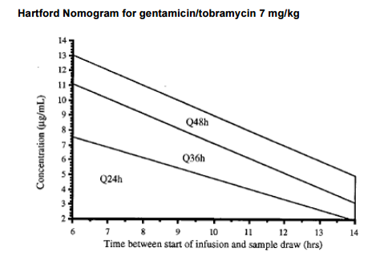

*Antimocrob Agents Chemother. 1995; 39(3):650-655.
APPENDIX 2: Details of Aminoglycoside Traditional Dosing
Procedure for determining patient candidacy for traditional dosing
STEP 1: Determine Dosing Weight
- Use the table from APPENDIX 1 to determine the patient's ideal body weight (IBW) and 120% of ideal body weight:
- Determine the patient's dosing weight
- If a patient's actual body weight (ActBW) is not greater than 120% of IBW: the dosing weight is the patient's actual weight.
- If patient's actual body weight IS greater than 120% of ideal body weight calculate the patient's adjusted body weight using the following equation:
    - Dosing Weight = Adjusted Body Weight = IBW + 0.4 (ActBW - IBW)

STEP 2: Calculate Estimated Creatinine Clearance*
Male: Est CrCl = (140-age) (Actual Weight**) Female: Est CrCl = (140-age) (Actual Weight**) x 0.85
(72)(SCr) (72)(SCr)

*For patients ≥ 65 years with SCr < 0.8 mg/dL, round SCr to 0.8 mg/dL.
*If actual weight is < IBW, use actual weight; if actual weight is > IBW but < 120% of IBW, use IBW; if actual weight is ≥ 120% IBW, use Adj BW.

STEP 3: Determine Aminoglycoside Dose
Aminoglycoside | Loading Dose | Maintenance Dose
Gentamicin/Tobramycin | 2 mg/kg | 1.7 mg/kg
Amikacin | 7.5 mg/kg | 7.5 mg/kg

STEP 4: Determine Dose Frequency
Est CrCl (ml/min) | Interval
> 50 | q8h
10-50 | q12-48h**
<10 | q48-72h**
Hemodialysis | post-dialysis
- For renal failure and Continuous Veno-Venous Hemofiltration (CVVH), obtain levels daily and re-dose when levels fall below 1 mg/L for gentamicin or 5 mg/L amikacin.
**An internet-based clinical calculator (i.e. Clinicalc® or GlobapRPH®) may be utilized to more specifically determine the aminoglycoside dose and interval frequency based on patient factors (age, weight, creatinine, etc). NOTE: The usual range of volume of distribution for aminoglycosides is 0.25 - 0.35 L/kg.

STEP 5: Obtain Lab Values for Therapeutic Monitoring
- Obtain trough level immediately before 3rd maintenance dose.
- Obtain peak level 30 minutes after the end of infusion of 3rd maintenance dose.
- After initial peak and trough, obtain peak and trough levels every 3-5 days to ensure dose and interval are still appropriate.
- Obtain SCr at baseline and at least every 3 days while on aminoglycoside therapy or daily in the presence of baseline renal insufficiency, severe infection/sepsis or concomitant use with other nephrotoxic agents.
- For renal failure and CVVH, obtain levels daily and re-dose when levels fall below 1 mg/L for gentamicin or 5 mg/L amikacin.

STEP 6: Interpret Aminoglycoside Serum Levels and Adjust Dosing Appropriately
- Interpret peak and trough levels based on indication.
Infection Type | Desired Peak Level |  | Desired Trough Level
 | Gentamicin/Tobramycin | Amikacin | Gentamicin/Tobramycin | Amikacin
Pneumonia, Documented Pseudomonal Infections | 7-10 | 30-35 | <1 | <5
Non-Pseudomonal Gram Negative Infection | 5-7 | 20-30 | <1 | <5
Gram Positive Synergy (Gentamicin only), UTIs | 3-4 | N/A | <1 | N/A

- Adjust aminoglycoside dose based on the peak and trough obtained**
Peak | Trough | Recommended Change
> desired range | > desired range | decrease dose and increase dosing interval
> desired range | within desired range | decrease dose
< desired range | > desired range | increase dose and increase dosing interval
< desired range | within desired range | increase dose
within desired range | within desired range | continue with same dose and dosing interval
**An internet-based clinical calculator (i.e. Clinicalc® or GlobapRPH®) may be utilized to more specifically determine the revised aminoglycoside dose and interval frequency based on serum concentrations and patient factors (age, weight, creatinine, etc).

APPENDIX 3: Details of Aminoglycoside Gram Positive Synergy Specific Dosing
Procedure for determining indication-specific dosing
STEP 1: Determine Dosing Weight
- Use the table from APPENDIX 1 to determine the patient's ideal body weight (IBW) and 120% of ideal body weight:
- Determine the patient's dosing weight
- If a patient's actual body weight (ActBW) is not greater than 120% of IBW: the dosing weight is the patient's actual weight.
- If patient's actual body weight IS greater than 120% of ideal body weight calculate the patient's adjusted body weight using the following equation:
    - Dosing Weight = Adjusted Body Weight = IBW + 0.4 (ActBW - IBW)

STEP 2: Calculate Estimated Creatinine Clearance*

Male: Est CrCl = (140-age) (Actual Weight**) Female: Est CrCl = (140-age) (Actual Weight**) x 0.85
(72)(SCr) (72)(SCr)

*For patients ≥ 65 years with SCr < 0.8 mg/dL, round SCr to 0.8 mg/dL.
*If actual weight is < IBW, use actual weight; if actual weight is > IBW but < 120% of IBW, use IBW; if actual weight is ≥ 120% IBW, use Adj BW

STEP 3: Determine Gram Positive Synergy Specific Dosing and Frequency:
Unknown Species:
Renal Function (CrCl mL/min) | Gram-Positive Synergy Dose + Frequency
>60 | 1 mg/kg q8h
40-59 | 1 mg/kg q12h
20-39 | 1 mg/kg q24h
<20, HD, CVVH or CRRT | 1mg/kg than redose when serum conc. < 1 mg/L

Known Species in patient with CLcr > 60 ml/min:

Infective Microorganism | Gentamicin Dosing
Gram Positive Infective Endocarditis (IE)  Streptococcus virdans/bovis  Staphylococcus aureus Prosthetic-valve IE  Enterococcus | Gentamicin  3 mg/kg q24h  3 mg/kg q24h OR 1 mg/kg q8h OR  1.5 mg/kg q12h  1 mg/kg q8h OR 1.5 mg/kg q12h

**An internet-based clinical calculator (i.e. Clinicalc® or GlobapRPH®) may be utilized to more specifically determine the revised aminoglycoside dose and interval frequency based on serum concentrations and patient factors (age, weight, creatinine, etc).

STEP 4: Obtain Lab Values for Therapeutic Monitoring
- For all regimens, obtain trough level immediately before 3rd maintenance dose.
- For regimens other than 3 mg/kg every 24 hours, obtain peak level 30 minutes after the end of infusion of 3rd maintenance dose.
- After initial peak and trough, obtain peak and trough levels every 3-5 days (trough levels only for patients receiving 3 mg/kg every 24 hours) to ensure dose and interval are still appropriate.
- Obtain SCr at baseline and at least every 3 days while on aminoglycoside therapy or daily in the presence of baseline renal insufficiency, severe infection/sepsis or concomitant use with other nephrotoxic agents.
- For renal failure and CVVH, obtain levels daily and re-dose when levels fall below 1 mg/L for gentamicin or 5 mg/L amikacin.

STEP 5: Interpret Aminoglycoside Serum Levels and Adjust Dosing Appropriately
- Interpret peak and trough levels based on indication.
Infection Type | Desired Peak Level |  | Desired Trough Level
 | Gentamicin/Tobramycin | Amikacin | Gentamicin/Tobramycin | Amikacin
Gram Positive Synergy, 1 mg/kg dosed every 8,12, or 24 hours  Gram Positive Synergy, 3 mg/kg dosed every 24 hours | 3-4  N/A | N/A  N/A | <1  <1 | N/A  N/A

- Adjust aminoglycoside dose based on the peak and trough obtained**
Peak | Trough | Recommended Change
> desired range | > desired range | decrease dose and increase dosing interval
> desired range | within desired range | decrease dose
< desired range | > desired range | increase dose and increase dosing interval
< desired range | within desired range | increase dose
within desired range | within desired range | continue with same dose and dosing interval
**An internet-based clinical calculator (i.e. Clinicalc® or GlobapRPH®) may be utilized to more specifically determine the revised aminoglycoside dose and interval frequency based on serum concentrations and patient factors (age, weight, creatinine, etc).
APPENDIX 4 Initial Dosing Smart-Text

UCONN RX AMINOGLYCOSIDE TRADITIONAL OR GRAM POSITIVE SYNERGY SPECIFIC DOSING MONITORING INITIAL [408011]
Pharmacy Note: Aminoglycoside Traditional dosing initial note.
Patient Name: @NAME@ DOB: @DOB@
MRN#: @MRN@
Admission Date: PATADMDT@ Attending: @ENCPROVNMTITLE@ Consult ordering provider:
Allergies:
@NAME@ is a @AGE@ @SEX@ who has been consulted for {PKCONSULT_AG_MEDICATION:20910} dosing for {PKCONSULT_AG_INDICATION:20906}.
Current Antimicrobial Medications @RXABXLPG@

Height | @LASTHT(3)@
Actual Body Weight (ABW)  (use if it is not greater than 120% of IBW): | @LASTWT(3)@
Ideal Body Weight (IBW) | @IBW@
120% of ideal body weight: | ***
Adjusted Body Weight = IBW + .4 (ActBW - IBW) (use if ActBW is greater than 120% of IBW)
Dosing weight: {PKCONSULT_DOSING_WEIGHT:20917}. = *** kg

Current Antimicrobial Medications: @RXABXLPG@
Problem List |  | Pertinent Medical History
@PROB@ |  | @PMH@
Dialysis :{TREATMENTS; DIALYSIS GENERAL TYPE:18239}

Labs:
BUN | @LASTLAB(BUN:3)@
CREATININE | @LASTLAB(CREATININE:3)@
Estimated CrCl: (Note: not an accurate estimate of renal function in patients receiving renal replacement therapies.) | @CRCL@
WBC | @LASTLAB(WBC:3)@
NEUTROABS | @LASTLAB(NEUTROABS:3)@
ANCA | @LASTLAB(ANCA:3)@
PROCALCITONIN | @LASTLAB(PROCALCITONIN:3)@
CRP | @LASTLAB(CRP:3)@
ALBUMIN | @LASTLAB(ALBUMIN:3)@
LACTATE | @LASTLAB(LACTATE:3)@
Aminoglycoside Drug Levels:
PEAK | @LASTLAB(GentPEAK:1)@; @LASTLAB(TOBRAPEAK:1)@;  @LASTLAB(AMIKPEAK:1)@
RANDOM | @LASTLAB(GENTRANDOM:1)@;  @LASTLAB(TOBRRANDOM:1)@;  @LASTLAB(AMIKRANDOM:1)@;
TROUGH | @LASTLAB(GENTTROUGH:1)@;  @LASTLAB(TOBRTROUGH:1)@  @LASTLAB(AMIKTROUGH:1)@
MICROBIOLOGY
Baseline culture/source/susceptibility: | @LABRCNT(CULTURE:*)@
Relevant microbiology
Culture results:
{CULTURES:23518}
Calculate Estimated Creatinine Clearance: *** mL/min.
*For patients ≥ 65 years with SCr < 0.8 mg/dL, round SCr to 0.8 mg/dL.

Vital Signs (last 24 hours): @VSRANGES@
Current I/O Net Intake/Output (last 24 hours):@IOBRIEF@ Urine output for previous 24 hours: ***
Medications with nephrotoxic potential: {UCONN RX NEPHROTOXIC MEDICATIONS:25829} Potentially significant drug interactions:
Temperature: @LASTTE | MP(3)@
Clinical Status: | Temperature: {INCREASING/DECREASING/STABLE:15050}
 | WBCs: {INCREASING/DECREASING/STABLE:15050}
 | Renal Function: {IMPROVING/STABLE/WORSENING:21462}

Assessment/Plan
Loading Dose | {UCONN RX AMINOGLYCOSIDE CONVENTIONAL LOADING DOSE:26848}
Maintenance Dose | {UCONN RX AMINOGLYCOSIDE CONVENTIONAL MAINTENANCE DOSE:26849}
Serum Levels Ordered: | {Y/N:29038}

The patient will be started on {PKCONSULT_AG_MEDICATION:20910} utilizing traditional dosing based on {PKCONSULT_DOSING_WEIGHT:20917}. Baseline risks associated with therapy include: {PKCONSULT_AG_BASELINE_RISKS:20914}. Will initiate dose at *** mg/kg/dose {PKCONSULT_AG_DOSING_INTERVAL:20916}. Pharmacy will also follow closely for {PKCONSULT_AG_MONITORING:20908}. Serum creatinine will be ordered per policy. Plan for peak and trough 30 minutes before and after the *** dose. Due to infection severity, will target a peak level of {PKCONSULT_AG_GOAL_PEAK:20945} ug/mL and trough of
{PKCONSULT_AG_GOAL_TROUGH:20990} ug/mL. Pharmacy will continue to follow the patient’s culture results and clinical progress daily.

Assessment completed by:
@ME@ | at@TD@ | @NOW@@TD@
Contact information: Voalte Me or Main pharmacy at 860-679-7627
References: http://uchcportal.uchc.edu/clinical/jdh/standards/Records/UCHC/JDH/Pharmacy/Aminoglycoside%20Pharmacokinetic%20Assessment.doc

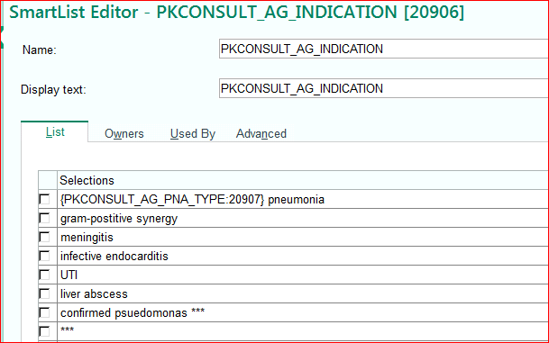
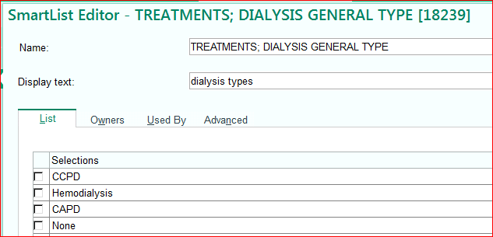
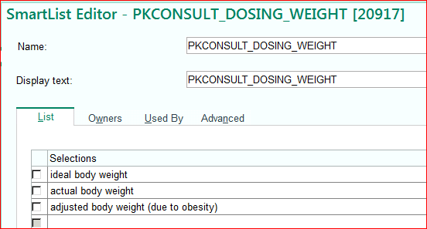
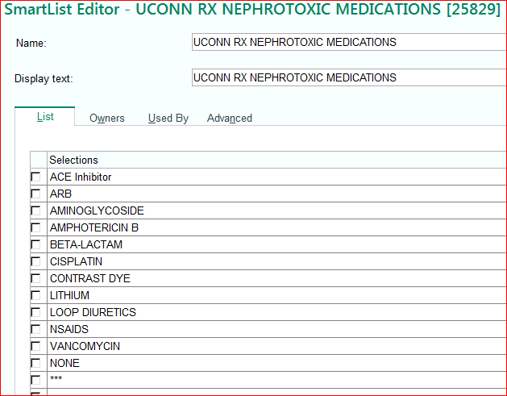
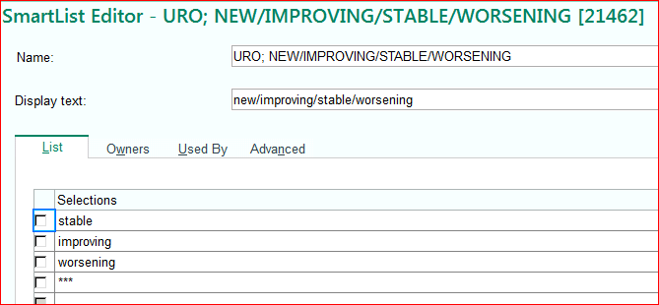
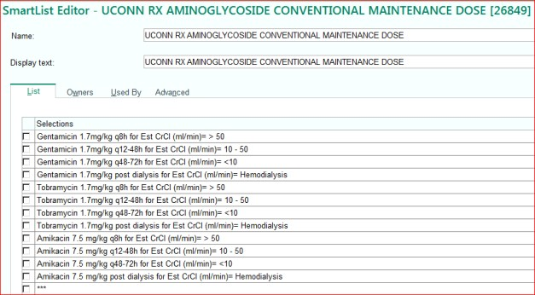
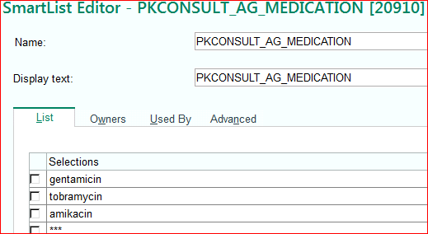

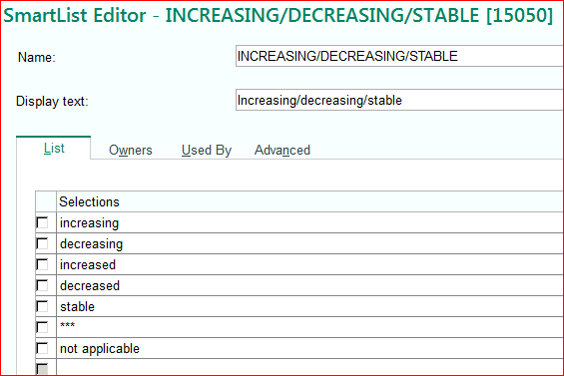

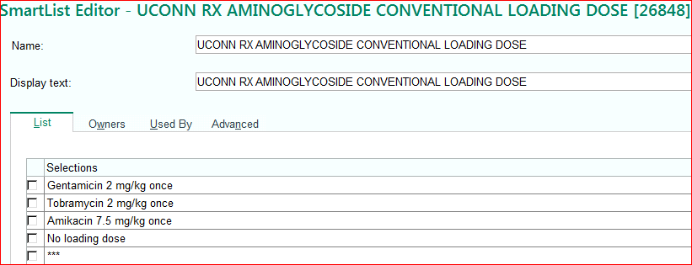
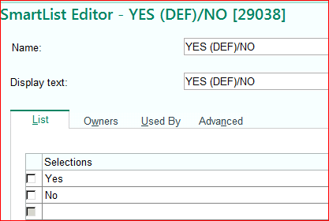

UCONN RX AMINOGLYCOSIDE EXTENDED INTERVAL DOSING MONITORING INITIAL [15228}
Pharmacy Note: Aminoglycoside Extended interval dosing initial note.
Patient Name: @NAME@
DOB: @DOB@
MRN#: @MRN@
Admission Date: @PATADMDT@ Attending: @ENCPROVNMTITLE@ Consult ordering provider:
Allergies:

@NAME@ is a @AGE@ @SEX@ who has been consulted for {PKCONSULT_AG_MEDICATION:20910} dosing for {PKCONSULT_AG_INDICATION:20906}.
Review of contraindications to extended interval dosing:
Ensured pregnancy test performed (if female): | Pregnancy status:@OBSTATUS@
Dialysis | {TREATMENTS; DIALYSIS GENERAL TYPE:18239}
Estimated creatinine clearance of < 20 ml/min Unstable renal function (with a change in serum creatinine by 0.5mg/dl or 50% within 48 hours) | @CRCL@  @LASTLAB(CREATININE:3)@
Ascites, severe liver disease or excessive third spacing of fluids | {YES/NA/NO:23853}
Burns (>20% body surface area) | {YES/NA/NO:23853}
Cystic Fibrosis | {YES/NA/NO:23853}
Gentamicin use as a synergistic agent for a gram- positive infection | {YES/NA/NO:23853}

Height | @LASTHT(3)@
Actual Body Weight (ABW)  (use if it is not greater than 120% of IBW): | @LASTWT(3)@
Ideal Body Weight (IBW) | @IBW@
120% of ideal body weight: | ***
Adjusted Body Weight = IBW + 0.4 (ActBW - IBW) (use if ActBW is greater than 120% of IBW):
Dosing weight: {PKCONSULT_DOSING_WEIGHT:20917}. = *** kg

Current Antimicrobial Medications: @RXABXLPG@

Problem List |  | Pertinent Medical History
@PROB@ |  | @PMH@

Labs:
BUN | @LASTLAB(BUN:3)@
CREATININE | @LASTLAB(CREATININE:3)@
Estimated CrCl: (Note: not an accurate estimate of renal function in patients receiving renal replacement therapies.) | @CRCL@
WBC | @LASTLAB(WBC:3)@
NEUTROABS | @LASTLAB(NEUTROABS:3)@
ANCA | @LASTLAB(ANCA:3)@
PROCALCITONIN | @LASTLAB(PROCALCITONIN:3)@
CRP | @LASTLAB(CRP:3)@
ALBUMIN | @LASTLAB(ALBUMIN:3)@
LACTATE | @LASTLAB(LACTATE:3)@
Aminoglycoside Drug Levels:
PEAK | @LASTLAB(GentPEAK:1)@; @LASTLAB(TOBRAPEAK:1)@;  @LASTLAB(AMIKPEAK:1)@
RANDOM | @LASTLAB(GENTRANDOM:1)@; @LASTLAB(TOBRRANDOM:1)@;  @LASTLAB(AMIKRANDOM:1)@;
TROUGH | @LASTLAB(GENTTROUGH:1)@; @LASTLAB(TOBRTROUGH:1)@  @LASTLAB(AMIKTROUGH:1)@
MICROBIOLOGY
Baseline culture/source/susceptibility: | @LABRCNT(CULTURE:*)@
Relevant microbiology
Culture results:
{CULTURES:23518}
Calculate Estimated Creatinine Clearance: *** mL/min.
*For patients ≥ 65 years with SCr < 0.8 mg/dL, round SCr to 0.8 mg/dL.

Vital Signs (last 24 hours): @VSRANGES@
Current I/O Net Intake/Output (last 24 hours):@IOBRIEF@ Urine output for previous 24 hours:
Medications with nephrotoxic potential: {UCONN RX NEPHROTOXIC MEDICATIONS:25829} Potentially significant drug interactions:
Temperature: @LASTTEMP(
Clinical Status: | Temperature: {INCREASING/DECREASING/STABLE:15050}
 | WBCs: {INCREASING/DECREASING/STABLE:15050}
 | Renal Function: {IMPROVING/STABLE/WORSENING:21462}

Assessment/Plan
Review of contraindications for extended interval dosing: : {UCONN RX AMINOGLYCOSIDE EXTENDED CONTRAINDICATIONS:26844} Dose and Interval: {UCONN RX AMINOGLYCOSIDE EXTENDED DOSE/INTERVAL:26845}

Recommended Lab Monitoring: {UCONN VANCOMYCIN/AMINOGLYCOSIDE Recommended Lab Monitoring:26939}
The patient will be started on {PKCONSULT_AG_MEDICATION:20910} utilizing extended interval dosing based on {PKCONSULT_DOSING_WEIGHT:20917}. Baseline risks associated with therapy include: {PKCONSULT_AG_BASELINE_RISKS:20914}. Will initiate dose at *** mg/kg/dose {PKCONSULT_AG_DOSING_INTERVAL:20916}. Pharmacy will also follow closely for
{PKCONSULT_AG_MONITORING:20908}. Plan for trough 30 minutes before the *** dose. Due to infection severity, will target a peak level of trough of {PKCONSULT_AG_GOAL_TROUGH:20990}
ug/mL. Pharmacy will continue to follow the patient’s culture results and clinical progress daily.

Assessment completed by:
@ME@ | at@TD@ | @NOW@@TD@
Contact information: Voalte Me or Main pharmacy at 860-679-7627
References: http://uchcportal.uchc.edu/clinical/jdh/standards/Records/UCHC/JDH/Pharmacy/Aminoglycoside%20Pharmacokinetic%20Assessment.doc

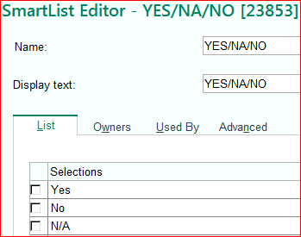 | 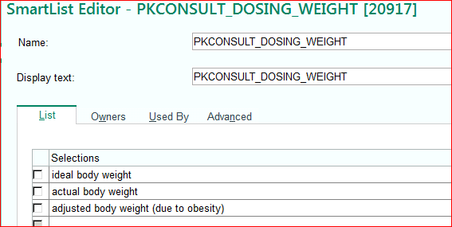
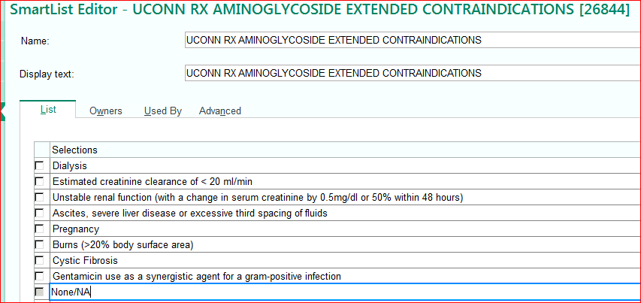 | 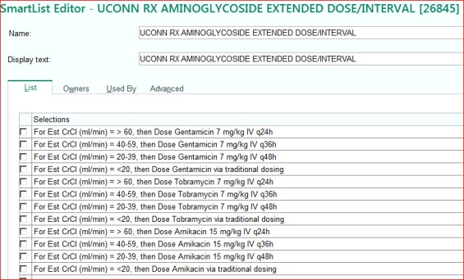
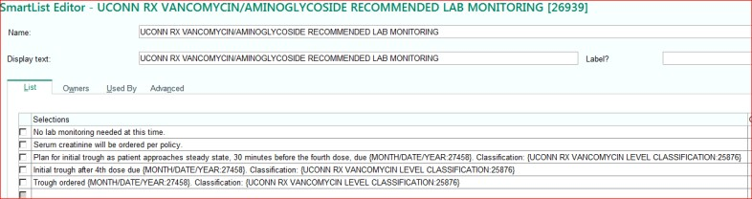 | 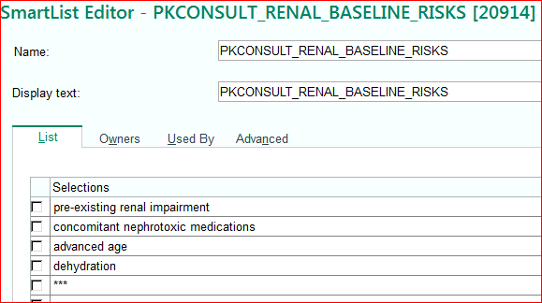
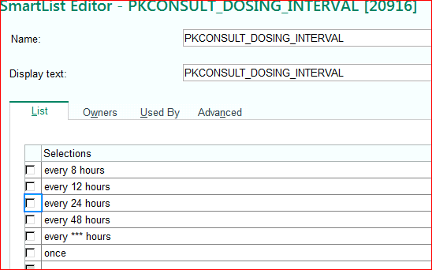 | 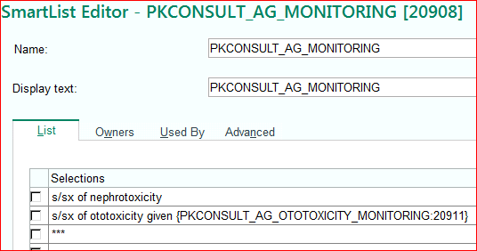
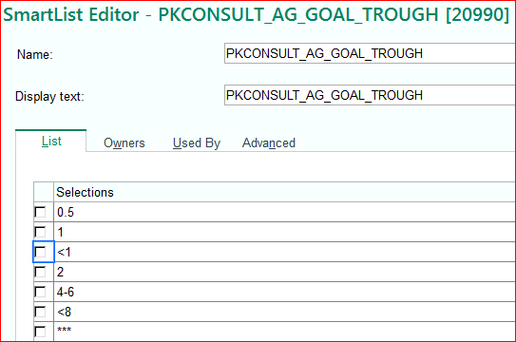 | 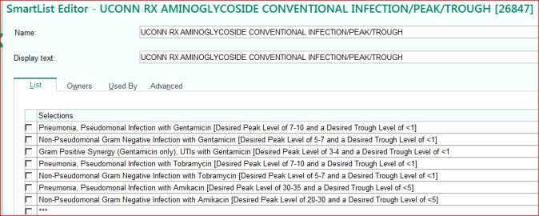
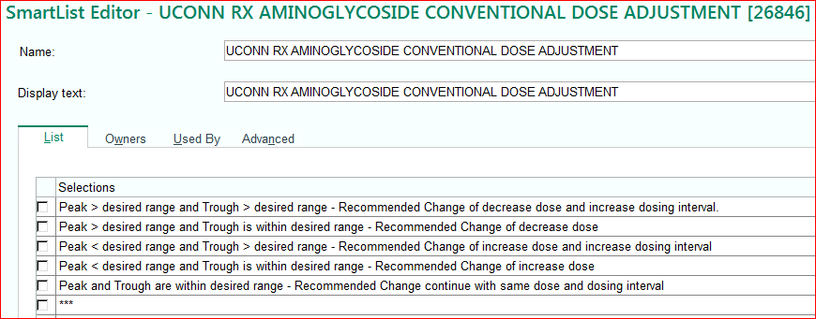

APPENDIX 5 Follow-up Dosing Smart-Text
UCONN RX AMINOGLYCOSIDE DOSING CONVENTIONAL or GRAM POSITIVE SYNERGY SPECIFIC DAILY MONITORING [13929]
Pharmacy Note: Aminoglycoside Traditional dosing initial note.

Patient Name: @NAME@ DOB: @DOB@
MRN#: @MRN@
Admission Date: @PATADMDT@ Attending: @ENCPROVNMTITLE@ Consult ordering provider: ***
Allergies:

@NAME@ is a @AGE@ @SEX@ who has been consulted for {PKCONSULT_AG_MEDICATION:20910} dosing for
{PKCONSULT_AG_INDICATION:20906}.

Current Antimicrobial Medications
@RXABXLPG@
Medications with nephrotoxic potential: {UCONN RX NEPHROTOXIC MEDICATIONS:25829} Potentially significant drug interactions:
Temperature: @LAST | TEMP(3)@
Clinical Status: | Temperature: {INCREASING/DECREASING/STABLE:15050}
 | WBCs: {INCREASING/DECREASING/STABLE:15050}
 | Renal Function: {IMPROVING/STABLE/WORSENING:21462}

Labs:
BUN
@LASTLAB(BUN:3)@
CREATININE
@LASTLAB(CREATININE:3)@
Estimated CrCl: (Note: not an accurate estimate of renal function in patients receiving renal replacement therapies.)
@CRCL@
WBC
@LASTLAB(WBC:3)@
NEUTROABS
@LASTLAB(NEUTROABS:3)@
ANCA
@LASTLAB(ANCA:3)@
PROCALCITONIN
@LASTLAB(PROCALCITONIN:3)@
CRP
@LASTLAB(CRP:3)@
ALBUMIN
@LASTLAB(ALBUMIN:3)@
LACTATE
@LASTLAB(LACTATE:3)@
Aminoglycoside Drug Levels:
PEAK
@LASTLAB(GentPEAK:1)@;
@LASTLAB(TOBRAPEAK:1)@;
@LASTLAB(AMIKACIN PK:1)@
RANDOM
@LASTLAB(GENTRANDOM:1)@;
@LASTLAB(TOBRARND:1)@; @LASTLAB(AMIKACIN RM:1)@;
TROUGH
@LASTLAB(GENTTROUGH:1)@;
@LASTLAB(TOBRAMYCIN TR:1)@
@LASTLAB(AMIKACIN TR:1)@
MICROBIOLOGY
Baseline culture/source/susceptibility: ***.
@LABRCNT(CULTURE:*)@
Relevant microbiology ***
Culture results: ***
{CULTURES:23518}

Desired Serum Levels based on indication:{UCONN RX AMINOGLYCOSIDE CONVENTIONAL INFECTION/PEAK/TROUGH:26847}
{UCONN RX AMINOGLYCOSIDE CONVENTIONAL DOSE ADJUSTMENT:26846}

{UCONN RX AMINOGLYCOSIDE CONVENTIONAL DOSE ADJUSTMENT:26846}

Recommended Lab Monitoring: {UCONN VANCOMYCIN/AMINOGLYCOSIDE Recommended Lab Monitoring:26939}

Assessment Completed by:
@ME@ @NOW@@TD@ Contact information: Voalte Me or Main pharmacy at 860-679-7627

References: http://uchcportal.uchc.edu/clinical/jdh/standards/Records/UCHC/JDH/Pharmacy/Aminoglycoside%20Pharmacokinetic%20Assessment.doc

UCONN RX AMINOGLYCOSIDE DOSING EXTENDED INTERVAL DAILY MONITORING [15253]
TBD
Pharmacy Note: Aminoglycoside Extended interval dosing initial note.
Pharmacy Note: Aminoglycoside Traditional dosing initial note.

Patient Name: @NAME@ DOB: @DOB@
MRN#: @MRN@
Allergies:
Admission Date: @PATADMDT@ Attending: @ENCPROVNMTITLE@ Consult ordering provider: ***

Ensured pregnancy test performed (if female): Pregnancy status:@OBSTATUS@

@NAME@ is a @AGE@ @SEX@ who has been consulted for {PKCONSULT_AG_MEDICATION:20910} dosing for {PKCONSULT_AG_INDICATION:20906}.

Height | @LASTHT(3)@
Actual Body Weight (ABW)  (use if it is not greater than 120% of IBW): | @LASTWT(3)@
Ideal Body Weight (IBW) | @IBW@
120% of ideal body weight: | ***
Adjusted Body Weight = IBW + 0.4 (ActBW - IBW) (use if ActBW is greater than 120% of IBW):
Dosing weight: {PKCONSULT_DOSING_WEIGHT:20917}. = *** kg

Current Antimicrobial Medications: @RXABXLPG@

Problem List |  | Pertinent Medical History
@PROB@ |  | @PMH@
Dialysis :{TREATMENTS; DIALYSIS GENERAL TYPE:18239}

Labs:
BUN | @LASTLAB(BUN:3)@
CREATININE | @LASTLAB(CREATININE:3)@
Estimated CrCl: (Note: not an accurate estimate of renal function in patients receiving renal replacement therapies.) | @CRCL@
WBC | @LASTLAB(WBC:3)@
NEUTROABS | @LASTLAB(NEUTROABS:3)@
ANCA | @LASTLAB(ANCA:3)@
PROCALCITONIN | @LASTLAB(PROCALCITONIN:3)@
CRP | @LASTLAB(CRP:3)@
ALBUMIN | @LASTLAB(ALBUMIN:3)@
LACTATE | @LASTLAB(LACTATE:3)@
Aminoglycoside Drug Levels:
PEAK | @LASTLAB(GentPEAK:1)@; @LASTLAB(TOBRAPEAK:1)@;  @LASTLAB(AMIKACIN PK:1)@
RANDOM | @LASTLAB(GENTRANDOM:1)@; @LASTLAB(TOBRARND:1)@;  @LASTLAB(AMIKACIN RM:1)@;
TROUGH | @LASTLAB(GENTTROUGH:1)@; @LASTLAB(TOBRAMYCIN TR:1)@  @LASTLAB(AMIKACIN TR:1)@
MICROBIOLOGY
Baseline culture/source/susceptibility: | @LABRCNT(CULTURE:*)@
Relevant microbiology
Culture results:
{CULTURES:23518}

Calculate Estimated Creatinine Clearance: *** mL/min.
*For patients ≥ 65 years with SCr < 0.8 mg/dL, round SCr to 0.8 mg/dL.

Vital Signs (last 24 hours): @VSRANGES@
Current I/O Net Intake/Output (last 24 hours):@IOBRIEF@ Urine output for previous 24 hours:
Medications with nephrotoxic potential: {UCONN RX NEPHROTOXIC MEDICATIONS:25829} Potentially significant drug interactions:
Temperature: @LASTTEMP( | 3)@
Clinical Status: | Temperature: {INCREASING/DECREASING/STABLE:15050}
 | WBCs: {INCREASING/DECREASING/STABLE:15050}
 | Renal Function: {IMPROVING/STABLE/WORSENING:21462}

Assessment/Plan
Review of contraindications for extended interval dosing: : {UCONN RX AMINOGLYCOSIDE EXTENDED CONTRAINDICATIONS:26844} Dose and Interval: {UCONN RX AMINOGLYCOSIDE EXTENDED DOSE/INTERVAL:26845}

Recommended Lab Monitoring: {UCONN VANCOMYCIN/AMINOGLYCOSIDE Recommended Lab Monitoring:26939}
The patient will be started on {PKCONSULT_AG_MEDICATION:20910} utilizing extended interval dosing based on {PKCONSULT_DOSING_WEIGHT:20917}. Baseline risks associated with therapy include: {PKCONSULT_AG_BASELINE_RISKS:20914}. Will initiate dose at *** mg/kg/dose {PKCONSULT_AG_DOSING_INTERVAL:20916}. Pharmacy will also follow closely for
{PKCONSULT_AG_MONITORING:20908}. Plan for trough 30 minutes before the *** dose. Due to infection severity, will target a peak level of trough of {PKCONSULT_AG_GOAL_TROUGH:20990}
ug/mL. Pharmacy will continue to follow the patient’s culture results and clinical progress daily.

Assessment Completed by:
@ME@ @NOW@@TD@ Contact information: Voalte Me or Main pharmacy at 860-679-7627

References: http://uchcportal.uchc.edu/clinical/jdh/standards/Records/UCHC/JDH/Pharmacy/Aminoglycoside%20Pharmacokinetic%20Assessment.doc

