Overview

The new form is a fillable PDF so you can complete it electronically and no longer need to scan it in. These instructions will help you understand how to use the new form including:
- Filling out the form
- Creating a Digital Signature
- Signing and Submitting the form

Filling out the form

Before you start a new form, it is important that you have a detailed understanding of what you need to request. Providing all of the details will help us get you the data you need more quickly and efficiently. There are Tool Tips visible when you hover over each field to help you understand what is needed in each field.
The requester or person submitting the form will need to electronically sign the form with a Digital Signature also known as a Digital ID. The term Digital Signature and Digital ID are used interchangeably in this context.
If you have already configured a Digital Signature, then you will be able to use that to sign the form. Otherwise, you will be prompted to configure a new Digital Signature.

Creating a Digital Signature

If you do not have a digital signature configured and available on the PC you are using, then you will need to create a new one. Here is the process:
- Select “Create a new Digital ID”. As the notes indicate, that is not a legally binding, certified signature but it is something that you setup and control with a password/pin so no one else can sign for you.
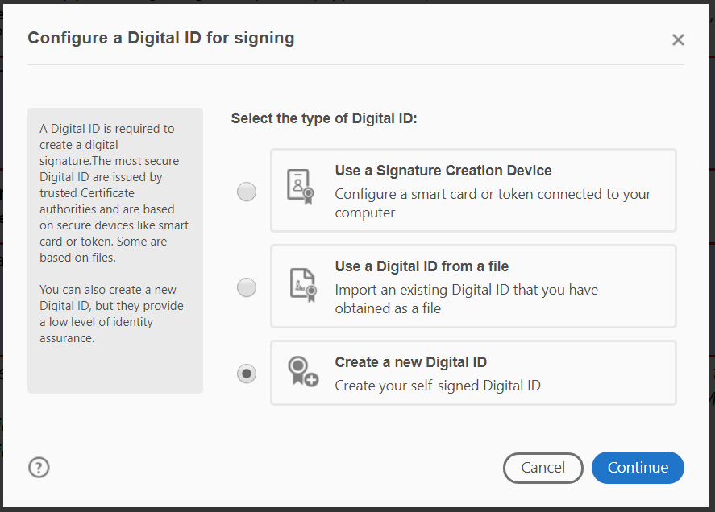
- Select “Save to a File” and click Continue. In a later step you will select where on your PC you want to save this file.
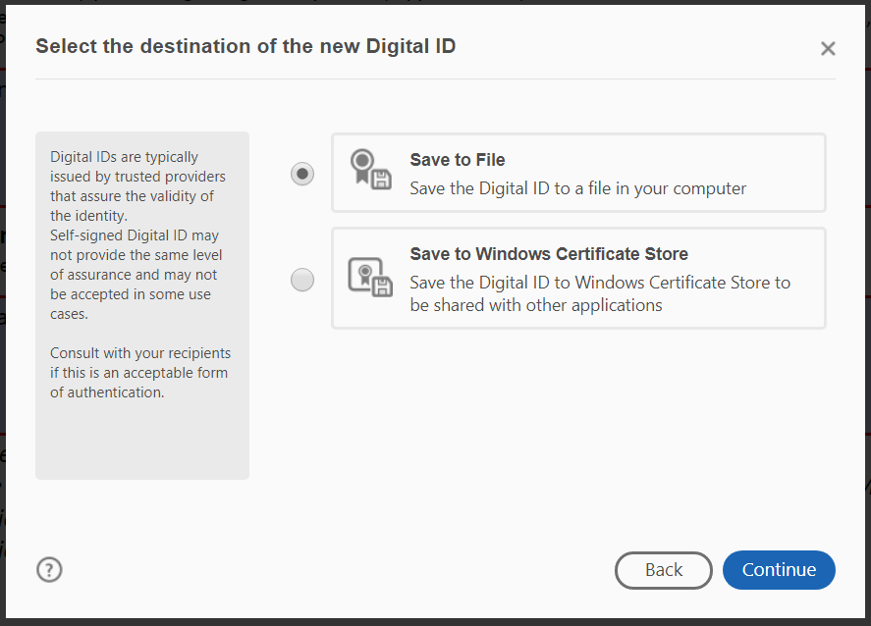

- Enter your name and email address, leave the other values with the default setting. Click Continue.
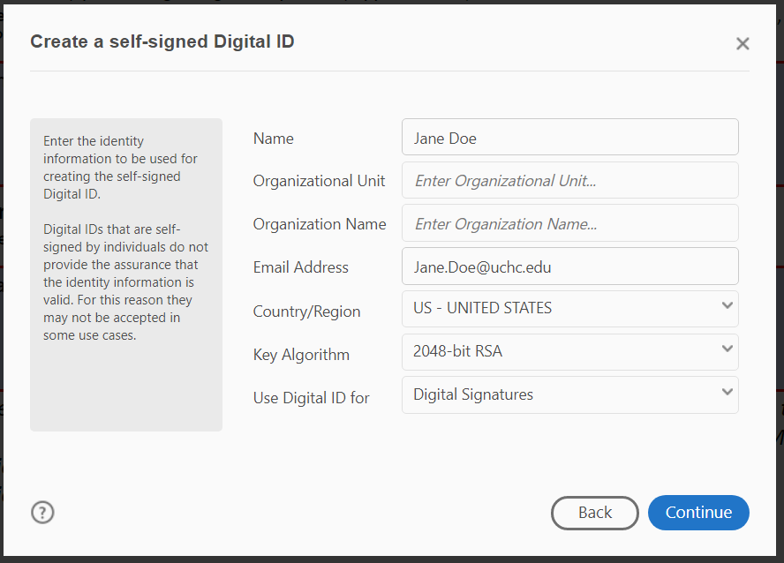

- Choose a location on your own PC to store the file and setup a password. Remember this password as you will need it each time you use your Digital ID. There is a red/green bar indicating the strength of your selected password.
Remember this password as you will need it each time you use your Digital ID.
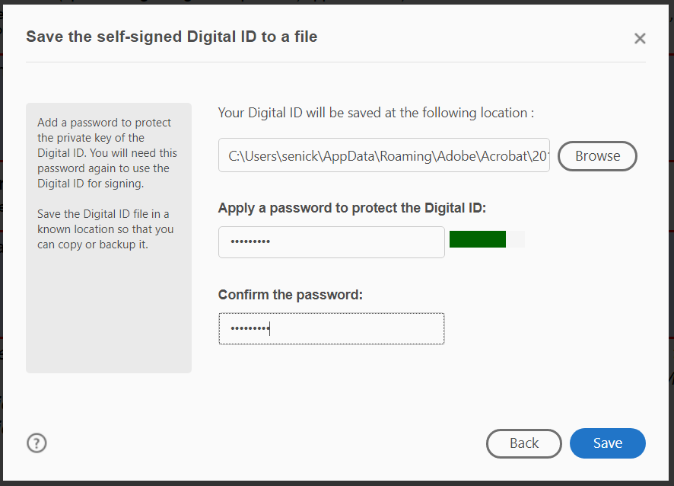

Signing and Submitting the form
Once you have your Digital Signature configured then you are ready to actually sign the document.
- Select your Digital ID and click Continue.
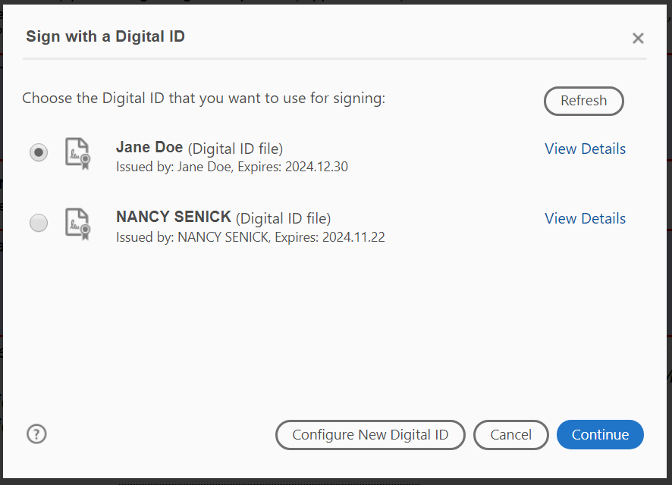

- Your Digital ID and a timestamp are displayed and you must enter the password/pin you entered when configuring your Digital ID. Click Sign.
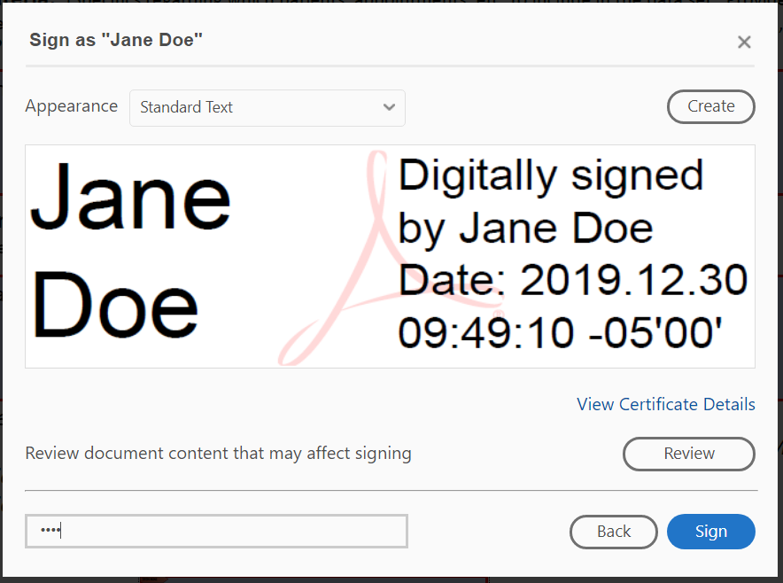

- When you sign a Fillable PDF, you must save a new version of the document. Select a location on your PC and change the File name to reflect to something meaningful as this is your copy of the request.

Un-Signing a Form
Once you sign the form, you will not be able to make any changes unless you un-sign the form by clearing your signature by Right Clicking on the signature and selecting Clear Signature.
. 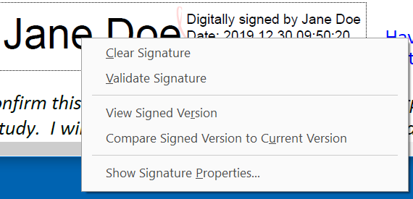
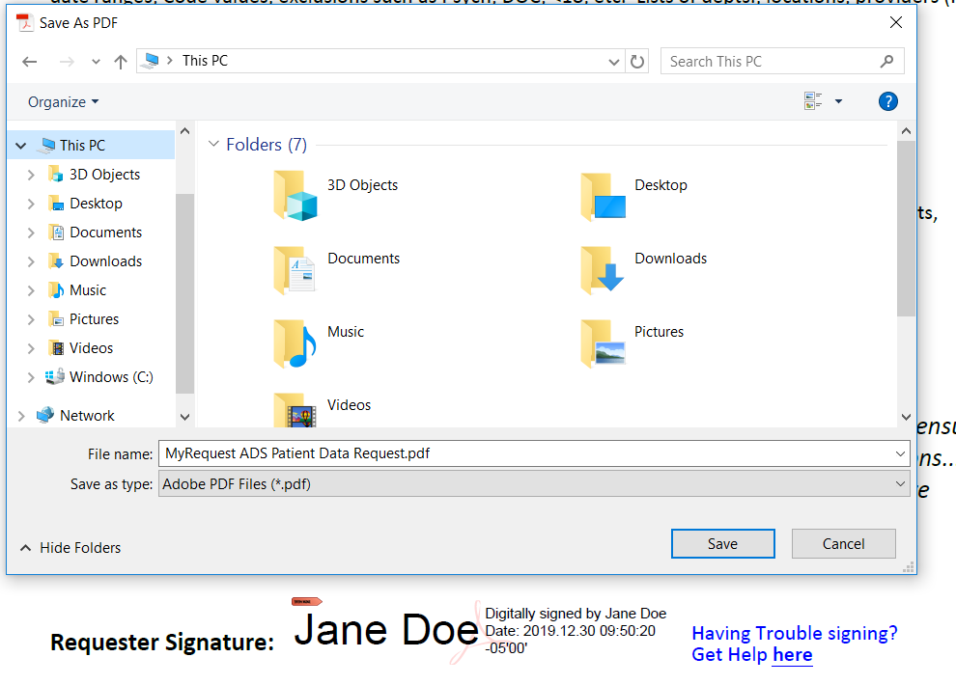
- Once the form is completely filled out and signed, then you can click on Submit Request. You may see this dialog box. You need to select Default email application (Microsoft Outlook) and check the Remember my choice box, then click Continue.
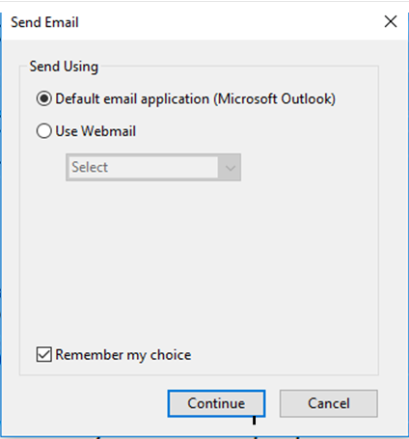
Next, you will see a pre-populated email with your request form attached, unless your request is for a Research Study. You add recipients or update the body of the email to provide additional information along with your request.
Please do NOT change the subject line so we can promptly process your request.
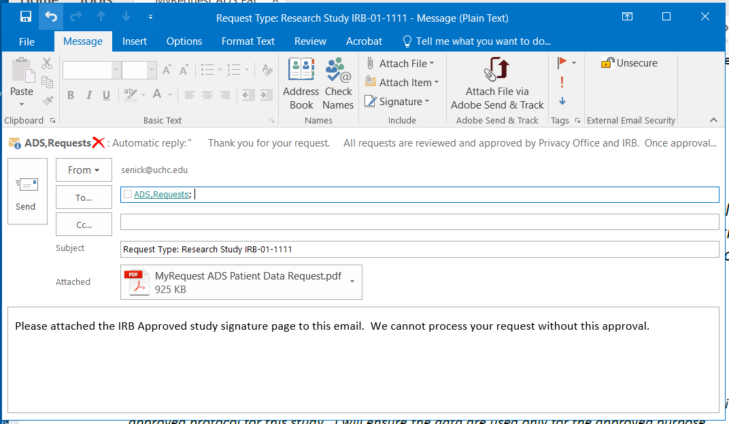

Research Studies
If you are requesting data for a Research Study, then you will not be able to Submit the request until you obtain the Prinicpal Investigator’s signature. You will also need to attached a copy of the approval letter or signed HIPAA Assurance of Preparatory Research form.
If the Requester is also the PI, then the PI can sign as both the Requester and PI and then click on Submit Request.
If the Requester is not the PI, then the Requester can email their saved, signed form to the PI and the PI can sign and click on Submit Request.
NOTE: Only the Requester can make changes to the content of the request by un-signing the form.

