**Senator Douglas McCrory**

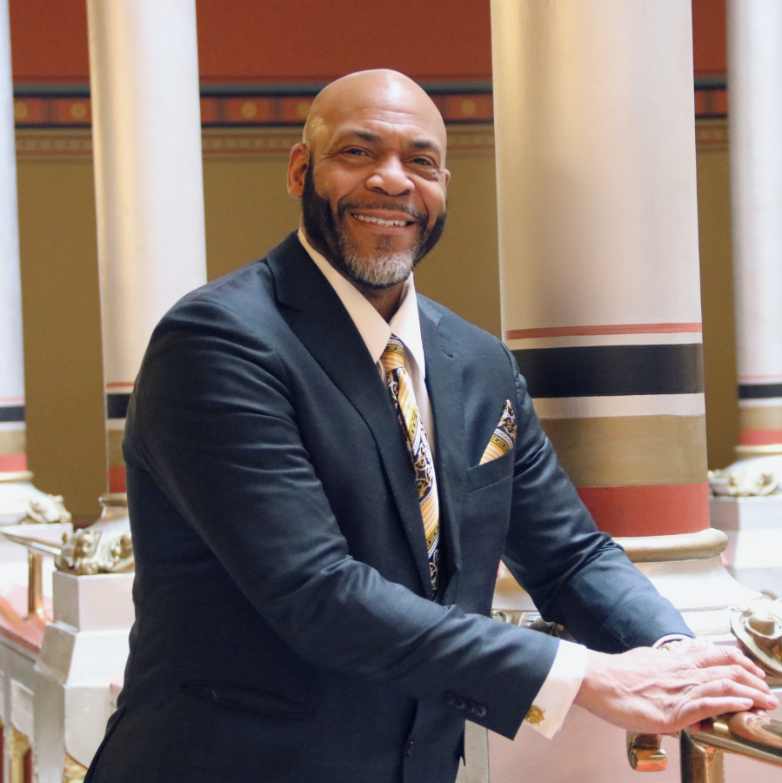

For Doug McCrory, giving back has always been a top priority. He was elected with the continued promise of continued accountability and accessibility as the State Senator for the 2nd Senate district in a special election in February 2017 to represent parts of Bloomfield, Hartford, and Windsor. He was first elected to the General Assembly in 2004 to represent the 7th House district, which he served for six full terms. Even before his service as a legislator, Doug has been committed to strengthening neighborhoods through education, economic development, and civic engagement.

An administrator for the Capitol Region Education Council (CREC), Doug has been an educator for over 30 years. Beginning as a teacher at Sarah J. Rawson Elementary School, he has also taught at and served as vice principal at Lewis Fox Middle School. Recognizing the importance of strong role models and education as the keys to positive development, Doug worked with fellow teacher Sadiq Ali to found the Benjamin E. Mays Institute, which emphasizes positive self-esteem through the use of a curriculum infused with African American history and themes.

Doug has also been involved in politics at the grassroots level, serving as a Democratic Town Committee member in the 7th District for many years. Recognizing the importance of participation among people of color in the political process, Doug continuously encourages young people to become engaged civically, to register and vote.

As Senate Chair of the Education Committee, Doug led the approval of a 2019 law creating an African American and Latino studies course available to high school students. Doug continues to champion equity in education through advancing minority teacher recruitment and retention, increased education funding, and supporting youth mental health.

Having a quality education may lead to better job employment which may lead to a better quality of life and overall health. Doug fervently works with his colleagues, various government agencies, and small businesses to find ways to improve economic development and is committed to finding and affording access to resources that will encourage and promote the necessary job growth his district, and our state, need to thrive.

Doug is a Blue Hills resident of Hartford.