**Britt-Marie Cole-Johnson, Esq.**

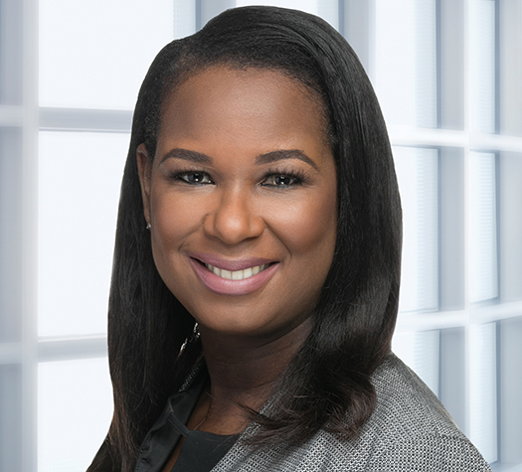A noted employment lawyer, board member, and speaker, Britt-Marie counsels companies, from startups to the Fortune 500, in many areas of employment law, including sensitive, high-risk personnel issues, workplace investigations, DEI, compliance and separations. She is a partner in the Labor + Employment Group at Robinson+Cole, an *AmLaw 200* law firm, and was elected to the firm’s Managing Committee. Britt-Marie offers insightful, forward-thinking, and practical counsel, is well-versed in the key responsibilities of directors, and supports clients’ boards of directors seeking guidance on governance, risk, and strategy. She is also a trained workplace investigator and regularly conducts, manages, and provides advice regarding workplace investigations involving all types of employment-related issues, particularly those requiring Board of Director and senior management involvement and high-profile matters. She serves as a faculty member for the UConn School of Business and the Association of Workplace Investigators.

Britt-Marie was appointed by Connecticut Governor Ned Lamont to serve on the Board of the Connecticut Paid Leave Authority and also serves on a number of other Boards, including the Association of Workplace Investigators, Oak Hill, UConn Health, The Connecticut Project, and Teach for America – Connecticut, where she serves as Board Chair. She has been ranked in *Chambers USA: America's Leading Lawyers for Business* in the State of Connecticut in the area of Labor & Employment since 2014 and in the *Connecticut Super Lawyers* list since 2020 after being recognized as a Rising Star from 2013 to 2018.  Most recently, she was recognized as a 2023 Women in Business Honoree by the *Hartford Business Journal*.

Britt-Marie earned her B.A. in English from Emory University and her J.D. from Emory University School of Law.