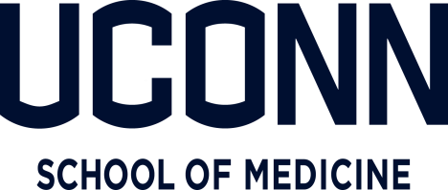

March 9, 2020

To Whom It May Concern,

As the University of Connecticut School of Medicine continues to monitor the spread of COVID-19, or coronavirus, across the globe, we are taking steps to help improve our informational awareness and reduce the risk to our community state-wide.

After seeing what is happening with the overwhelming spread of COVID-19 on a national level, we have asked all resident physicians to carefully consider their travel plans as they are essential front-line providers who will need to be available for their patients and our health systems.

<insert name here> is a resident physician employed by the University School of Medicine which has exposure to the patient population from 5 major teaching hospitals in the greater Hartford community with outreach through Connecticut. As such, we ask you to extend any possible courtesies with regards to issuing full monetary refunds of hotel, airfare, or vacation packages to our physicians being asked to alter personal planned vacations in order to be ready and capable to care for the needs of our patients and communities.

On behalf of the patient population and caregivers in Connecticut, we thank you in advance for your flexibility during these unprecedented time given the magnitude and potential seriousness of the COVID-19 situation.

If there are any questions, please feel free to contact me at siraco@uchc.edu.

Sincerely,
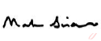
Mark Siraco
Director, Graduate Medical Education Finance
UConn School of Medicine

