- Log into the Strata website
  - In web browser (Google Chrome is recommended), go to:
https://secure.stratanetwork.com/StrataJazz/login-fs.aspx

  - Enter your UConn email address and click Next button

- Things to know
  - FOAPAL is Department in Strata
  - Department format is Entity-Organization-Activity-Fund-Program
  - Frequently used reports can be marked as FAVORITE under Option 2 below and show up on the home screen
  - Single Click hyperlinks are used throughout Strata System
  - After generating reports, DO NOT SAVE, as these are public reports
  - Click Close option when finished with a report 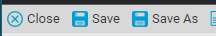
  - When finished in Strata, Click the gear button in the top right hand corner and select Log Out 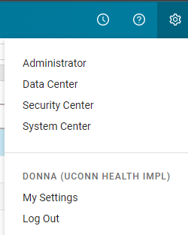

- Viewing Budget Process reports
  - Option 1 – In Strata’s top menu bar, click Analytics, then Dashboards 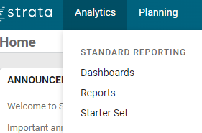
    - Use the menu to choose ‘Fiscal Budgeting Reports’ in the General folder (Note: depending on your security, it may default you to the correct screen)
    - Navigate to the reports under Management Reporting and Staffing Reports for the most commonly used reports.
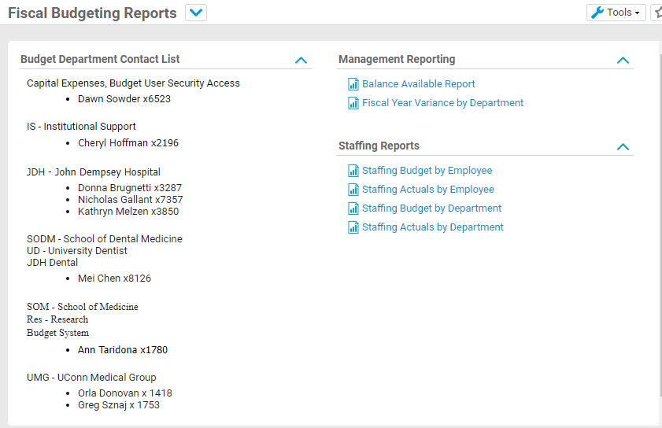
  - Option 2 - In the Strata’s top menu bar, click Analytics, then Reports
    - On the System Reports page 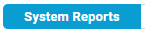, navigate to a section to see available reports
      - Management Reporting section – contains all GL/Profit and Loss based reports i.e. Monthly Variance Report, Balance Available Report
      - Operating Budgeting section – should only be used during the budget process for creating a new fiscal budget
      - Productivity Reporting – contains Staffing/Personnel reports
  - Click on the report name to open report
  - Use report filter options at the top of the report to select criteria to generate a report
    - Each report’s filter name may be slightly different, reference screenshot below.
    - For the Personnel Budget Report by Position, filter by Employee or Employee – CustomPosition
      - The Employee filter can search by any part of the position description included i.e. Employee name, Banner B#, Position Control number and Jobcode/Position Title
      - The Employee – CustomPosition filter is the BannerHR PC number
    - Using filters
      - Click on the words highlighted in blue next to filter icon to open the Filter window
      - Under “2. Configure member selections:”, click the magnifying glass icon (located on the right side of the line) to search
      - In the search field, type the value to be searched and click enter or click the icon
      - Check the box to select item and click the button
      - Click
  - Select the refresh data button to load the report data

- Export Report to Print
  - Click the Export button
  - Choose Export to Excel
    - Report will pop up in the lower left hand corner of the Strata window. If using Edge the report will pop up in the top right hand corner
    - Click the report to open in Excel
    - Report can be modified and saved however you choose
    - Use the print option in Excel

