

**Srdjan D. Antic, MD**

Promotion to Professor

Department of Neuroscience

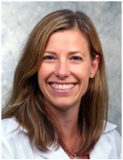

**Jennifer D. Baldwin, MD**

Promotion to Associate Professor

Department of Medicine



**Linda K. Barry, MD**

Promotion to Professor

Department of Surgery

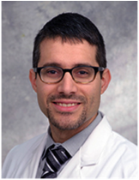

**David B. Banach, MD**

Promotion to Professor

Department of Medicine



**Christine R. Beck, Ph.D**

Promotion to Associate Professor w/Tenure

Department of Genetics & Genome Sciences



**Robert A. Byrd, Ph.D**

Appointment as Professor

Department of Molecular Biology and Biophysics



**Melissa J. Caimano, Ph.D**

Promotion to Professor

Department of Medicine



**Markus J. Bookland, MD**

Promotion to Associate Professor

Department of Surgery

(Connecticut Children’s)

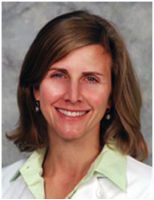

**Lisa M. Chirch, MD**

Promotion to Professor

Department of Medicine

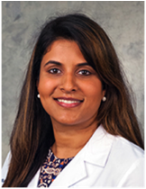

**Saira R. Cherian, DO**

Promotion to Associate Professor

Department of Medicine

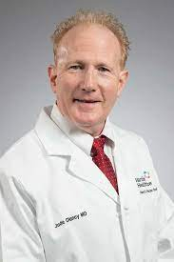

**Jude F. Clancy, MD**

Appointment as Associate Professor

Department of Medicine

(Hartford HealthCare Corp.)

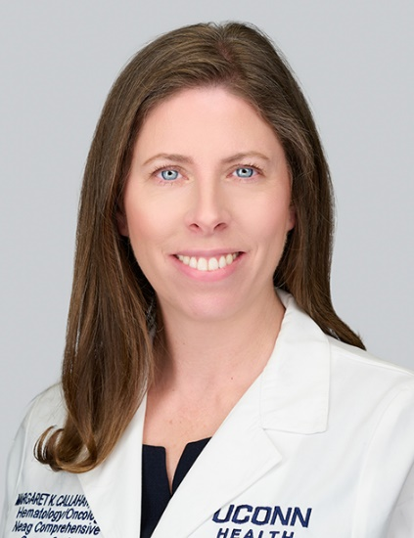

**Margaret K. Callahan, MD, Ph.D**

Appointment as Professor

Department of Medicine

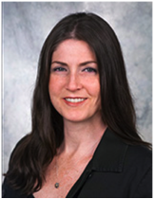

**Alicia G. Dugan, Ph.D**

Promotion to Associate Professor w/ tenure

Department of Medicine

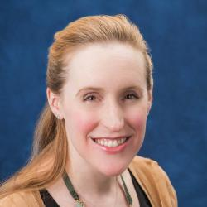

**Anne G. Dudley, MD**

Promotion to Associate Professor

Department of Surgery

(Connecticut Children’s)

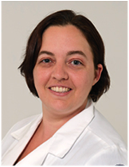

**Shannon L. DeGroff, MD**

Promotion to Associate Professor

Department of Obstetrics & Gynecology



**DonnaMaria E. Cortezzo, MD**

Appointment as Associate Professor

Department of Pediatrics

(Connecticut Children’s)

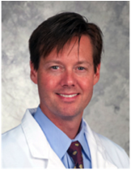

**Cory M. Edgar, MD, Ph.D**

Promotion to Associate Professor

Department of Orthopaedic Surgery



**Barbara S. Edelheit, MD**

Promotion to Associate Professor

Department of Pediatrics

(Connecticut Children’s)

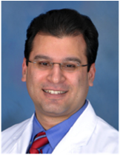

**Khayyam Durrani, MD**

Promotion to Associate Professor

Department of Surgery

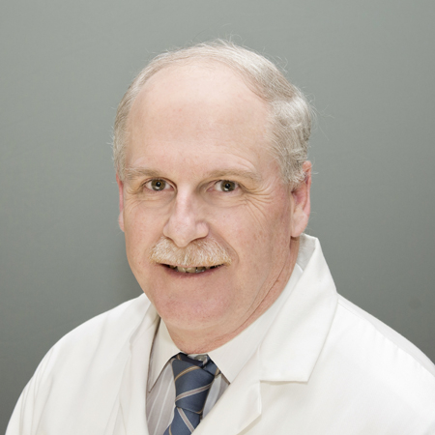

**William Duggan, MD**

Promotion to Associate Clinical Professor

Department of Anesthesiology

**Gary X. Gong, MD, Ph.D**

Appointment as Associate Professor

Department of Diagnostic Imaging & Therapeutics

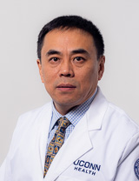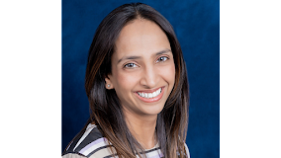

**Majida Gaffar, MD**

Promotion to Associate Professor

Department of Surgery

(Connecticut Children’s)

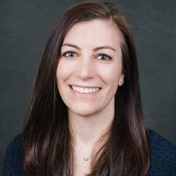

**Jennifer T. Haile, MD**

Promotion to Associate Professor

Department of Pediatrics

(Connecticut Children’s)

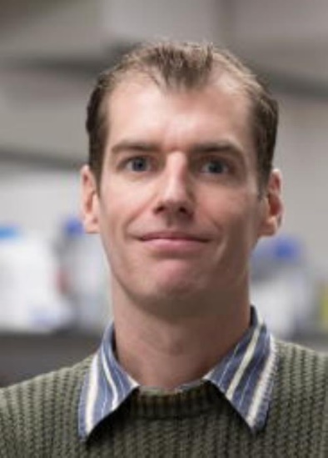

**Michael J. Guertin, Ph.D**

Award of Academic Tenure

Department of Genetics & Genome Sciences

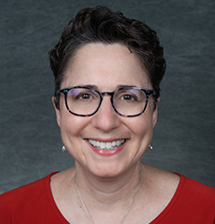

**Felice A. Heller, MD**

Promotion to Associate Professor

Department of Pediatrics

(Connecticut Children’s)

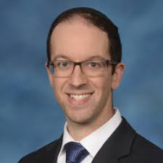

**David S. Hersh, MD**

Promotion to Associate Professor

Department of Surgery

(Connecticut Children’s)



**Alexander H. Hogan, MD**

Promotion to Associate Professor

Department of Pediatrics

(Connecticut Children’s)

**Cathryn G. Holzhauer, Ph.D**

Appointment as Associate Professor

Department of Psychiatry

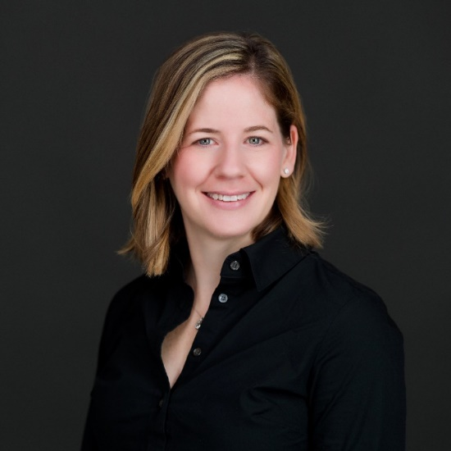

**Sivapriya Kailasan Vanaja, Ph.D**

Promotion to Associate Professor w/tenure

Department of Immunology



**Jaclyn O. Jaeger, DO**

Promotion to Associate Professor

Department of Medicine

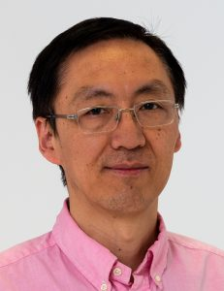

**Xiangyou Hu, Ph.D**

Promotion to Associate Professor

Department of Neuroscience

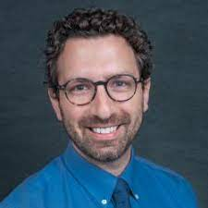

**Bradley Jerson, Ph.D**

Promotion to Associate Professor

Department of Pediatrics

(Connecticut Children’s)

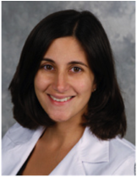

**Electra V. Kaloudis, MD**

Promotion to Associate Professor

Department of Diagnostic Imaging & Therapeutics

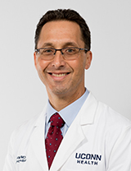

**Richard A. Kamin, MD**

Promotion to Professor

Department of Emergency Medicine

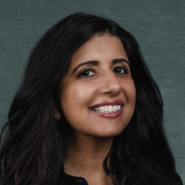

**Sunpreet Kaur, MD**

Appointment as Associate Professor

Department of Pediatrics

(Connecticut Children’s)

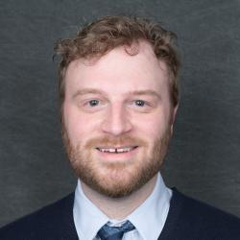

**Robert D. Keder, MD**

Promotion to Associate Professor

Department of Pediatrics

(Connecticut Children’s)



|  |  |  |  |
| --- | --- | --- | --- |
| ***Diane Whitaker-Worth, MD***  *Promotion to Professor Department of Dermatology* |  |  |  |

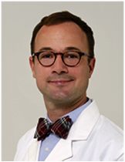

**Michael D. Kisicki, MD**

Appointment as Associate Professor

Department of Psychiatry

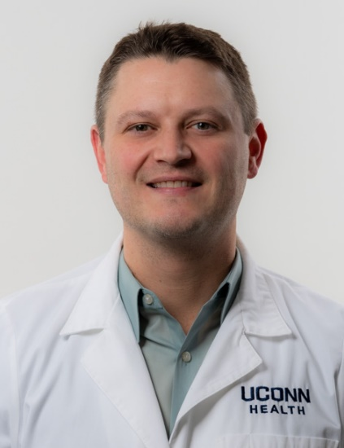

**Donald Kirton MD**

Appointment as Associate Professor

Department of Obstetrics & Gynecology

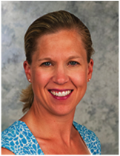

**Danielle E. Luciano, MD**

Promotion to Professor

Department of Obstetrics & Gynecology

**Paul Rocco LaSala, MD**

Appointment as Professor

Department of Pathology & Laboratory Medicine

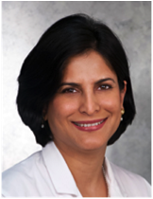

**Pooja Luthra, MD**

Promotion to Professor

Department of Medicine



**Adam P. Matson, MD**

Promotion to Associate Professor

Department of Pediatrics

(Connecticut Children’s)

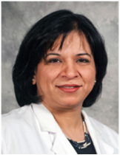

**Faryal S. Mirza, MD**

Promotion to Professor

Department of Medicine

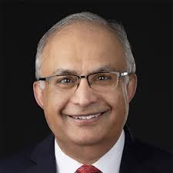

**Atique Mirza, MD**

Promotion to Associate Clinical Professor

Department of Medicine

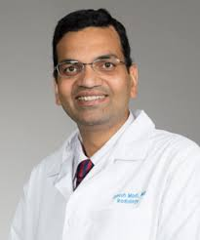

**Jignesh Modi, MD**

Promotion to Associate Clinical Professor

Department of Neurology

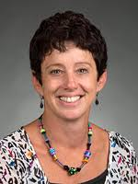

**Lisa Namerow, MD**

Promotion to Clinical Professor

Department of Psychiatry

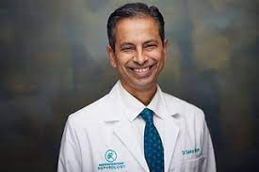

**Sankar Niranjan, MD**

Promotion to Associate Clinical Professor

Department of Medicine

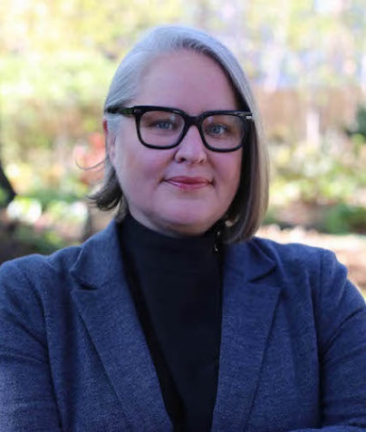

**Megan O’Grady, Ph.D**

Promotion to Associate Professor w/Tenure

Department of Public Health Sciences

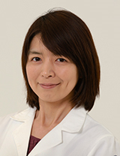

**Mayu Oguro, Ph.D**

Promotion to Associate Professor w/Tenure

Department of Cell Biology

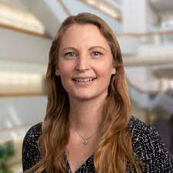

**Silke Paust, Ph.D**

Appointment as Professor

Department of Immunology

(Jackson Laboratory)

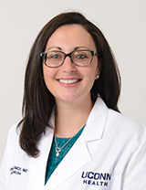

**Jennifer A. Ozimek, MD**

Promotion to Associate Professor

Department of Medicine

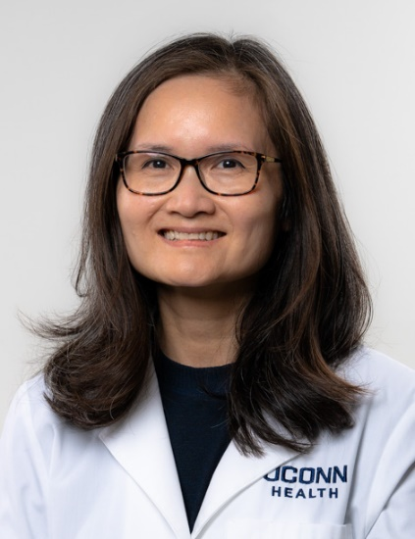

**Giao Q. Phan, MD**

Appointment as Professor

Department of Surgery

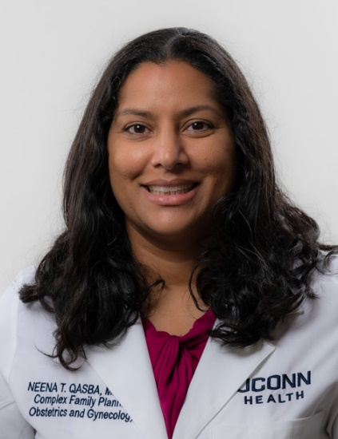

**Neena T. Qasba, MD, MPH**

Appointment as Associate Professor

Department of Obstetrics & Gynecology

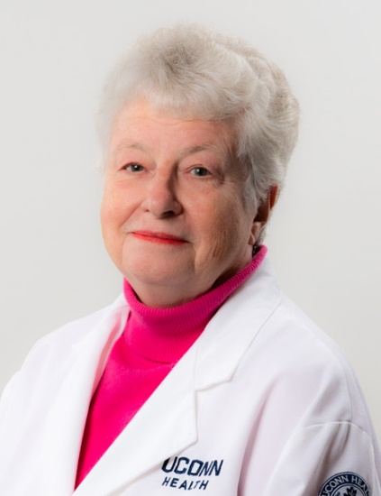

**Martha J. Radford, MD**

Appointment as Professor

Department of Medicine



**Vijay A. Rathinam, DVM, Ph.D**

Promotion to Professor

Department of Immunology

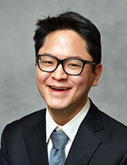

**Taeho (Greg) Rhee, Ph.D**

Award of Academic Tenure

Department of Public Health Sciences

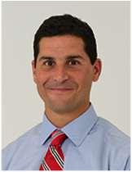

**Craig M. Rodner, MD**

Promotion to Professor

Department of Orthopaedic Surgery

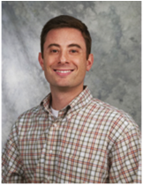

**Adam D. Schuyler, Ph.D**

Promotion to Associate Professor

Department of Molecular Biology & Biophysics



**Paul Robson, Ph.D**

Promotion to Professor

Department of Genetics & Genome Sciences

(The Jackson Laboratory)

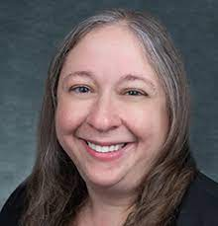

**Rebecca Riba-Wolman, MD**

Promotion to Associate Professor

Department of Pediatrics

(Connecticut Children’s)



**Linda S. Sprague Martinez, Ph.D**

Appointment as Professor w/ tenure

Department of Medicine

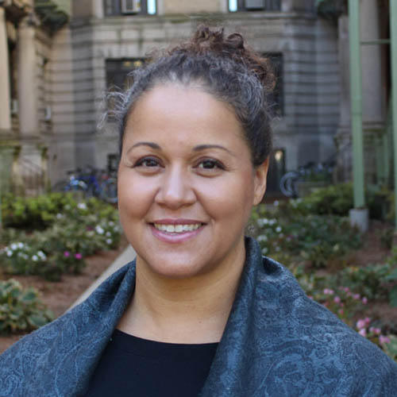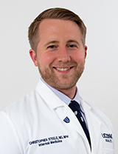

**Christopher L. Steele, MD**

Promotion to Associate Professor

Department of Medicine

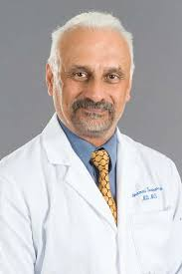

**Subramani Seetharama, MD**

Promotion to Associate Professor

Department of Medicine

(Hartford Healthcare Corp.)



**Jeffrey S. Shenberger, MD**

Appointment as Professor

Department of Pediatrics

(Connecticut Children’s)



**Emily O. Wakefield, Psy.D**

Promotion to Associate Professor

Department of Pediatrics

(Connecticut Children’s)

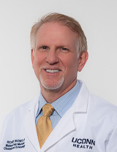

**Richard K. Wagner, MD**

Promotion to Associate Professor

Department of Obstetrics & Gynecology

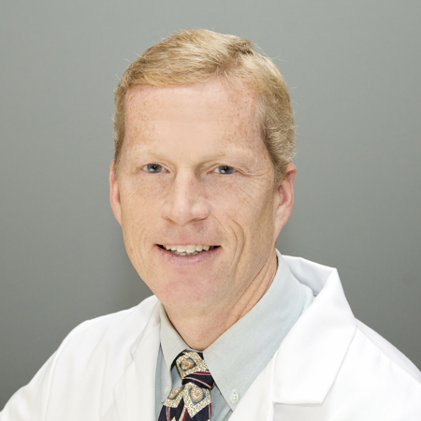

**John F. Tiernan, MD**

Promotion to Associate Clinical Professor

Department of Anesthesiology

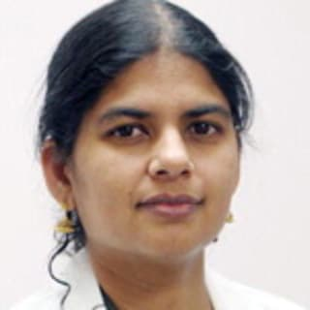

**Banu Sundar, MD**

Appointment as Associate Professor

Department of Neurology

(Veterans Administration Medical Center)

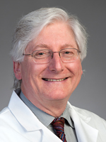

**Witold Waberski, MD**

Promotion to Associate Clinical Professor

Department of Anesthesiology



**Carrie D. Walker, Ed.D**

Appointment as Associate Professor

Department of Psychiatry



**Yulan Xiong, Ph.D**

Promotion to Associate Professor w/Tenure

Department of Neuroscience

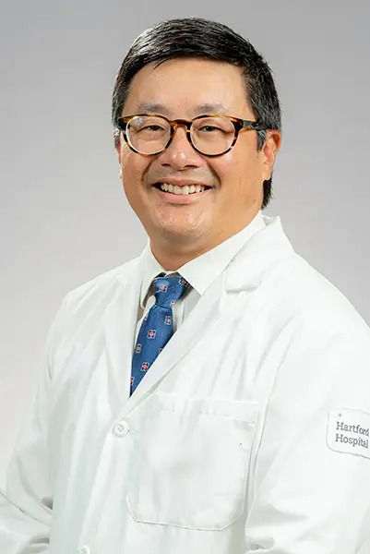

**Peter S. Yoo, MD**

Appointment as Professor

Department of Surgery

(Hartford Healthcare Corp.)

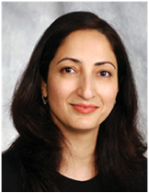

**Asima A. Zehgeer, MD**

Promotion to Associate Professor

Department of Psychiatry



***The Office of Faculty Affairs***

**would like to congratulate**

**the following faculty who were approved for**

**Senior Rank Appointment, Promotion and/or Tenure during the 2023-2024 cycle.**

