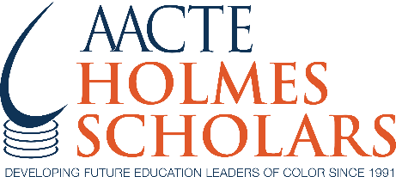
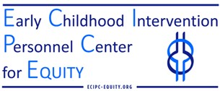

FAQ on Programmatic Partnership:
Early Childhood Intervention Personnel Center for Equity + Holmes Program Partnership

Who are the program partners?
- Early Childhood Intervention Personnel Center for Equity – The ECIPC-Equity at the University of Connecticut, School of Medicine is a technical assistance center funded by the US Department of Education, Office of Special Education Programs to increase the capacity of institutions of higher education, professional organizations, states, territories, and tribal nations to prepare and support a diverse and competent workforce able to deliver early intervention/early childhood special education services to each and every child and their family.
- AACTE's Holmes Program – The Holmes Program supports scholars who self-identify as racially and ethnically diverse and are pursuing doctoral degrees in education at AACTE member institutions.

What is the goal of the project?
The goal is to work toward meeting the demand for more early childhood intervention leaders and practitioners with the requisite knowledge and skills to meet the needs of children ages birth to five with disabilities and their families. To achieve this, there must be an adequate number of early childhood and early childhood special education programs, which have effective recruitment and retention systems to sustain these professionals.
The primary outcome is:
- Professional development to a cohort of ten Doctoral candidates (Ed.D. or Ph.D.) Holmes Scholars whose program and research is specialized in early childhood special education or those in early childhood who plan to specialize on children with disabilities.

How does the program benefits to Holmes Scholars?
- Enhanced professional development experiences. In addition to professional development (PD) provided by the project partners, Holmes scholars will receive funding to attend three in-person events hosted by AACTE listed below.
- Enhanced networking and support experiences. In addition to the support of their cohort of 10, the selected
Holmes Scholars will receive special mentoring sessions from experts in the field. Each cohort will have a one-year tenure commencing in September.

Who is eligible?
- Participants must be at an Institution of Higher Education that participates in the Holmes Program through AACTE.
- Participants must be a doctoral candidate in an early childhood special education program or special education with a concentration in early childhood intervention. (Ed.D. and Ph.D.)

What is the funding amount?
- Each scholar will receive a one-time, $3,100 stipend in financial support to attend the three annual Holmes in person conferences: Holmes Preconference, Washington Week, and the Research & Dissertation Retreat.

