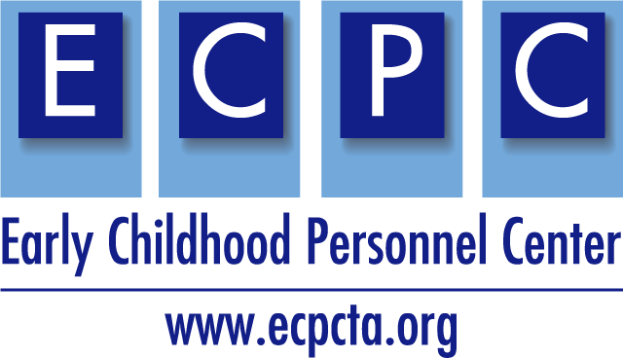

ECPC Syllabus Checklist
Align Your Syllabi with EI/ECSE Professional Standards
This checklist includes seven sections typically included in course syllabi and is designed to facilitate alignment of the course content and requirements with the EI/ECSE standards and components: Initial Practice-Based Professional Preparation Standards for EI/ECSE (2020). Your Institute of Higher Education (IHE) may require additional sections and/or content within sections of the syllabus. The checklist can be used as a self-assessment for the course(s) that you teach. It should be used as part of a program self-assessment when developing or revising the program of study. For sample syllabi, https://ecpcta.org/ihe-faculty/.

Name
University
Course number and title
Standards and Components Addressed
Aligned with State CSPD

Syllabus Sections | Syllabus Content | Yes | No | Notes/Feedback
Course and Instructor Information | Course title, number, section
 | Date (semester and year)
 | Course meeting days and times
 | Course location: on-campus or virtual
 | Instructor’s name and title
 | Instructor’s office location and office hours
 | Instructor’s phone number, email address, and web page
 | Course web page URL
 | Other information as required by the IHE
Course Description | IHE approved course description, as in catalog
 | Prerequisites and course requirements (e.g., field hours) as in catalog
 | Course format (e.g., lecture, on-line, hybrid, field work)
Course and University Policies | Attendance
 | Academic integrity/dishonesty/plagiarism
 | Accommodations for students with disabilities
 | Course evaluation/grading
 | Late assignments/make-up work or exams
 | File type accepted (e.g., docx, pdf, etc.)
 | Other, based on individual instructor expectations and/or IHE policies
Student Learning Outcomes/Objectives  reflect the Standard/s and Component/s | Identify what the student will know and/or be able to do upon successful completion of course requirements
 | Each objective is operationalized with observable/measurable outcomes
 | Each objective identifies the EI/ECSE component |  |  | .
Required Text and Supplemental Materials reflect the Standard/s and Component/s | Required text:  Align with standard(s) and component(s) addressed by course
Supplemental materials:
Journal articles, etc.
Websites
Videos
Topical Course Outline (table format) | Date/Week
 | Readings
 | Assignments/exams and due dates
 | Title of assignment
 | Standard(s) and component(s) being assessed
 | Description of assignment (brief)
Assignments | Scoring
 | Due date
 | Contribution to course grade
Overall | Student can clearly identify how course objectives and outcomes are associated with specific EI/ECSE standard(s) and component(s)
Is the Standard/Component being covered in another class? If so, which one?
______________________________________________________________________________________________________________________________________________________________________________________________________________________________
This is a product of the Early Childhood Personnel Center (ECPC) and was made possible by Cooperative Agreement #H325B170008 which is funded by the U.S. Department of Education, Office of Special Education Programs. However, those contents do not necessarily represent the policy of the Department of Education, and you should not assume endorsement by the Federal Government. Project Officers Christy Kavulic and Tracie Dickson.

