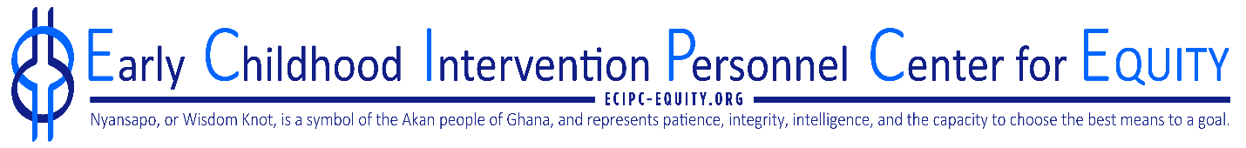
Early Childhood Intervention Personnel Center for Equity
The ECiPC - Equity provides TA to IHE faculty to help revise personnel preparation programs to reflect an equity framework for early childhood intervention for infants and young children with disabilities and their families. The ECiPC - Equity also provides TA to IHE and states to recruit and retain a diverse workforce.

The ECiPC - Equity is recruiting up to 30 LEND trainees across diverse cultural groups to join the 2023-2024 cohort of Early Childhood Intervention Equity Champions. This nationwide cohort will participate in a workshop on equity in early childhood intervention and monthly meetings for 6 months. Each participant will be required to implement a capstone project to advance equity.

The expectations for the program are:
- Attendance at the ECI-Equity Champion orientation on February 6-7, 2024, in Avon, CT
- Participation in monthly ECI-Equity Champion meetings
- Completion of program evaluation surveys
- Completion and presentation of a capstone project

Trainees will receive a stipend for their participation in the cohort. Transportation and overnight accommodations for those accepted into the cohort will be provided to attend the workshop in Connecticut in February 2024.

Trainees applying for this opportunity must have the support of their current LEND and/or training director and provide a letter of support with the application.

Application and support letter are due December 1, 2023.

Link to Application: https://uconn.co1.qualtrics.com/jfe/form/SV_9mJbocrNfjhKsXs

The ECiPC-Equity is directed by Mary Beth Bruder, PhD from the University of CT and Tawara Goode, from Georgetown University.

For further information please contact Darla Gundler, Associate Director at Gundler@uchc.edu

