**Instructions for Posting CME Approved Events on CME Event Calendar**

The centralized CME event calendar is set up through the Storrs’ Event Calendar so posted events stream into the CME website.

To view the CME calendar, just click on CME web site: [**https://health.uconn.edu/continuing-medical-education/**](https://health.uconn.edu/continuing-medical-education/)

Five events are viewable on the CME Homepage at one time – just click on “Calendar of CME Events” button at top to view all posted CME events. First, go to the UConn Events calendar by clicking on <http://events.uconn.edu/2016/week/44/all>

First, go to the UConn Events calendar by clicking on <http://events.uconn.edu/2016/week/44/all>

**Any questions or help you need in submitting your event, please feel free to contact me or UConn’s Technical Support: Any questions or problems with using the calendar, with submitting or managing events, are handled by the UITS Web Development Lab.**

**UITS Web Development Lab.**

[webdev@uconn.edu](mailto:webdev@uconn.edu)(860) 486-0654

**Submit Event**

**The Control Panel**

To get started, scroll to the bottom of the page, and click the “Submit Events” button in the Control Panel. This will require you to log in to [NetID](http://netid.uconn.edu/) login page. After logging in, or if you are already logged in, the control panel will fix itself to the bottom of the window frame.

[](http://help.events.uconn.edu/wp-content/uploads/sites/439/2014/02/control-panel.png)

**The Form**

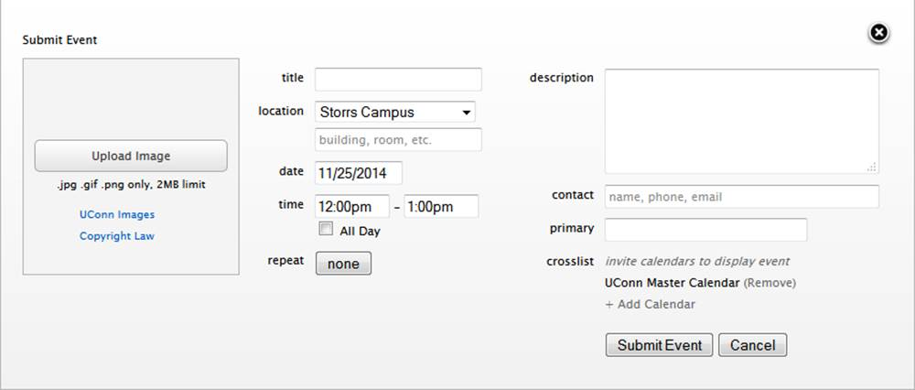

**Upload Image**

* Upload a photo, and you might appear on the Events calendar homepage, and get a little extra promotion or your event.
* Images must be less than 2 megabytes (2000 kb) in file size.
  + Photoshop:
    - Go to Image > Image Size… and reduce the file to no more than 1000px in either dimension.
    - Go to File > Save for Web…  choose JPG.
  + Free Online Image Tools:
    - <http://www.picresize.com/>
    - <http://www.webresizer.com/>
    - <http://www.shrinkpictures.com/>
* Images must be in a compressed web format, (.jpg, .gif, or .png).
* Images must not violate copyright laws. (Do not just download random images from google).
  + You can use any image from the [~~UConn Image database~~](http://mediashare.uconn.edu/res/sites/public/), or other [public-domain image libraries](http://en.wikipedia.org/wiki/Wikipedia:Public_domain_image_resources).

**Title:  Title of the CME presentation**

* Limited to 50 characters
* Remember that in most views, people will only ever see about 20 characters worth of your title. We recommend using as brief a title as possible here. You can always write a longer version in the description.

**Location :  Typically select: UConn Health from dropdown menu.**

**Then on below line, can enter more specifics (building, room etc.) – e.g. Low Learning Center – OR, *LIVE via WebEx Conference* or whatever the case may be: e.g. LIVE via Mediasite Link or Live via Zoom, etc.**

* Select a campus
* Enter details like building and room number.

**Date**

* The day the event will begin.

**Time – e.g. 1 pm to 2 pm**

* The start and end time of the event.
* If the event last the entire day, (i.e. First day of classes or Thanksgiving) then use the All Day checkbox.

**Repeat**

* If the event repeats regularly without changing, (i.e. Chess Club Weekly Meeting) use the repeating patterns to make multiple events that are linked.

**Description :  Please copy and paste the CME event flyer to this area – (it will accommodate all text on the flyer.)**

* Limited to 300 characters.
* The description is limited to plain text only, no formatting.

**Contact:  Please enter your name and either your e-mail or phone or both**

* Enter any information about who should be contacted for more information about this event.

**Primary (Calendar)  - Continuing Medical Education will automatically appear here.**

* If you only manage one calendar, your calendar will appear here.
* For those who manage multiple calendars, you may select which calendar will be listed as the owner and organizer of the event.

**Crosslist – you can leave or remove UConn Master Calendar.  No need to cross list to other calendars unless you have one for your Dept.’s specialty.**

* With this tool, you can send invitations to other calendars to have them list your event.
* Be default, the UConn Master Calendar is selected. This is the calendar that feeds to the popular go.uconn.edu site, and to other high profile university websites. It is not required, only preloaded for your convenience.
* You may send promote invites to up to 5 other calendars in total.