

REDCap: Granting User Access to New Instruments

When a new instrument is added and the project is in production, all users will automatically receive "No Access" - Data Export Rights and "No Access (Hidden)" - Data Viewing Rights. Users with the high-level access of 'User Rights' will need to update the access for all project users or user roles who should have view/and or export access to the instrument once the project changes have been committed.

Note: When adding a new data collection instrument to a project, if the project is in development status, all users will automatically receive "Full Data Set" Data Export Rights and "View & Edit" Data Viewing Rights for that new instrument.

How to Give Users Access to a New Instrument in a Project:
You will need to adjust the user permissions for the users in the project. You can do this by individually editing users' access or by using the option to download/upload a CSV. (Using the upload option will be much faster if you have a lot of users in your project.)

Editing Individual User Access:
After your drafted changes that create a new instrument have been committed to the project, navigate to the User Rights page, and then choose the user who needs access to the new instrument. In the pop-up window, you will see that the new instrument has defaulted to a setting of "No Access (Hidden)" - Change this setting to the correct level of access and save. If you have user roles set up on your project, the user role will need to be modified.

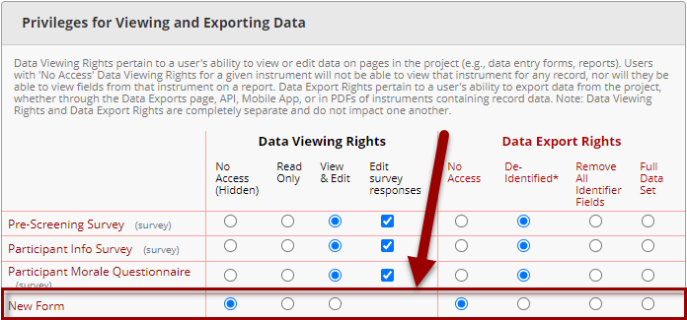Navigate to a user or role in User Rights and assign the appropriate access to the new form

Editing User Access in Bulk:
Download CSV file(s): After your drafted changes that create a new instrument have been committed to the project, navigate to the User Rights page. If every user in your project is assigned to a user role, use the "Download user roles (CSV)" option. If everyone is not assigned to a user role, then you will also need the "Download users (CSV)" file.
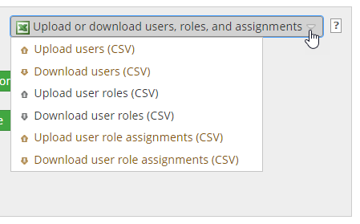
Option to download and upload user rights for bulk editing

Modify the CSV file(s): Edit the CSV file(s) you have downloaded. The column named "forms" contains the unique instrument names of all the forms the user/role has access to in a comma-separated list. Each form name is followed by a colon and an integer that indicates their level of access.

For example, the value may read: "form_1:3,survey_1:3,new_form:0". This indicates that for form_1 and survey_1, they have View/Edit access and can modify survey responses. For new_form, the user has no access.

The coded values for each level of access are as follows:
- 0, No Access (Hidden)
- 1, View/Edit (No ability to edit survey responses)
- 2, Read Only
- 3, View/Edit and Edit Survey Responses

To add read-only access to a form called "new_form", you would add "new_form:2" (separate by a comma) to the value in the "forms" column on the CSV.

Upload the CSV back into the project: Upload the modified CSV. A pop-up window will ask you to confirm the changes you are making before they are committed to the project.

Tip: If you have a large number of users who all need the same access to the instruments in the project and you haven't enabled user roles, it may be easier to modify one user's access individually before downloading the CSV, then copy the value to rows for other users. Best practice is to enable user roles for any project, and this will make managing a large number of users much easier, as you are able to edit the role access.

