

e-Consent
Overview | Setup e-Consent | Adding New e-Consent | e-Consent Storage | Survey Certification | Multi-Survey Consent | Multi-Survey Consent

Overview
Electronic Consent (e-Consent) is a platform for consenting patients or research subjects either on site or at home using a computer-based consent form rather than traditional paper documentation. Consent forms can be implemented in a REDCap survey via computer, mobile phone, or tablet.
Most importantly, it is highly recommended that you discuss with the IRB your intention to use e-Consent in REDCap for patient consents prior to implementation.
The REDCap e-Consent Framework provides standardized tools to obtain consent and store consent documentation with a certification screen and a storage function that automatically generates a "hard-copy" PDF of the signed form. The e-Consent Framework offers many options to allow customization to your specific needs. The e-Consent Framework can be enabled for any survey in this project. You may optionally provide consent forms as either an inline PDF or rich text that will be displayed on the consent survey itself.
The e-Consent Framework adds two things to the typical survey-taking process:
- Before a participant completes the survey, an extra certification page is added to the end of the survey that displays an in-line PDF copy of their survey responses, in which they will be asked to confirm that all information in the document is correct. Once they confirm all is correct, the survey will then be marked as complete. The survey will not be considered complete until it fulfills the certification step.
- Upon completion of the survey, a static copy of their responses in the form of a consent-specific PDF will be stored in the project's File Repository. The consent-specific PDF will have the values of the e-Consent Framework Options inserted at the bottom of each page in the PDF. These values (i.e., name, date of birth, etc.) are added to the PDF as extra documentation of the identity of the person who is consenting.
The consent forms can be context-specific if you are using MLM languages and/or Data Access Groups, so that it display the correct consent form for a participant with a specific language set and/or assigned to a specific DAG. See the "Add consent form" link for more details after enabling e-Consent for a survey.
To access the e-Consent, navigate to REDCap's Online Designer page. Under the Data Collection Instruments banner, there is a labeled button "e-Consent and PDF Snapshots". Select this button to begin setting up e-Consent surveys.
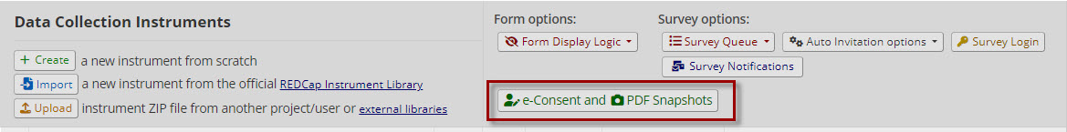Button to set up e-Consent in the Online Designer

Setup e-Consent
Once you navigate to the e-Consent Framework page from the Online Designer, you will first select the "Enable the e-Consent Framework for a survey" button. This option will allow you to select which survey(s) you would like to use as a consent form, along with some initial settings.
An instrument must be enabled as a survey to be enabled for e-Consent.
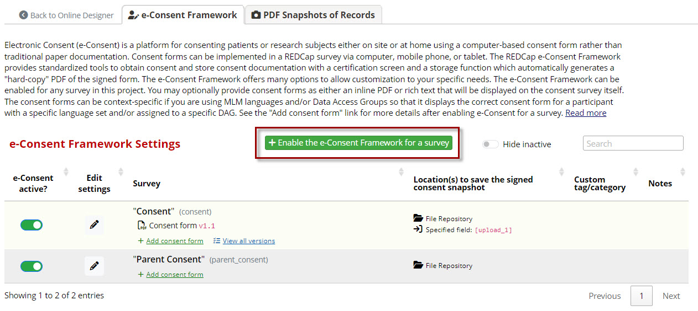Button to enable e-Consent Framework for a survey.

Settings for your e-Consent form can also be modified after the initial setup by selecting the Pencil icon under the "Edit settings" column in the list of active e-Consents.
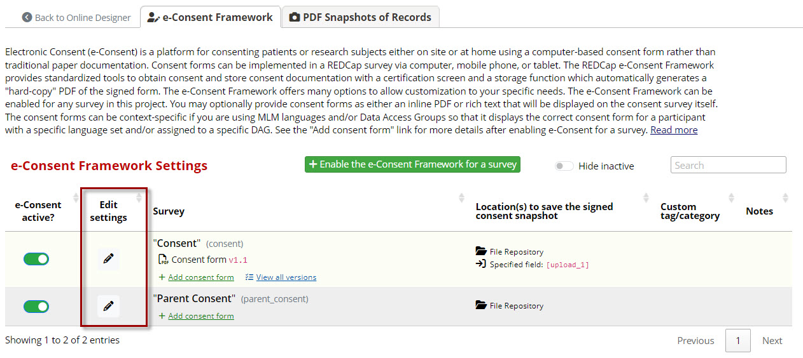
Option to edit settings for surveys enabled with e-Consent

e-Consent Settings
There are several settings that will need to be configured to use e-Consent appropriately.
The first set of options involves selecting fields that exist within your e-Consent survey to be used for a standard consenting process. The fields that must be included with the consent form are First Name, Last Name, and a Signature Field. The signature field MUST be a Required Field to be used as the e-Consent signature.
Multiple signature fields may be used in a consent to be completed at the time of survey completion. Other optional settings you can designate include: Date of birth, custom PDF footer, and custom PDF header.
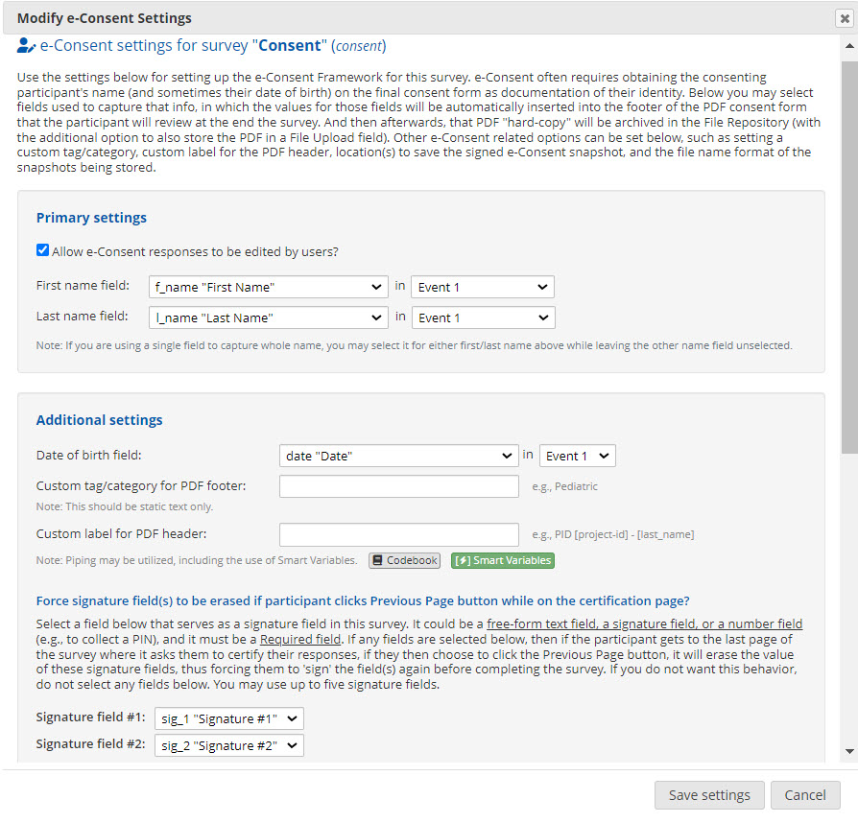
Setting name, date of birth, and signature fields to be used by e-Consent

After setting designated fields, you will have the option to specify where you would like the PDF copy of the consent form to be saved. Automatic PDF archiving will always save to REDCap's File Repository, and this cannot be disabled. You can also specify an additional File Upload field within your REDCap project to also hold a saved copy of this PDF. If you are using Multi-language Management, a translated copy will be stored as well.
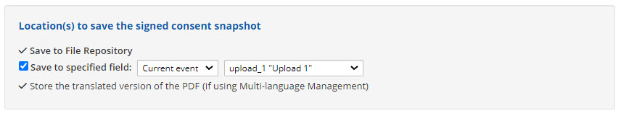Option to use a File Upload field to store a copy of the e-Consent

Finally, you can alter the file name format under which the PDF copy will be stored. By default, REDCap will include the project ID number, instrument name, and record ID number. You may use piping within this option to add other details from the record.
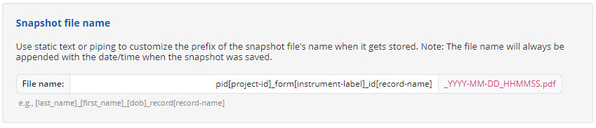Option to change the e-Consent file name format.

Adding a New e-Consent Form and Version
Once e-Consent has been enabled for a survey, you may add a consent form by selecting the "Add consent form" button. New options will open up that will allow you to add a consent form PDF or custom text and/or replace an existing consent with a new version.
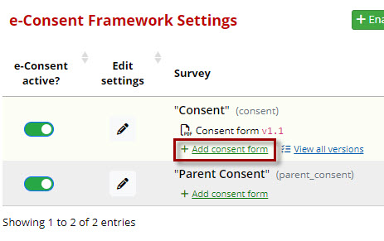
Add a new consent form version.

Consent forms added here will be displayed dynamically on the survey based on the current context. The consent forms provided here will be displayed immediately below a specific Descriptive field (specified in these settings) on the survey.
NOTE: After clicking the "Add new consent form" submit, the new consent form version will be active immediately for the e-Consent survey.
Steps for adding a consent form:
- Enter your consent version.
- Select a Descriptive Field to place the contents of your consent.
- If you are using DAGs with different consents, select the appropriate DAG group.
- If you are using multi-language management, select the consent language.

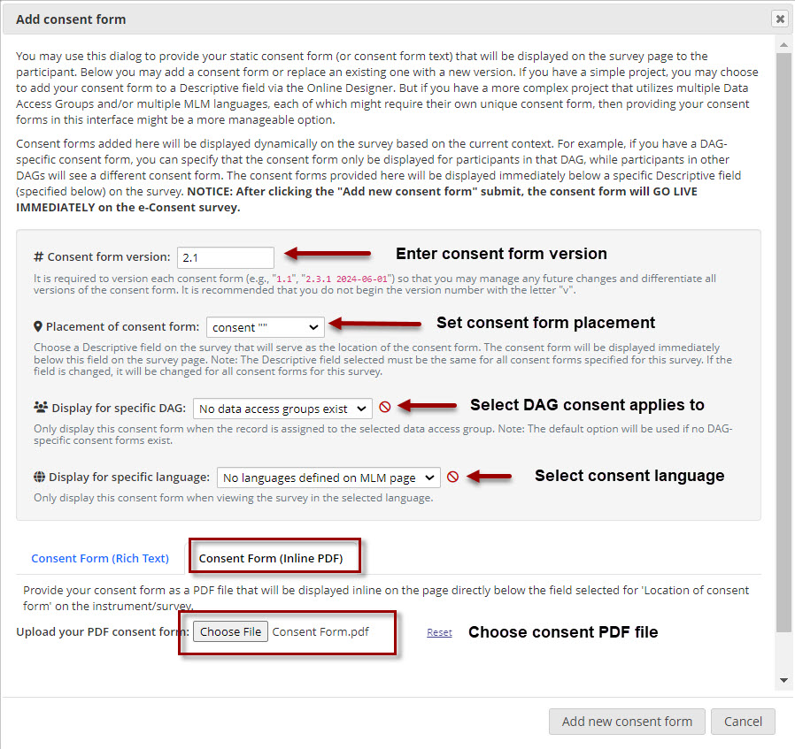Option to select and use PDF file of the approved consent form.

We HIGHLY recommend using the Consent Form (Inline PDF) option for uploading a consent for a research project. This PDF should be the IRB-approved and stamped version that has been reviewed. This PDF will display inline within the survey and allow respondents to read through before signing.

e-Consent Form Versioning
On the main e-Consent page, there is an additional option to "View all versions". Selecting this option will open a table of all previous versions of the given consent form, including the active version. If you would like to disable the consent, you can select the "Set as inactive" option for the most recent version.
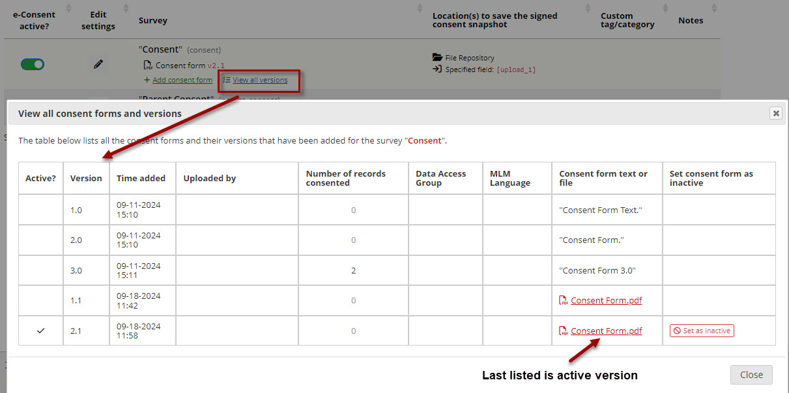Table of historical consent versions, including the current version.

e-Consent Storage
Surveys enabled as e-Consents are automatically saved as PDFs into the File Repository when they are submitted. These copies contain a PDF of the single survey instrument with the completed responses and content of the consent at the time it was signed
. 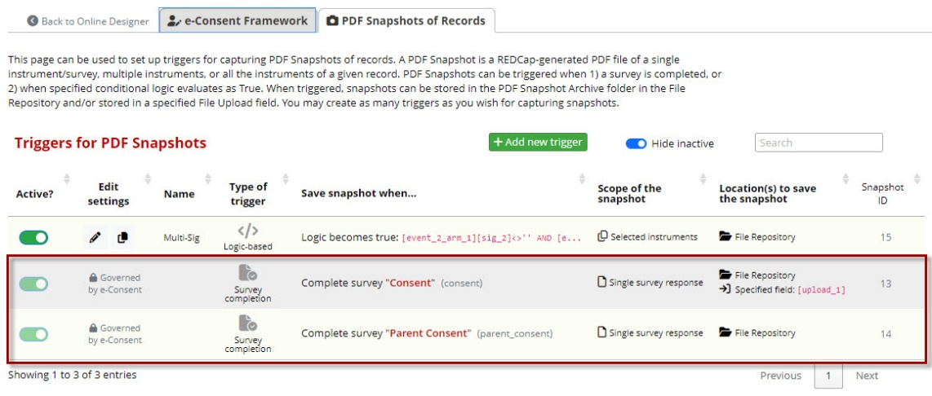
Auto-saved e-Consent single surveys
If you have specified another location or field to save the PDF, it will display in the e-Consent settings. For any complete consents, you will also be able to find a PDF copy in any field where you specified the copy should be saved.
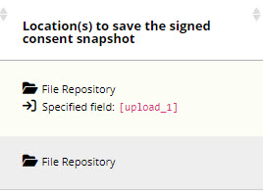
Example of locations to save the signed e-Consent

Within the File Repository, PDF copies are automatically saved to a folder named "PDF Snapshot Archive". Any completed consents will be stored in this folder under the file name specified during the setup of the e-Consent form.
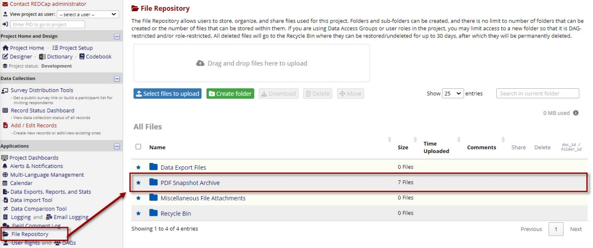
PDF Snapshot archive folder within the File Repository

Survey Certification
After completing the e-Consent Survey, participants will be prompted to certify the information entered and acknowledge that signing the form electronically is the equivalent of signing a physical document. Survey respondents MUST check this box in order to submit their completed and signed e-Consent form.
If they select the box and return to the previous page, they will have to recertify before submitting the survey.
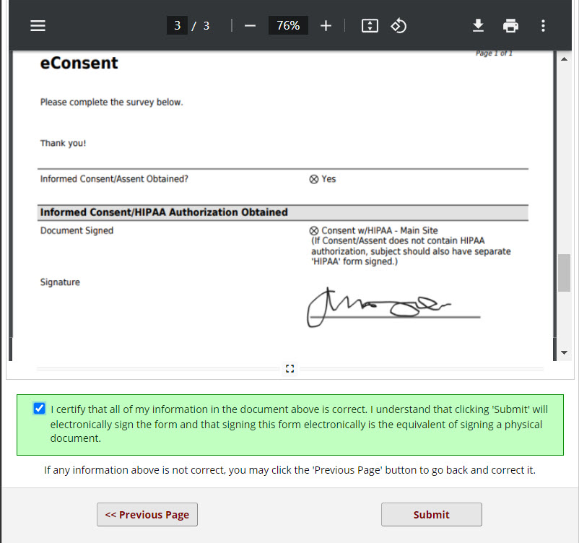
Example of e-Consent certification message prior to survey completion

Multi-Survey Consent
Multiple completed e-Consent-enabled surveys can be combined and saved as a single PDF form.
To save multiple surveys, navigate to the PDF Snapshots of Records tab under the e-Consent Framework. From here, you can add additional time points when a PDF copy should be saved and which instruments should be saved.
The triggers can be used to save a single survey or to select multiple surveys that can be combined into one saved PDF response.
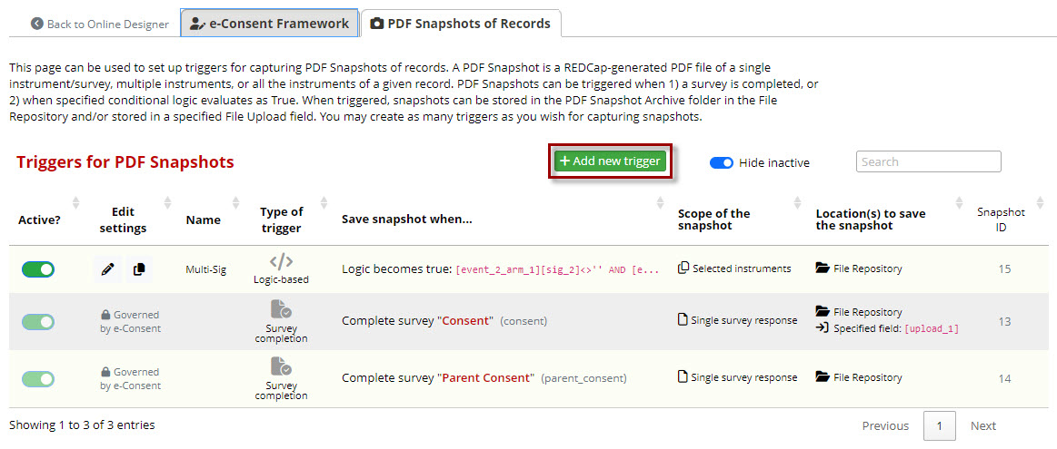Add a new trigger to save custom e-Consent PDF, including multiple surveys.

Step 1: Trigger Conditions
Select the conditions when a new PDF should be created and saved. This can be based on:
- When a specific survey is completed
- When a record has specific values saved
- Any other conditional logic using piping and Smart Variables

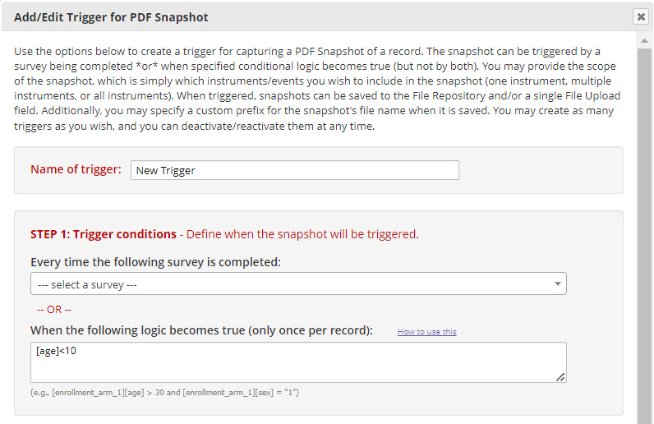
Example of setting trigger conditions for when to save a new PDF

Step 2: Scope of the Snapshot
Select which instruments should be combined and saved into a PDF. You can select a single instrument or select multiple. If you select multiple instruments, you can select "Save as Compact PDF" to combine all instruments into a single PDF file.
You can also select to save a translated version if you are using the Multi-language Management tool.
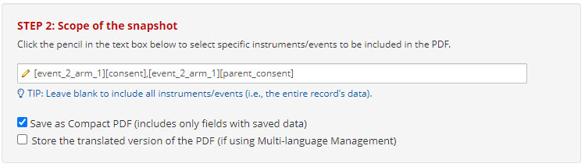Example of saving multiple survey instruments into a single PDF snapshot

Step 3: Location(s) to Save the Snapshot.
Select where you would like this PDF copy to be saved. You can save to the File Repository, or you can choose a File Upload Field to store the PDF within a record.
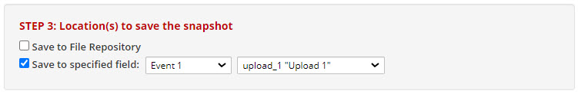Specify where to save the e-Consent PDF

Step 4: Snapshot File Name
Use the default file name or change the file name to something new. This will be the name that is used for the file that is stored. You may use piping here to insert other information from the project or record into the file name.
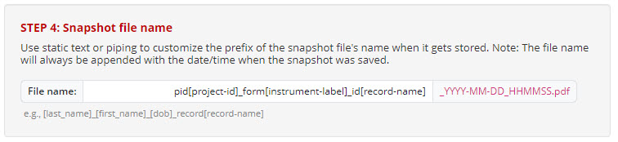Option to change the default file name for the e-Consent PDF

After you save a new trigger, it will display in the list of all triggers for the e-Consents you have enabled. The triggers you set up will be displayed as editable and as "Logic-based". Other triggers listed that are governed by e-Consent are not editable and will automatically save a copy in the File Repository upon signing the e-Consent form.
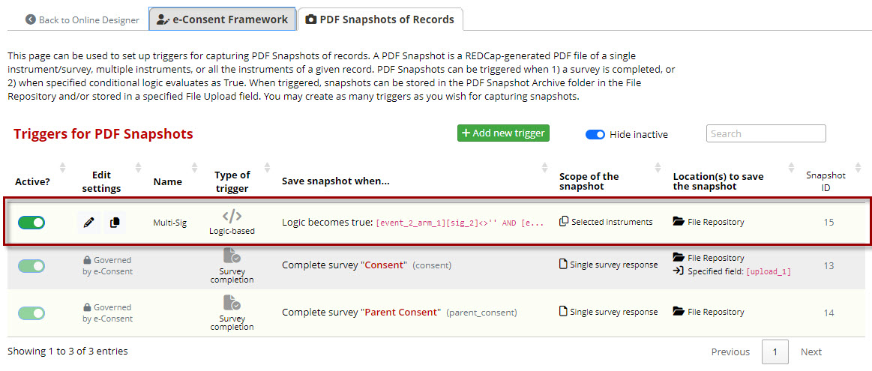Custom PDF Snapshot trigger saved under "Logic-based."

Recommendations
- If your consent is IRB-approved, use the Consent Form Inline option for adding your consent form.
  - This option ensures the form is exactly as approved without formatting changes and with the IRB approval included.
- Test your e-Consent as a survey and then view the generated PDF to ensure the full consent renders appropriately.
- If you are using the Rich Text Editor for your consent language, double-check that the elements used appear properly on the generated PDF. Some items, like tables, may not render in the same way as they appear in the survey.

