


Managing REDCap Project Users - User Access Dashboard and Sponsor Dashboard

What is the User Access Dashboard?
The User Access Dashboard is a centralized reporting tool that supports efficient user management for all REDCap projects where you have User Rights privileges. It provides a summary of:
- All projects in which you are authorized to manage user access.
- All users with access to each of those projects.
- Project filters, including by status and purpose, to help focus your review.
To maintain proper data security and project oversight, all Designated Project Managers (and/or PIs) are expected to periodically review their User Access Dashboard—ideally once per month. This routine check ensures that:
- All project users have appropriate access levels.
- Users who have left or are leaving your project are promptly removed or expired.
- Access privileges are up to date with current project needs.

How to Use the Dashboard?
To see your User Access Dashboard, navigate to the REDCap Home Page when you are logged in and click the link at the top of the page:
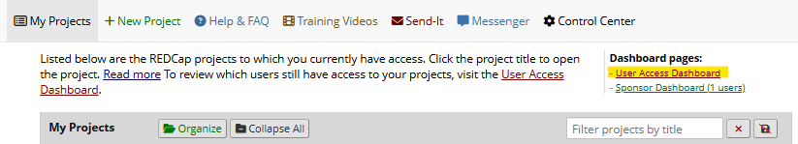
Review the User Access Dashboard periodically to review project users
- Review the table: Check each project and associated users.
- Update access as needed:
  - Remove users who should no longer have access.
  - Expire access by setting the end date (default: yesterday).
- Apply changes: Be sure to click the button at the bottom of the page to confirm and implement your changes. Updates take effect immediately.

Note: While changes can still be made directly within individual projects, using the Dashboard helps streamline and centralize the process.

Managing External Accounts in REDCap
All non-UConn Health users are set up with external accounts and must be sponsored by their UConn/UCH Principal Investigator (PI). The Sponsor (PI) is responsible for managing those account operations.

If you are a PI with external REDCap users, please review your Sponsor Dashboard on the My Projects page to:

- View who has access to your projects.
- Request password resets.
- Request account extensions for external users.

Sponsor Dashboard Overview
The Sponsor Dashboard allows sponsors to manage their sponsored external users' accounts. Key features include:
- Account information: View username, name, expiration date, and last activity date.
- Administrative actions: Submit requests to the REDCap Admin for:
  - Password resets
  - Changing expiration dates
  - Suspending or unsuspending accounts

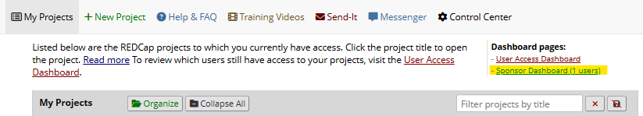

Suspending External User Accounts
PI/Sponsors should request the suspension of accounts for users who are no longer active on a project by following the steps below:

- Go to the Sponsor Dashboard.
- Check the box next to the user(s) to suspend.
- Click the red “Suspend user” button.
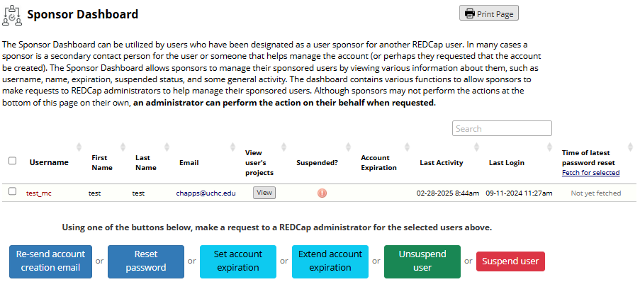
- In the pop-up window, click Submit.
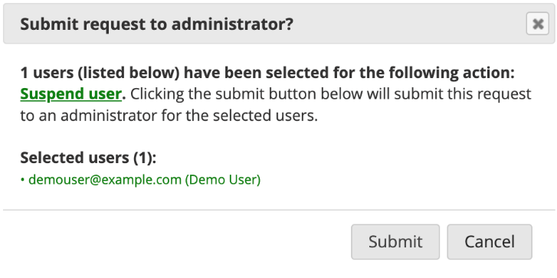

- The REDCap Team is notified and approves the request.
- The sponsor will receive an automatic email confirmation when the suspension is approved.

Unsuspending External User Accounts
Sponsors may request to unsuspend an account if the user needs continued access.

🔒 If an account is automatically suspended due to inactivity, it should remain suspended. Do NOT request unsuspension.

How to Unsuspend an Account:
- Go to the Sponsor Dashboard.
- Check the box next to the user(s) to unsuspend.
- Click the green “Unsuspend user” button.

- In the pop-up window, click Submit.
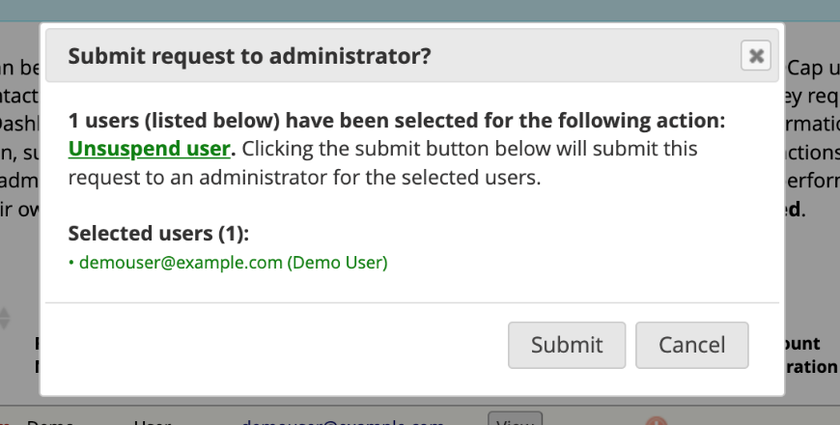

- The REDCap Administrator is then notified and will approve the request.
- The Sponsor receives an automatic email confirmation when the unsuspension is approved.

Changing Sponsors

- If there is a change in the external user’s PI, the new PI should be designated as their sponsor. Please submit a request to redcap@uchc.edu and cc the new Sponsor.
- Include the following information in your email:
  - External user's username.
  - New Sponsor's name. Sponsors must be a UCH REDCap user, i.e. UCH/UConn Faculty/Staff who have logged into REDCap and set up their profile with their uchc.edu/uconn.edu email address.

