**

# **REDCap - Randomization Module Documentation**

**All information on this page can be found in the REDCap Project Setup tab.**

Randomization is a process that assigns participants/subjects by chance (rather than by choice) into specific groups, typically for clinical research and clinical trials. The randomization module in REDCap will help you implement a defined randomization model within your project, allowing you to randomize your subjects (i.e. records in your project). In this module, you first define the randomization model with various parameters. Based on the defined parameters, the module creates a template allocation table, which you can use to structure the randomization table you will import. The module also monitors the overall allocation progress and assignment of randomized subjects.

User privileges can be set to allow only certain users to be able to set up the randomization, perform the randomization, or view the allocation dashboard to view progress. If someone is given 'Randomize' privileges, they will be able to view and modify any existing data already collected for the randomization strata fields (if stratification is used) when they are performing the randomization, even if they do not specifically have form-level rights to view the form on which a strata field exists. Thus Randomize rights trumps form-level rights in this way, but only for the randomization strata fields.

Please go to the **Project Setup** tab under the **Enable optional modules and customizations** section to enable.

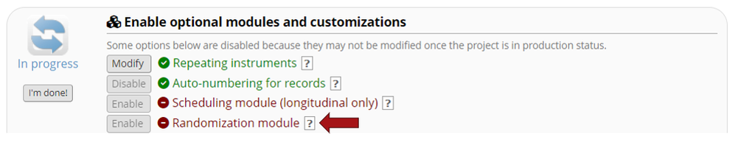

**The information below is available after the randomization module is enabled**

**How it works**  
Randomization in REDCap works by allowing you to create your custom allocation list, which will serve as a lookup table for deciding how to randomize subjects. In step 1 below, you will set up your randomization model and all its parameters, after which step 2 will provide some examples of how to set up your allocation table before you will finally upload it in step 3. **NOTE:** The randomization module does not create the randomization table for you. This table must be generated outside of REDCap using other software (e.g., SAS, Stata, R), most likely by the statistician/data analyst involved in your project. The randomization table you upload will be used as a lookup table for randomizing subjects. By letting you create your own allocation table outside of REDCap, it lets you and your team choose exactly how you wish to structure your allocations and assignments (e.g., block sizes, permutations, stratification balancing). It does not necessarily matter how you create or set up your allocation table so long as you structure it correctly, as prescribed in the steps listed below in this module.

**When randomization occurs**  
Randomization of subjects will occur on the data collection form where your randomization field (from step 2) is located. Before a subject is randomized, a 'Randomize' button will appear next to that field. When a user (who has been given appropriate 'Randomize' user privileges) clicks that button, a pop-up box will appear that will allow the user to randomize the subject. If any grouping or stratification is being used, the user must provide the group or strata values if any are missing before they can randomize the subject. After a subject has been randomized, the grouping and/or strata fields (if any of these are used) will become permanently locked and unmodifiable. The randomization field will always be locked and unmodifiable both before and after randomization has occurred for a subject. When the user randomizes the subject, REDCap will check the allocation table and assign that subject's randomization field value, which will be derived from the next match in the table based upon the criteria (e.g., strata field values, group). If not using stratified randomization and not randomizing by group/site, then it will simply provide the subject with the very next value in the allocation table.

**User privileges**  
There are several different user privileges that can be utilized for randomization, all of which correspond to different roles during the randomization process and can be set on the User Rights page. These specific randomization privileges are named 'Setup', 'Dashboard', and 'Randomize'. If you have been given 'Setup' privileges, you will see the Setup tab on the Randomization page, which will allow you to define the randomization model and all its parameters, as well as upload your custom allocation table. If you have 'Dashboard' privileges, you will see the Allocation Dashboard tab on the Randomization page, in which you may view the overall allocation progress and assignments for subjects that have been randomized. If you have 'Randomize' privileges, you will be able to view the Randomize button on the data collection form that contains the randomization field, thus allowing you to perform the randomization on the subject/record you are viewing. If someone is given 'Randomize' privileges, they will be able to view and modify any existing data already collected for the randomization strata fields (if stratification is used) when they are performing the randomization, even if they do not specifically have form-level rights to view the form on which a strata field exists. Thus 'Randomize' rights trumps form-level user privileges in this way, but only for the randomization strata fields. All three user rights for randomization ideally belong to three different types of people in your project (although it is possible that you may have some users with overlapping roles). It makes most sense for a normal data entry person to have 'Randomize' privileges but not other randomization privileges. 'Setup' and 'Dashboard' privileges should be given only to the highest ranking people in your project, such as a PI or statistician/data analyst, most likely someone having past experience with randomization or data quality.

**Restrictions**  
**The Setup phase for randomization is ONLY available while the project is in development status, and thus the entire setup process should be completed before the project is moved to production status. Once the project is in production, the Setup tab will become permanently locked and no settings can be modified, nor can any assignments be undone**