**REDCap: User Rights Management**  
**REDCap Account:** When a person is set up with a UCH REDCap *account*, they are given access to the overall UCH REDCap system - we do not give them access to specific projects. They can create their own projects and/or their study team can add them as a project user to their project/s.  
  
**Project Users:** Each REDCap project has users. These are the specific users with *REDCap accounts* that can access the project. For someone to be added as a user to a project, they first need a UCH REDCap account. When a user account is added to a project, the user must be assigned a role or given a set of custom permissions. The role or permissions given to a user account is determined at the project-level settings and determines a user's access to data and ability to make changes in that specific project. For a detailed review of the user rights settings that can be granted or restricted, please see: [REDCap: User Rights Definitions](https://view.officeapps.live.com/op/view.aspx?src=https%3A%2F%2Fhealth.uconn.edu%2Fclinical-research-center%2Fwp-content%2Fuploads%2Fsites%2F50%2F2024%2F09%2FUser-Rights-Definitions.docx&wdOrigin=BROWSELINK).

**User Roles:** Each project can have pre-defined user roles. Then individual users can be assigned to a role. This is helpful, for instance, if a project will have several data entry staff who only need access to certain parts of the project or a statistician who may need to export data but not enter data. By setting up a pre-defined user role, it streamlines the process of adding new users to a project.  Please see: [REDCap: Recommended User Roles](https://view.officeapps.live.com/op/view.aspx?src=https%3A%2F%2Fhealth.uconn.edu%2Fclinical-research-center%2Fwp-content%2Fuploads%2Fsites%2F50%2F2024%2F03%2FRecommended-User-Roles.docx&wdOrigin=BROWSELINK) for recommended access based on a role.  
  
**User Rights Management:** User rights management is the responsibility of the project owner (the person who creates the project) and/or the users they add to the project with User Rights access. User roles and individual user access rights should be set appropriately and reviewed periodically.

# **Summary of Best Practices for User Rights Management in REDCap:**

* **ONLY provide needed access rights**: Only provide user rights that a person actually needs.  DO NOT just check all possible options in the User Rights section in REDCap.  This is especially important for the high-level roles of "Project Design & Setup" and "User Rights".  Additionally, DO NOT select "REDCap Mobile App" rights if you are not using the Mobile App as this complicates changes to your project.
* **Set expiration dates for users:** If you are adding a user to a project who you know will need access to the project for a limited amount of time, set an expiration date for their access at the time you add them to the project.
* **Review your User Access Dashboard periodically**: The User Access Dashboard will show all of the users for all of the projects that you managed User Rights before. Review it at least every six months to ensure that all users have the appropriate level of access to the projects they are on.
* **Create and utilize User Roles in your project:** A User Role has a pre-defined level of access. For instance, you might create a user role for Data Entry, that allows a user to enter data but not change project settings or delete records.
* **Consolidate sensitive information in one instrument**: If there are users who should not see identifiable information in the project, the best solution is to keep all of the sensitive information on one instrument and restrict read access to it.
* **Make use of Data Access Groups (DAGs) (for multi-site projects)**: Data Access Groups allow users to be assigned to a group (for instance, a study site) and then only have access to records from that particular DAG. Please see: [REDCap: Data Access Groups (DAGS)](https://view.officeapps.live.com/op/view.aspx?src=https%3A%2F%2Fhealth.uconn.edu%2Fclinical-research-center%2Fwp-content%2Fuploads%2Fsites%2F50%2F2023%2F11%2FData-Access-Groups.docx&wdOrigin=BROWSELINK) for more information.
* **Have a process for when study team members leave their role**: If you have a study team member who is departing, make sure their access to your REDCap project is expired. It is also important to ensure that their account is not tied to any project settings (for instance, API tokens or automated survey invitations) that will need to be transferred over to another study team member.

# **Adding Users to Your Project**

1. Log in to REDCap and open the desired project.
2. From the applications sidebar menu select, User Rights.  
   A screenshot of a computer

   Description automatically generated
3. You can add a user by either Adding with Custom Rights or Assigning to Role. If adding a user via “Assign to Role”, if the role is not yet created, you will have to create the role first. When creating roles or adding users via Custom Rights, please give some thought to which specific rights/privileges you give.
4. Search for a REDCap User to add to your project by typing their username, name, etc – once you start typing the user will auto-populate. Simply adding the user’s email address, does not add the user – their account name must auto-populate as seen below, and you must click on that auto-populated name.

* 1. If the user does not auto-populate during a name search, this means that the user does NOT have an active account:
     1. they have either not [Requested a REDCap Account](https://health.uconn.edu/clinical-research-center/services/informatics-core/redcap/redcap-user-eligibility/redcap-account-request/), or
     2. they have not activated it yet, or
     3. if they are a non-UCHC user, and haven’t logged into REDCap for an extended period, their account may be suspended. If this is the case, the PI should email us at [recap@uchc.edu](mailto:recap@uchc.edu) to reactivate.

1. If adding user via “Assign to Role”, you will select the role for which the user is being added to. Then click Assign.
   1. If adding user via “Custom Rights”, you will need to click “Add with Custom Rights” and assign the unique rights/privileges. Then click “Add User”.

# **Adding User Roles to Your REDCap Project**

To create a new User Role, navigate to the User Rights module. Enter the name of the role you'd like to create and hit the "Create Role" button:  
  
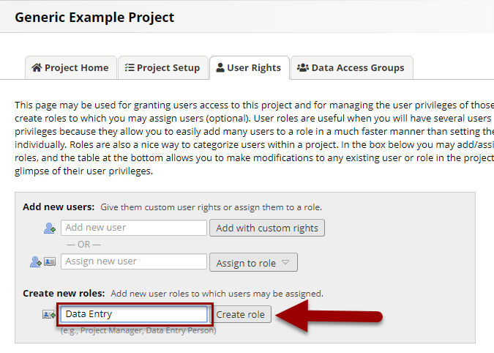

This will bring up a pop-up with the permissions you can grant or restrict for the role. For a detailed review of the user rights settings that can be granted or restricted: [REDCap: User Rights Definitions](https://view.officeapps.live.com/op/view.aspx?src=https%3A%2F%2Fhealth.uconn.edu%2Fclinical-research-center%2Fwp-content%2Fuploads%2Fsites%2F50%2F2024%2F09%2FUser-Rights-Definitions.docx&wdOrigin=BROWSELINK). For recommended access based on a role: [REDCap: Recommended User Roles](https://view.officeapps.live.com/op/view.aspx?src=https%3A%2F%2Fhealth.uconn.edu%2Fclinical-research-center%2Fwp-content%2Fuploads%2Fsites%2F50%2F2024%2F03%2FRecommended-User-Roles.docx&wdOrigin=BROWSELINK).

# **Automatic Account Suspension**

Users that have not logged into REDCap or used the API in the past 180 days will automatically have their account suspended by the REDCap system. Users will not be able to access any projects once an account is suspended. Users will be notified via email of their suspension and will need to contact the REDCap support team to unsuspend their account. External (non-UCH/non-UConn) users will need to have their sponsor request that their account be unsuspended via the Sponsor Dashboard. Once unsuspended, users will have the same access they previously had to projects.

The Sponsor Dashboard is a tool for sponsor users to manage the accounts of their sponsored users. The Dashboard contains information about each external user account sponsored, such as username, name, expiration, and date of last activity. From the Dashboard, the Sponsor can send requests to the REDCap Admin Team to help manage their sponsored external user, such as resetting a password, setting the account expiration, un/suspending the user, etc.

You can access your Sponsor Dashboard by going to your main My Projects tab and selecting Sponsor Dashboard, see the example below.



# **Remove a User from Your REDCap Project (Delete or Set an Expiration Date)**

To remove a user from your REDCap project, you can either set an expiration date OR you can remove the user entirely.  
  
**Setting an Expiration Date**  
An expiration date should be set when a user has left your project for a new position or role within your department as of a specific date. If the user should immediately lose access to the project and data, you can set an expiration date in the past and then save your changes. You can also update an expiration date if a user will continue with your project longer than initially planned. There are two options for adding or editing an expiration date. Both options begin with navigating to the User Rights Module and finding the user's name in your list of staff.  
  
**Option 1**: Next to the username, click on the word 'never' (or the date if you've already entered an expiration date) in the Expiration column. In the "Change user expiration" field that appears, add or update a date and then Save.

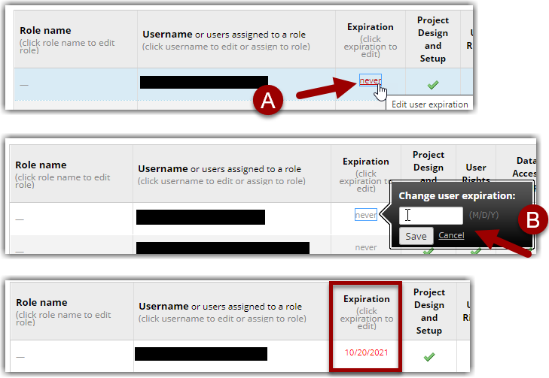

*Setting User Expiration dates*

**Option 2**: Click on the user's name and select the button "Edit User Privileges". (If they are assigned to a User Role, you will need to first un-assign them from the User Role before you can set an expiration date.) At the top of the "Edit existing user" page, enter an expiration date and then save your changes.

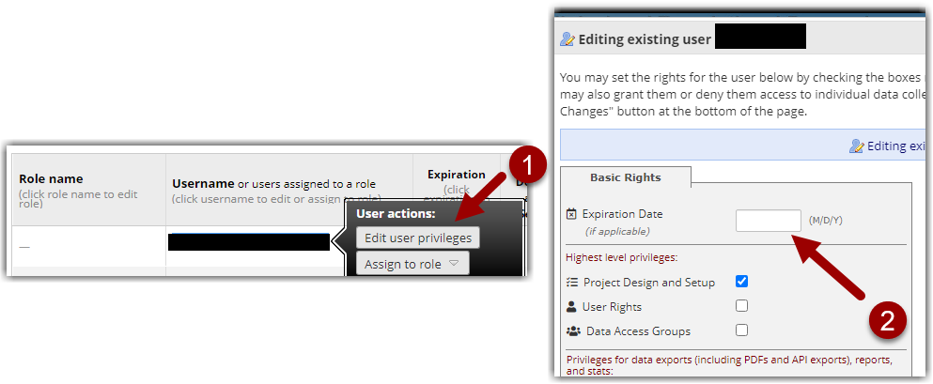 *Add expiration date by editing user privileges*

**Removing a User**  
Removing a user should only be done if the user was added mistakenly or was added with a "non-account" (e.g. email address, misspelled username, etc.). Click on the user's name and select the button "Edit User Privileges". Then select the 'Remove User' button at the bottom of the screen and confirm your changes.

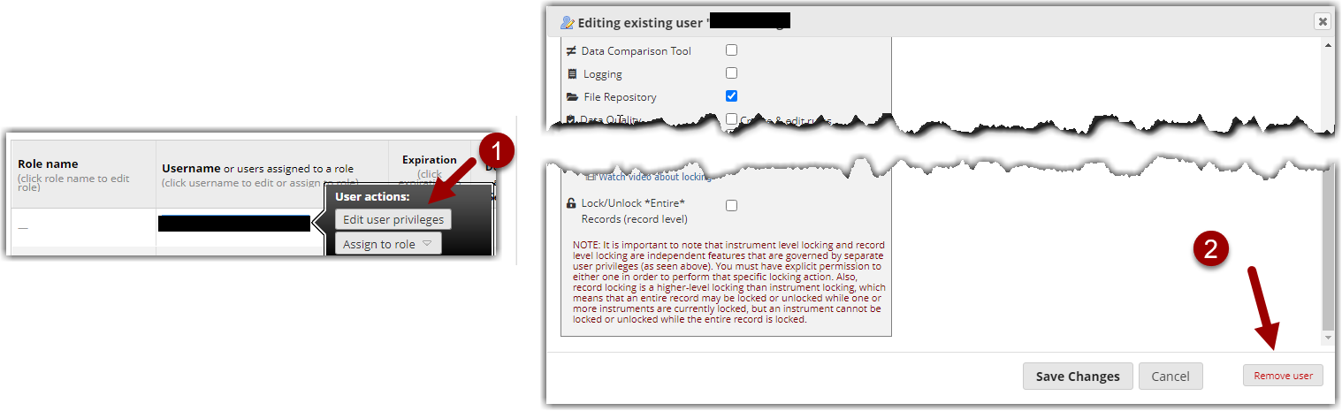

*Removing a user from a project*

# **Modifying User Rights in Bulk**

User rights can be managed by downloading/uploading a CSV file of all users or roles. Use this feature if you have multiple projects that should have the same user setup.

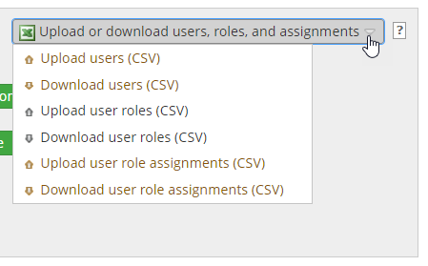

*Option to upload or download list of user rights for bulk changes*

# **User Access Dashboard**

The User Access Dashboard should be reviewed at least every six months. The User Rights Dashboard will give you an overview of the users for each project where you have User Rights access. To see your User Access Dashboard, navigate to the REDCap Home Page when you are logged in and click the link at the top of the page:

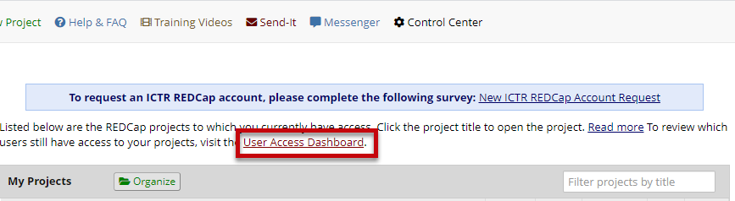

Review *the User Access Dashboard periodically to review project users*

# **Sponsor Dashboard**

All external (non-UCH) user accounts will be linked to their account sponsor (i.e., the PI identified in the REDCap Account application). The sponsor will have the ability/responsibility of managing their user’s account.

The sponsor will see a Sponsor Dashboard at the top of their My Projects page:

Once in the Sponsor Dashboard, the sponsor will see a list of all external users for whom he/she is a sponsor. From this

page, the sponsor can:

* Trigger the REDCap account creation email to be re-sent to the external user
* Trigger a password reset link for the external user
* Set the account expiration date for the external user
* Extend the account expiration for the external user
* Un-suspend the external user
* Suspend the external user

