Adding Images to Fields and Multiple-Choice Options
A step-by-step guide showing you how to add images to your REDCap Fields and how to use them as multiple-choice options.
How to Add an Image to a REDCap Field
- When adding a new field, make sure that Field Type is set to Descriptive Text and that you have a Field Label and Variable Name entered.
- Click Upload Document, choose the desired image, and then click Upload Document again.
- Once the image has been uploaded successfully, you can either set it as a Link, which creates a downloadable link for the image in the form, or you can set it as an Inline Image, which will show the image in the form. More than likely, you will want it set as an Inline Image.
- If you are using the image for a multiple-choice option (steps shown below), you will want to hide this image from the form by using the Action Tag: @HIDDEN.
- Finally, click Save.
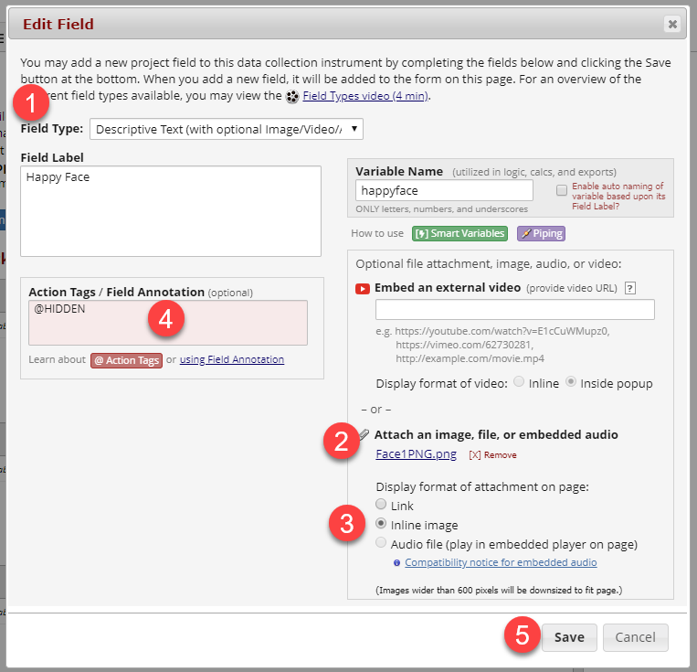
Steps to upload and save an inline image as a descriptive field
How to Use Images as Fields for Multiple-Choice
- Save the desired images that you want to use for the multiple-choice options as described above. Make sure that the Action Tag: @HIDDEN is used for each.
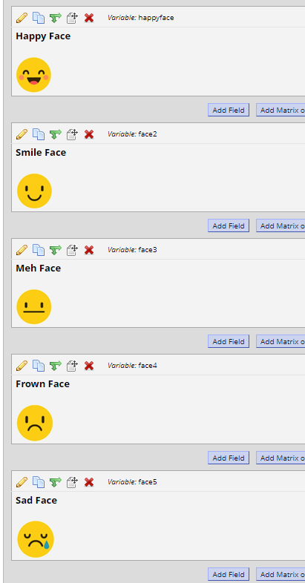
Save each descriptive field as the image you would like to use later
- Add a new field and make sure that Field Type is set to Multiple-Choice - Radio Buttons and that there is both a Variable Name and Field Label for the survey question. You can also edit which direction you want the images to line up.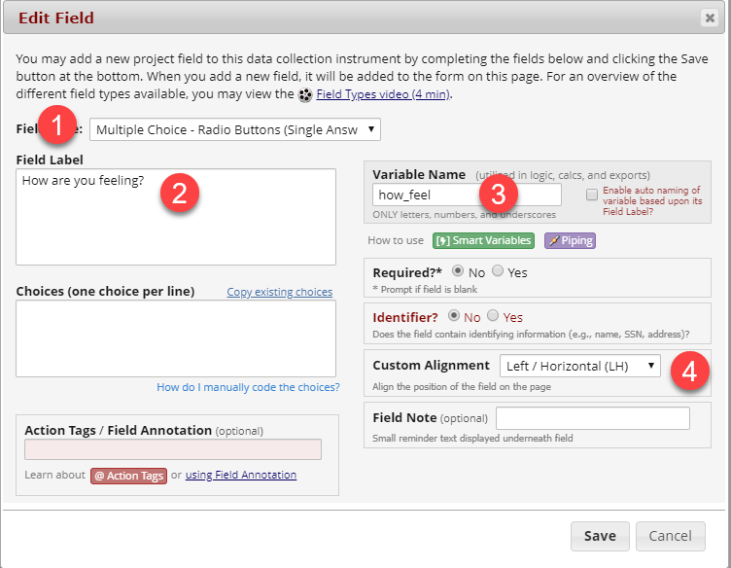Steps to create a multiple-choice field
- For each image, you will need to copy the img src, which is the HTML link to each image. To find the img src, right-click on the image and click Inspect. HTML code for that image will pop up and the img src should be highlighted in blue. Right-click on the img src and click Copy Element.
- In the Choices text box, you will type in: "1, ". After the comma, type a space, and then paste the img src HTML code for the desired image. Do this for each image using "2, " for choice 2 and "3, " for choice 3, etc. Click on the link below to watch a video of Steps 3 and 4 together.
- Finally, click Save and you should have your multiple-choice question with images!
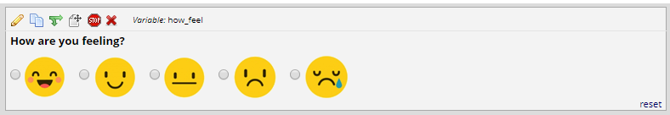Example display of image option choices

