REDCap: Survey Queues
The survey queue displays a list of your surveys to a participant all on a single page, in which the queue comprises all surveys that are to be completed (like a 'to-do' list).
Surveys can be set to appear in the survey queue based upon
- If the participant has completed a particular survey, and/or
- If certain conditions are met based upon data values (i.e. branching logic)
The survey drop-down for the “When the following survey is completed” setting in the dialog has a built-in search feature to easily find a specific survey if there are many surveys in the project. If the survey title does not match the instrument title, the drop-down list will also display the plain-text form name for the survey.
In their queue, the participant will only see the surveys they have already completed and the surveys that they are being requested to take next based upon the criteria defined. In this example, the Informed Consent survey will only appear if the Eligibility Checklist survey is completed AND the participant meets the listed eligibility requirements.
Conditional logic added will be evaluated at the record level and not within the context of an event or a repeating instance, which means that it is not possible to use relative instance or relative event Smart Variables - i.e., those with the name 'current', 'next', or 'previous', such as [next-instance] or [previous-event-name] in this logic.
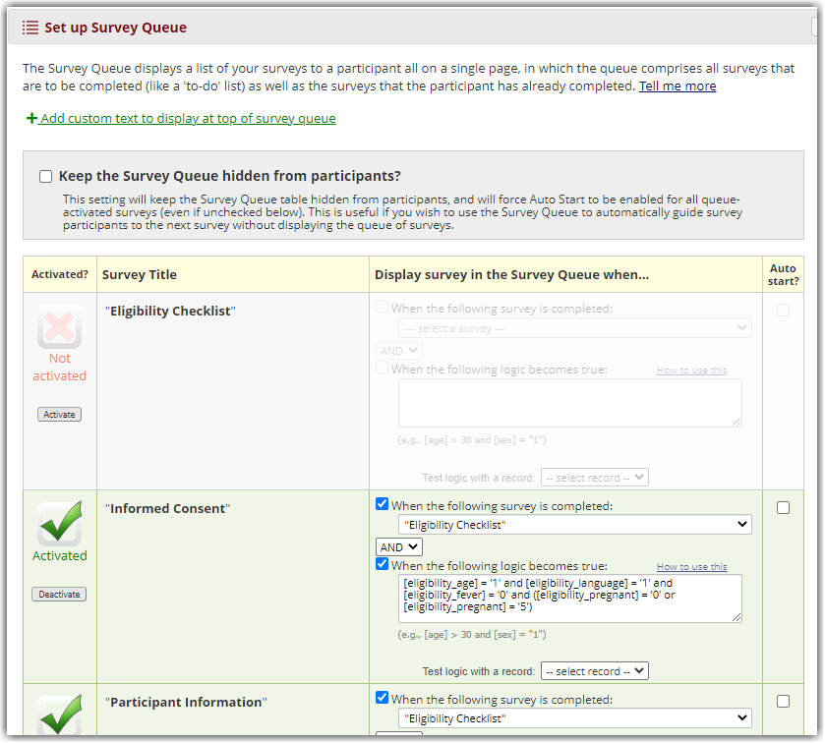Setting up the criteria for Survey Queue inclusion
Optionally, you can also provide custom text to display at the top of every participant's survey queue, in which you may customize the styling of the text with HTML tags or even utilize Piping to inject data values. If you don't include custom text, the following standard message will be displayed. "Listed below is your survey queue, which lists any other surveys that you have not yet completed. To begin the next survey, click the 'Begin survey' button next to the title."
img class="fig" src="/images/group461/102035/Survey_Queue_Custom_Text.png" alt="Survey Queue Custom Text" id="Survey_Queue_Custom_Text" width="839" height="620">Figure Caption

Survey Queue - Auto Start
The 'auto start' feature is optional and can be used to take the participant immediately to the first incomplete survey in the queue if 'auto start' is enabled for that survey. This allows for more rapid survey-taking if the participant is completing several surveys in one sitting. This is one way to ensure a participant completes all of the required surveys without having to return to the survey queue each time.
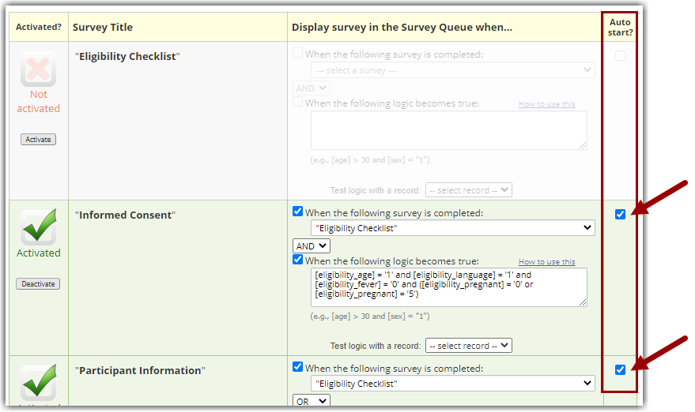Selecting the auto-start checkbox to allow surveys to auto-start after completion of another
NOTE: There is a similar feature within a Survey Setting for each survey. This feature is 'auto-continue' and works in a similar way. The biggest difference is that a participant will be taken to the next survey listed REGARDLESS of any branching logic used in a survey queue or the STOP feature for a specific field on the survey. When using a survey queue, it is highly recommended you not use this auto-continue option within a survey.
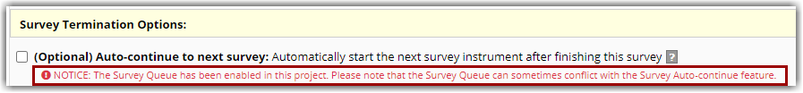Survey Queue can conflict with the survey setting's Auto-continue feature

To see an example of a Survey Queue with and without the auto start feature, watch this video: https://kb.wisc.edu/images/group461/102035/SurveyQueue_autostart.mp4

How to Hide Your Survey Queue
The survey queue pages may be confusing to participants, or maybe you would prefer the participant to not see how many surveys they will be taking. If they have access to the Survey Queue page or links, this can be problematic.
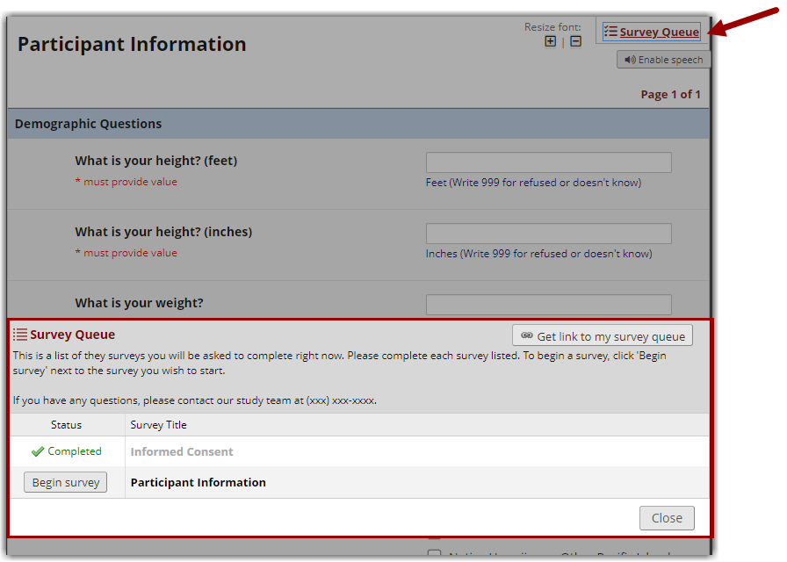Display of survey queue to users

In these cases, it would be beneficial to hide the survey queue table from participants. This will also force auto-start to be enabled for all queue-activated surveys (even if unchecked). This is useful if you wish to use the survey queue to automatically guide survey participants to the next survey without displaying the queue of surveys.
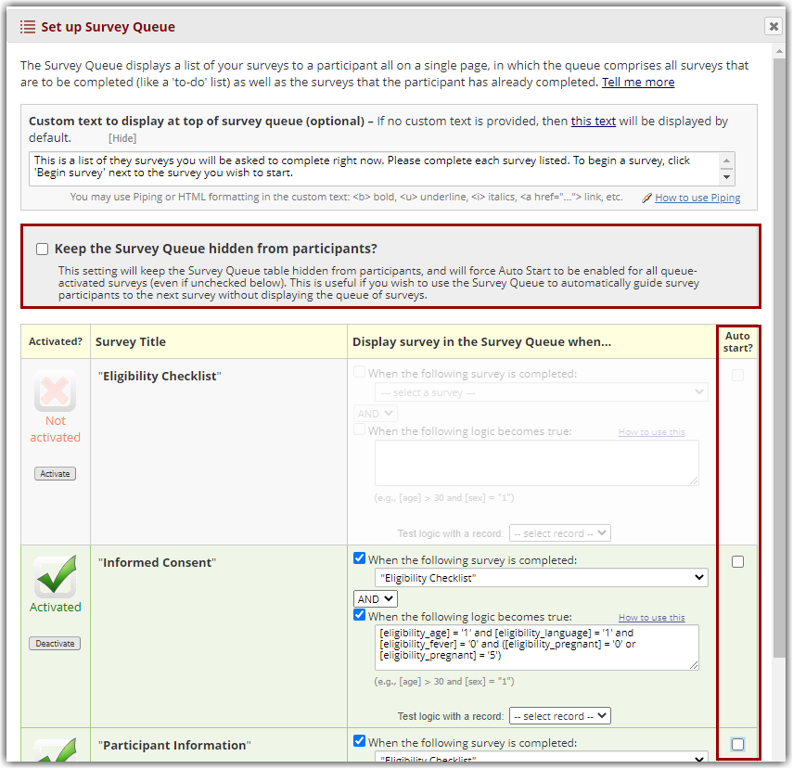Select option "Keep survey queue hidden from participants" if you would like to hide the queue from participants

