REDCap: How to find your Project ID (PID)
Each project in REDCap has a unique ID number known as the “Project ID” or “PID”. Your project ID is the easiest way for REDCap Administrators to navigate to your project. It is extremely helpful to include your Project ID when sending in requests for support!
To find your project ID within a Project:
- Click on “My Projects” when you are logged in to REDCap, then click on the specific project where you need help.
- The next screen will take you to the Project Home page (if you are in production) or the Project Setup page (if you are in development).
- Your project ID will appear at the top of your screen next to the title. In the screenshot, the PID is 79.
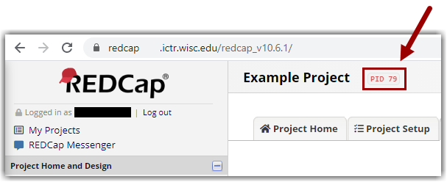
Example PID placement in REDCap Project

To Find your Project ID on the My Projects page:
- Select the My Projects tab on the top of the REDCap page
- Browse through your projects to find the one you need the number for
- The first column to the right of the project name will contain the project's PID number
Example PID placement on My Projects page

