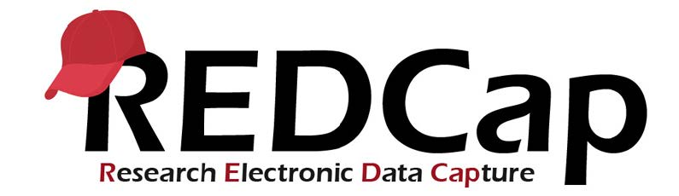

REDCap: Multi-Language Management
The Multi-Language Management module in REDCap gives you the ability to translate all text within REDCap - for logged-in users and for survey participants. Note that the MLM module does NOT translate any text for you. Multi-Language support is a tool where you can translate any kind of text found within REDCap (navigational buttons, REDCap instructional text, fields and options, emails, etc.)

Basic Setup of Multi-Language Management
Adding a New Language
To add a new language to your project, navigate to "Multi-Language Management" on the left-side menu within REDCap. Click the green "+ Add a new language" button." A pop-up window will open, where you can provide a display name for the language you are adding. It is recommended to use the ISO code for the language that you are trying to add - you can use this reference of ISO codes for different language character sets.
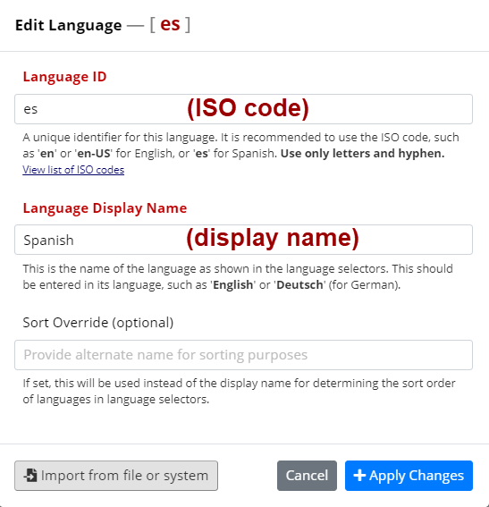
Example entry of ISO code compared to display name

Basic Language Settings
Once you have added multiple languages, you can choose which language you would like to be the Base Language (formerly "Default" language) for your project. SMPH REDCap has an overall base language of US English. Once you add another language to your REDCap project, if you still want US English display to be an option, you should add that in as a language also (and if desired, set it as the base language.) You can also set a "Fallback" language - if you have not provided a translation for something in the selected language, but there is a translation in the language designated as a fallback, then this translation will display. The main Languages tab also allows you to designate if a language should be read from right-to-left by modifying the "RTL" setting.
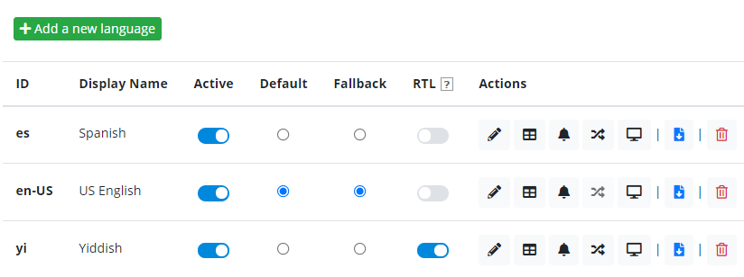
Example of Setting Base Language and Active languages

Providing Translations for Instruments and Surveys:
Use the "Forms/Surveys" tab to provide translations for the fields in different instruments in your project. Make sure to select the language you want to provide translations for at the top of the page. Once you have selected a language, you can choose which instruments you want to translate. Note that you can choose to provide translations for the instrument as a data entry form, as a survey, or both.
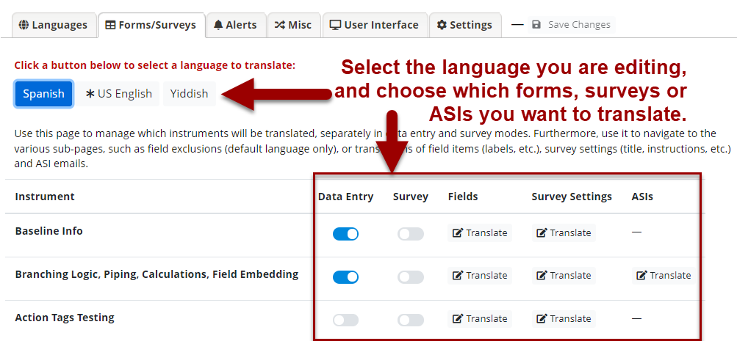You must choose the language at the top and then edit which instruments you would like to provide translations for. You MUST save the settings before navigating away from the MLM setup page.
Once you have selected an instrument, use the "Translate" link under "Fields" to provide translations. You can provide translations for all types of fields, and for all options within multiple choice fields.
If you are translating a survey, you can also provide translations for survey settings (e.g. the text that displays after a survey is completed), or for Automated Survey Invitations. If you provide translations for ASIs or Alerts/Notifications, you should also designate a field for storing a participant's language preference under the main Languages setup tab. (You may need to add a new field into the project to store this value.)

Providing Translations for Emails:
You can translate the text in ASIs under the "Forms/Surveys" tab. For alerts, navigate to the "Alerts" tab.

Providing Translations for User Interface Text:
The User Interface tab allows you to edit all other text found within REDCap. The most common settings you might want to translate include:
- Buttons like "Next" or "Submit."
- Text for 'Required' indicator for fields.
- The labels for Yes/No, True/False or date fields.
- Text that displays in pop-up if you have data validation set.
- Other survey-associated text, such as survey queue text, navigational buttons, or informational labels for signature or file upload fields.

Make Sure to Save!
When you are editing the Multi-Language setup, you must save your changes before leaving the MLM module page. If you do not save your changes, the edits you have made will be lost.
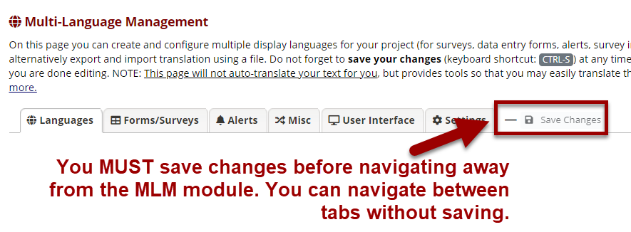Make sure to save changes! You can navigate between the tabs without saving, but if you leave the Multi-Language Setup module without saving, you will lose your work!
Importing Translations from Another Project:
The Forms/Surveys tab displays a download option for each instrument to allow you to export->import the translations for that single instrument in a project that has already translated the forms to another project that has the same instrument with the same fields and variable names.
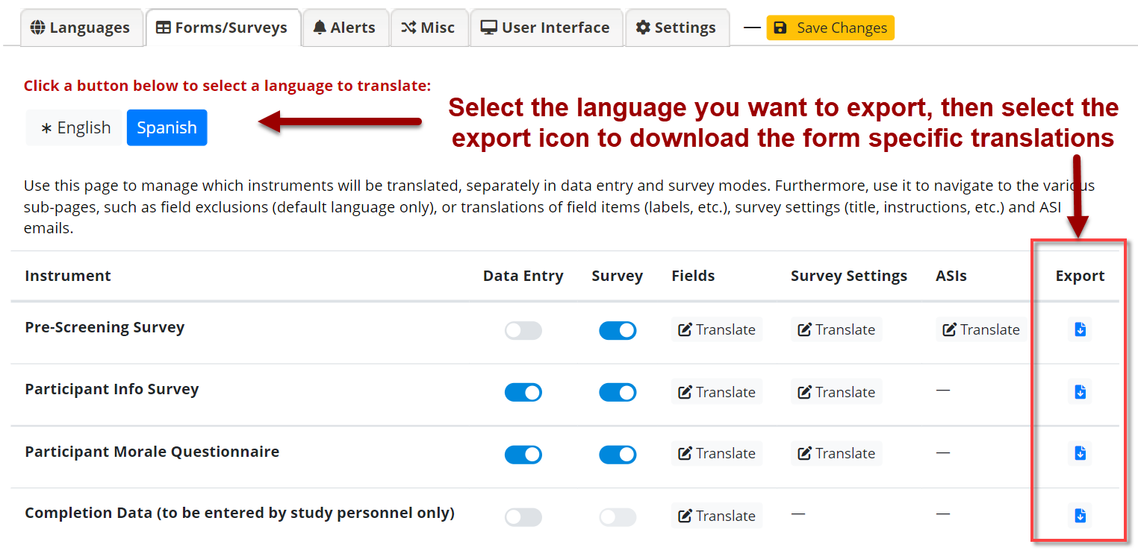Once forms have been translated, you can export the translations and settings by clicking the export icon for a given form.

After exporting from existing project, you can import the downloaded file on the Languages tab to transfer translation settings to a new project.
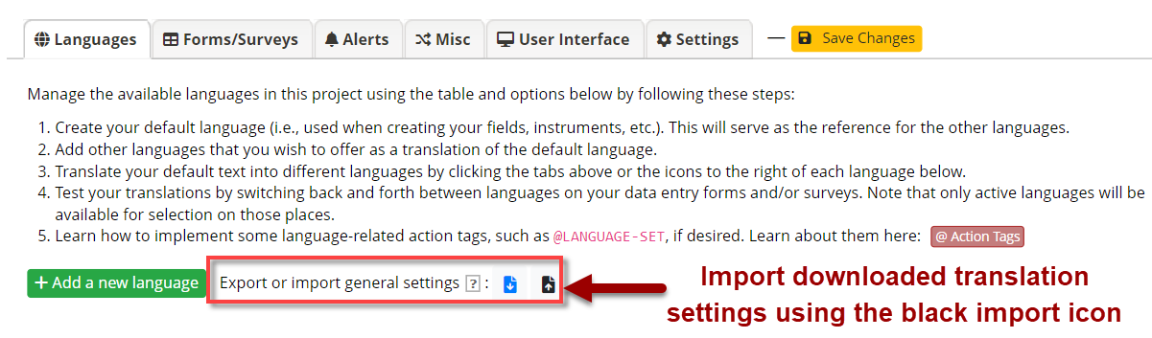Use the black icon on the Languages tab to import past translation exports.

Appearance on Data Collection Instrument
When you have enabled Multi-Languages on a project, a drop-down menu will appear in the relevant instruments allowing a user/survey respondent to select the language they would like to display:
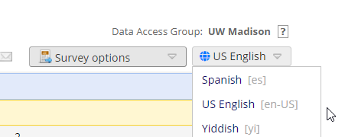
Appearance of drop-down menu on an instrument with multiple languages enabled.

Adding/Editing Translations for a Project in Production
If your project is in Production, you will need to enter Draft Mode before you can change language settings or provide translations. Once you have entered Draft Mode, the MLM options will become available to you. Make sure to Save Changes in the MLM module AND submit your drafted changes. The changes you make will not go into effect unless you do both of these things.

Important note: REDCap administrators normally review changes to your project to ensure that you aren't making changes that corrupt your data (for example, changing the labels of multiple-choice options that already have data saved.) If you make changes to translations, you must ensure you are not corrupting your existing data. REDCap administrators will not be able to verify that the changes you make are not qualitatively impacting existing data.

Testing Multi-Language Setup
The "Settings" tab provides helpful options for you to test and troubleshoot the Multi-Language setup. You have the option to highlight any untranslated text in both data entry and survey mode. You can also back up your existing translations by creating a translation snapshot.

Multi-Language Support Action Tags & URL Parameters
Action Tags
There are a number of action tags in REDCap that work with Multi-Language Management:
- @LANGUAGE-CURRENT-FORM: Captures the language currently used on a data entry form.
- @LANGUAGE-CURRENT-SURVEY: Captures the language currently used on a survey.
- @LANGUAGE-FORCE: Forces display of an instrument in a specific language.
- @LANGUAGE-FORCE-FORM: forces display of a specific, for a data entry form.
- @LANGUAGE-FORCE-SURVEY: forces display of a specific, for a survey.
- @LANGUAGE-SET: Use this action tag on a drop-down or radio button field to let it control the language display for the rest of the page.
See our REDCap: Action Tags page for more information on using action tags.

URL Parameters
It is now possible to preset the language of a survey by supplying the URL parameter "__lang", which must be set to a valid (active) language id (and is case-sensitive).
Example: https://redcap.vanderbilt.edu/surveys/?s=ABC123&__lang=es.
When used, this will override both a survey respondent's previous choice (stored in a browser cookie) as well as the language preference field. The @LANGUAGE-FORCE action tag will still take precedence.

Support for Multi-Language Setup in REDCap
REDCap administrators are not able to provide support and troubleshooting for translation-related issues. It is your responsibility to ensure that the translations you are providing are accurate and map correctly to the fields and options in your project.

Training Video
Multi-Language Management (vanderbilt.edu)

