Longitudinal Data Collection in REDCap

When planning your REDCap project, it is important to think about when data will be entered into REDCap, how often, and if the same instruments (forms or surveys) will be used to collect information at multiple time points.

One way to think about this is to consider whether your project is a cross-sectional or longitudinal study. Data in cross-sectional studies are typically collected at one time point and provide a snapshot of the population sampled at that specific timepoint. Longitudinal studies collect data from the same sample over time to establish sequences of events.

The longitudinal project mode is a project setting that allows for forms and surveys to be used at multiple time points in the data collection process, removing the need to recreate the same instrument for each time point. This setting must be enabled prior to moving the project into production and cannot be changed afterwards. Because of this, it is especially important to assess if the longitudinal features are right for your project needs and test its features thoroughly before moving the project to production and collecting real data.

It is important to note that just because a project is a longitudinal study does not mean it is well suited to the longitudinal module.

Longitudinal Data Collection

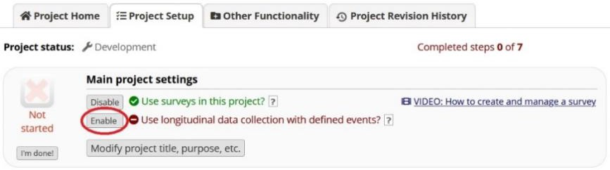
- While on the “Project Setup” tab, select “Enable” next to “Use longitudinal data collection with defined events?” under the “Main project settings” box to allow for longitudinal data collection.
  - Enabling this feature will cause a new module called “Define your events and designate instruments for them” to appear in your “Project Setup” tab.
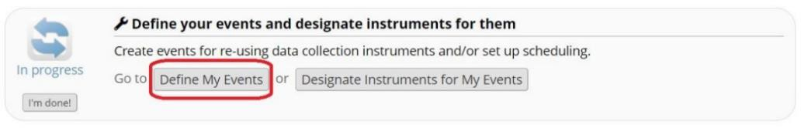

- Select “Define My Events” to set up the events for your project. An “event” is usually a temporal event, such as a participant visit or a task to be performed.

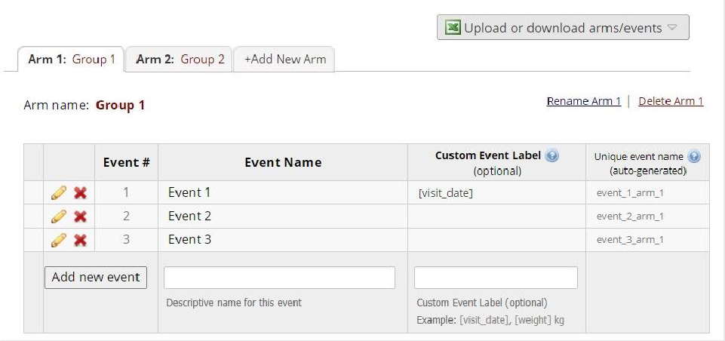

  - Arm # (tab) – Events can be grouped into “arms.” Arms are generally used for randomized trials when participants complete different tasks at different time points.
  - Event Name – The name you assign the event.
  - Custom Event Label – Variables can be piped into here to customize what appears next to each event name on an individual’s record dashboard to give context to each event.
  - Unique Event Name – This is auto-generated by REDCap and used in branching logic, calculated fields, importing data, etc. Even if you do not have multiple arms, it will end in “_arm_1.”
  - Scheduling Module – This is an optional module available on the “Project Setup” tab that can only be enabled with longitudinal data collection.
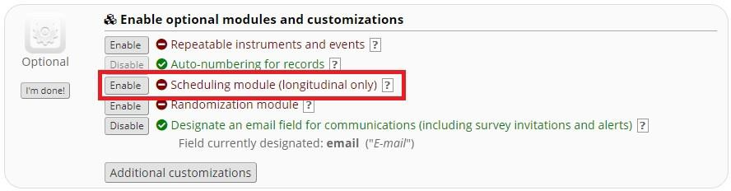

    - Enabling the scheduling module will help with generating schedules for your REDCap project calendar based on project-defined events established in the “Define My Events” tab. If this is enabled, your table will look like this:
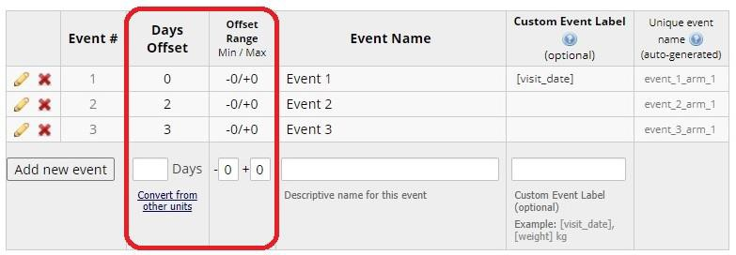
      - Days Offset: The number of days since time zero (start of the study or project period) an event is scheduled to occur.
      - Offset Range, Min/Max: Allows for scheduling within an assigned range of days.
    - To generate a schedule for an individual record, select the “Scheduling” tool under “Data Collection” on the left-hand panel.
    - You also can upload or download a CSV file of arms and/or events.
    - Important: The scheduling module does not integrate with automatic survey invitations or alerts. Its intended use is for study staff to stay organized and generate participant schedules.

- Once all your events are defined, select the next tab “Designate Instruments for My Events” (also accessible from the “Project Setup” tab).

  - Click “Begin Editing” to select which instruments should be included in each event. If there are multiple arms, repeat for each arm by clicking on the corresponding tab. Instruments will only appear after events have been defined.

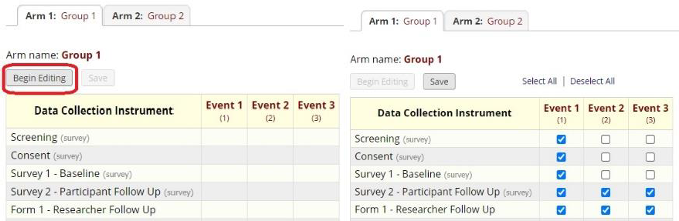

  - Once you click “Save”, checkmarks and/or arrows will appear next to the instruments included in each event. A downward arrow means the survey will auto-continue to the next survey. (The auto-continue feature is found in “Survey Settings.”)

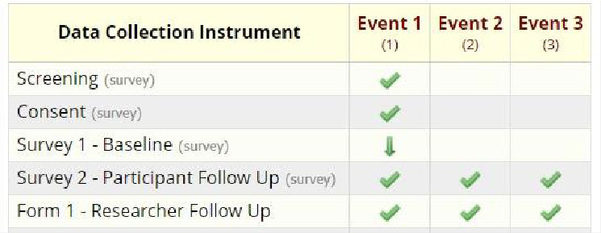

Other Important Notes When Using the Longitudinal Module

- Reports will have a “redcap_event_name” column noting which event each row of data is from. When importing data, the event name for each row of data needs to be specified in this column. See the Importing Data to REDCap document for more detailed information.

- Data using REDCap’s longitudinal module will export in a long format. This means each row represents one event per record. You may need to reformat your data after it is exported.
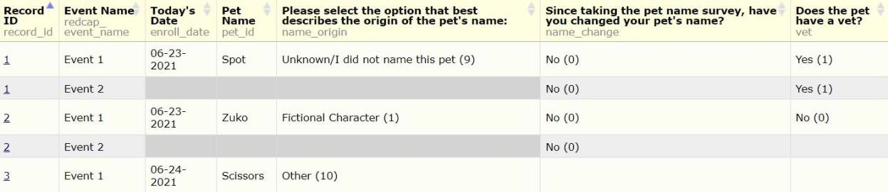

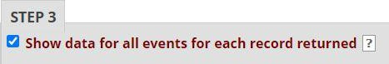
- To view all data for each event, when creating a custom report ensure the “Show All data for all events for each record returned” is checked in Step 3.

