Importing Project Data and Metadata into REDCap

There may be times when a research team will need to import existing data into REDCap. While it is possible to manually enter the data into REDCap, this can be time-consuming and increases the opportunity for data entry error. As such, people may prefer to import the data at one time instead.

Data can be imported into REDCap two ways:
- Manual import via a CSV (or Excel file saved as CSV), and
- Import via Application Programming Interface (API). The following instructions are for manual import. For more information on general API use in REDCap, see our API document.

Uploading Project Data into REDCap

- Build the project in REDCap, including all fields, validations, events, etc. We recommend testing data import with fake data while the project is still in development mode. Once you are satisfied with the project, real data should be imported after the project has been moved into production.

- Select “Data Import Tool” under “Applications” on the left-hand panel.
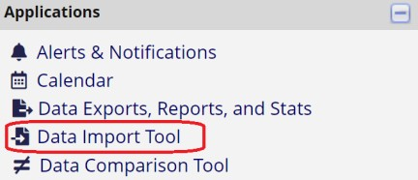

- On the “CSV import” tab, download one of the data import templates and save it as a .CSV (comma delimited) file to your computer.
  - It is recommended to download the template “with records in rows,” and these instructions are written for using the “with records in rows” template.

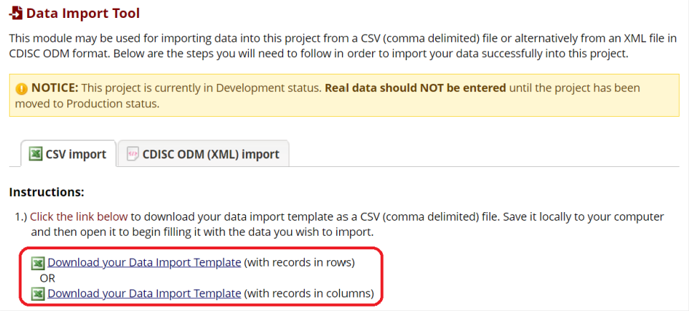

  - Map your data onto the data import template, ensuring that it matches the data structure as defined by the codebook. The codebook can be found on the left-hand panel under “Project Home and Design” and is a useful tool for ensuring all values entered are valid. This means the values fit in a range of expected numbers, are a legitimate code for a coded variable, and/or match any field validation requirements set on open text fields.

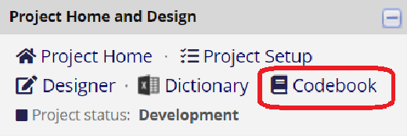

  - Note: If your project uses the longitudinal data collection and/or repeating instruments/events features, there are additional items to check when entering data into the data import template. These checks are listed at the end of the document. For more information on setting up a REDCap project with longitudinal data collection or repeatable instruments/events, see our Longitudinal Data Collection or Repeating Data Collection documents.

- On the “Data Import Tool” page, navigate to the green box at the bottom to upload the CSV file.
  - Set the “Record format” to rows.
  - Complete the other questions in the upload window (date formatting, overwriting data, and auto-numbering records).
  - Select “Choose File” and select the file to upload.
  - Select “Upload File.”

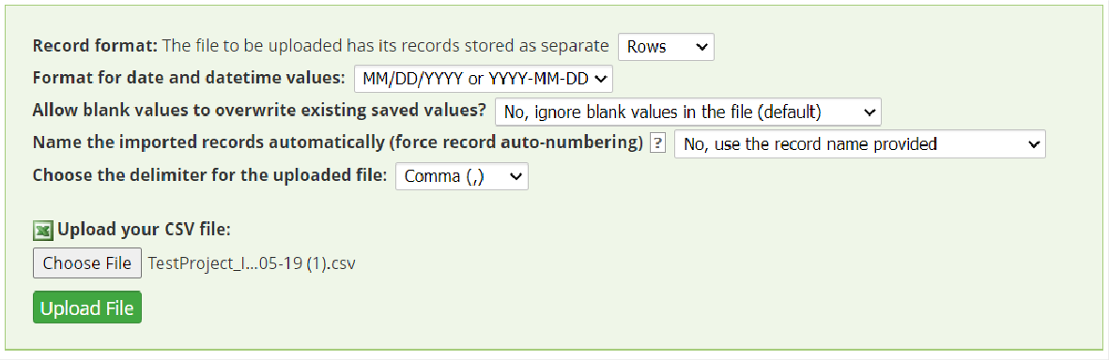

- The data does not automatically upload into REDCap. First, it must be reviewed and approved.
  - Review the data by reviewing the “Data Display Table” according to the instructions and key provided in the “Instructions for Data Review” box.
    - For example, in the image below, existing data for date_enrolled will be overwritten by the imported data.

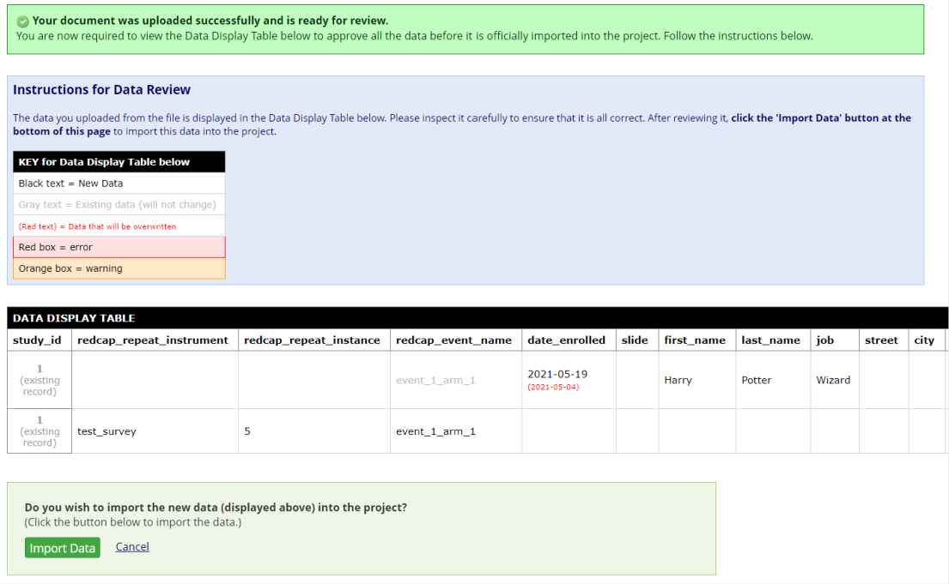

  - If there are any errors or warnings that need to be fixed, return to the CSV file and correct the data there, before returning to Step 5. Below is an example of errors encountered during an import.
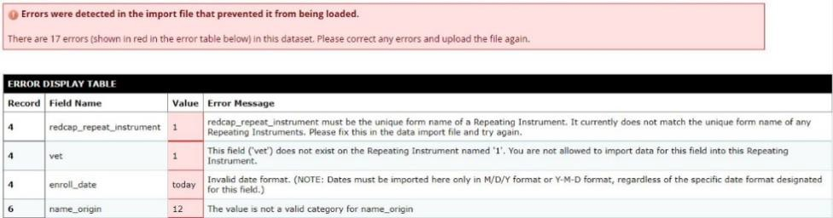

  - Data put into calculated fields are ignored during the import. Values will be calculated once the import is finished.
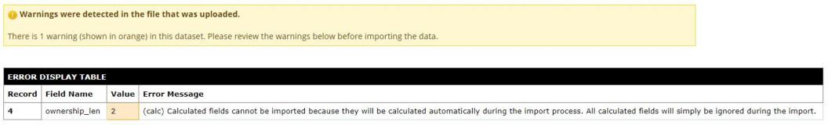

- When the data in the “Data Display Table” is accurate, scroll to the bottom and select “Import Data.” The data will be imported, and a green box will notify you of how many records were created or modified during the import.
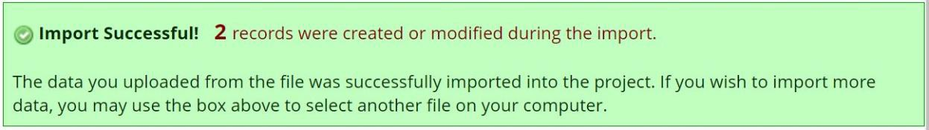

  - Note: If you have a particularly large dataset, you may need to import the data in stages. If you have trouble uploading a large dataset, follow these steps:

    - Before uploading data at Step 6 above, break the data into smaller portions by record number by creating several CSV files for import. For example, in the first file, you may choose to upload records 1-5,000, the second file would upload records 5,001-10,000, and so forth. Ensure each record has a unique record identifier so that no records will overwrite one another.
    - You can also reduce the size of the CSV by removing any columns that do not include any data for import.
    - If an import fails, you may need to reduce the number of datapoints per import file and try again. Consider reducing the number of records (the “length” of the file) and/or the number of variables (the “width” of the file) if you are having difficulties.
    - Upload the data in segments according to 6(a)(i) through 6(a)(iv) until all the data has been uploaded.

Importing Data into a Longitudinal Project

If data is longitudinal, the correct event needs to be identified for each piece of data and all defined events must exist in the project prior to data import.

- The data import template will include a column titled “redcap_event_name.” The event
name for each row of data needs to be specified here.
- Event names can be found on the “Define My Events” page, accessible through the “Project Setup” page. The event names are auto generated and visible in the column titled “Unique event name.”
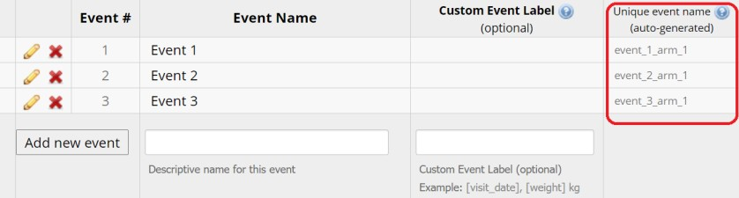
- For each record, enter data chronologically and in consecutive rows. For example:

record_id | redcap_event_name | age | marital
1 | year_1_arm_1 | 20 | 1
1 | year_2_arm_1 | 21 | 2
1 | year_3_arm_1 | 22 | 2
2 | year_1_arm_1 | 36 | 2
2 | year_2_arm_1 | 37 | 3
3 | year_1_arm_1 | 51 | 2
3 | year_2_arm_1 | 52 | 2
3 | year_3_arm_1 | 53 | 2

- Longitudinal data can be unbalanced; in other words, there can be an unequal number of observations across events. If you do not have data for an event, you do not need to include a row for that record and event. In the example above, there are only two waves of data for Record 2, and Record 2 has no row for the event “year_3_arm_1.”

Importing Data with Repeatable Instruments and/or Events
If data utilizes repeatable instruments and/or events, data needs to be entered into the correct instrument and/or event.

- For repeatable instruments:
  - All instruments that will repeat must be enabled as such prior to data import.
  - The data import template will include columns titled “redcap_repeat_instrument” and “redcap_repeat_instance.”
    - “redcap_repeat_instrument” is the name of the instrument that will repeat. It will be the name of the instrument, but with no capital letters and underscores instead of spaces. For instance, if the instrument is called “Exercise Survey,” the name in the spreadsheet will be “exercise_survey.”
    - “redcap_repeat_instance” is the number of the repeating instance (e.g., 1, 2, 3). You can pre-number the repeatable instance or event with its instance number, or write “new” in the “redcap_repeat_instance” column. Including “new” instead of a number will tell REDCap to auto-number that instance with the next number for that record.

  - For each record, enter data numerically ascending and in consecutive rows. For example:

record_id | redcap_repeat_instrument | redcap_repeat_instance | ex_today | minutes
1 | exercise_survey | 1 | 1 | 75
1 | exercise_survey | 2 | 0 | 0
2 | exercise_survey | 1 | 1 | 60
2 | exercise_survey | 2 | 1 | 45
2 | exercise_survey | 3 | 0 | 0
3 | exercise_survey | new | 0 | 0
4 | exercise_survey | 1 | 1 | 30

- For repeatable events:
  - All events that will repeat must be enabled as such prior to data import.
  - The data import template will include columns titled “redcap_event_name,” “redcap_repeat_instrument,” and “redcap_repeat_instance.”
    - “redcap_event_name” is the name of the event that will repeat. Event names can be found on the “Define My Events” page, accessible through the “Project Setup” page. The event names are auto generated and visible in the column titled “Unique event name.”

  - For each record, enter data numerically ascending and in consecutive rows. For example:

record_id | redcap_event_name | redcap_repeat_instrument | redcap_repeat_instance | date | healthy
1 | weekly_surveys_arm_1 |  | 1 | 1/1 | 0
1 | weekly_surveys_arm_1 |  | 2 | 1/8 | 1
1 | weekly_surveys_arm_1 |  | 3 | 1/15 | 1
1 | weekly_surveys_arm_1 |  | 4 | 1/22 | 1

record_id | redcap_event_name | redcap_repeat_instrument | redcap_repeat_instance | date | healthy
2 | weekly_surveys_arm_1 |  | new | 1/3 | 1
2 | weekly_surveys_arm_1 |  | new | 1/10 | 0
3 | weekly_surveys_arm_1 |  | 1 | 1/3 | 0
3 | weekly_surveys_arm_1 |  | 2 | 1/10 | 0
3 | weekly_surveys_arm_1 |  | 3 | 1/17 | 0
4 | weekly_surveys_arm_1 |  | 1 | 1/4 | 1

    - Even if you are not using repeatable instruments with repeatable events, the data import template will still include a “redcap_repeat_instrument” column. This is because repeatable instruments and events are enabled at the same time. If you are not using repeatable instruments, this column should be left blank when importing data.

Importing Project Structure (Metadata) and Data into REDCap

This process imports the data and the project structure, also called the project metadata. Project metadata includes project attributes, such as customized dashboards, events, and arms, as well as variable names and field labels. This is only used if you are migrating a project from another institution’s instance of REDCap. Project instruments (surveys and forms) can be imported on their own using the Data Dictionary.

- From the other organization’s REDCap instance, go the “Other Functionality” tab and select “Download metadata & data (XML).”
- In your Illinois REDCap account, create a new project and select “Upload a REDCap project XML file (CDISC ODM format).”
- Select the XML file downloaded in Step 1.
- Select “Create Project.”
- Go to “Online Designer” and make sure the forms or surveys function as needed.
- Go to “Data Exports, Reports, and Stats” and “View Report” to review the imported data and
ensure it is accurate.
- Move the project to production.

