REDCap: Email Alerts and Notifications
There are two ways that you can send emails automatically from your REDCap project. Automated Survey Invitations (ASIs) are designed to invite participants to take a specific survey. Email alerts allow an unlimited number of customized emails to be sent to participants, collaborators or study staff.
Differences between Automated Survey Invitations and Email Alerts
Feature | Automated Survey Invitations | Email Alerts
Number of customized emails that can be created (per instrument): | One | Unlimited
Types of instruments: | Surveys only | Surveys and forms
Emails can be sent to email addresses other than the designated email field:
Allows piping of information from records:
Emails can be triggered based on conditional logic:
Content of email can be based on conditional logic:
Use “Time Limit for Survey Completion” option found in Survey Settings:
The email alert feature is only available to users that have "Alerts & Notifications" rights for a project. If you have Alerts & Notification rights, "Alerts and Notifications" is the first link located under "Applications" on the left-hand navigation menu.
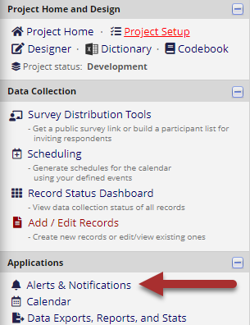

Select Alerts & Notifications

Adding a New Email Alert
When you select the “Alerts and Notifications” link you will be able to add an alert by selecting “Add New Alert”. A pop-up will appear with steps for adding a new alert.

Step 1:
Choose what will trigger the alert. You can have it triggered by form/survey save, conditional logic, or both. If you select when a record is saved on a specific form/survey you will be able to select the form/survey from a drop-down that is populated from your project. If you select conditional logic a box will appear for you to input the logic statement. There is not an easy builder option like with branching logic or the report builder so you will be required to know some logic basics.
Tip: Build a report using the same conditional logic first so that you can see which records would be triggered by your conditional logic.
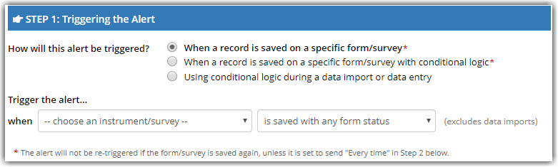
Step 1: Select conditions for triggering the alert email to send.

Step 2:
Will allow you to set how often you want the alert to go out. There is a broad variety of these to choose from including send immediately, send after a set amount of time, and send at specific date and time. You will also be able to choose if you would like the alert to be sent once or to repeat the alert.
**New in REDCap v13.4.10**
“When to send the alert?” contains a new drop-down choice "the day (beginning at midnight) that the alert was triggered" in the sub-option “Send the alert X days Y hours Z minutes before/after [drop-down]”. This new choice in the drop-down allows you to schedule the notification based on the day the alert was triggered and provides greater control for when exactly the notification will be sent.
Tip: If you send an alert based on a 'lapse of time', test your alert first using minutes rather than days (e.g. alert should be sent after lapse of 3 days - set the lapse for 3 minutes when testing, otherwise you would need to wait days to see if the alert works).
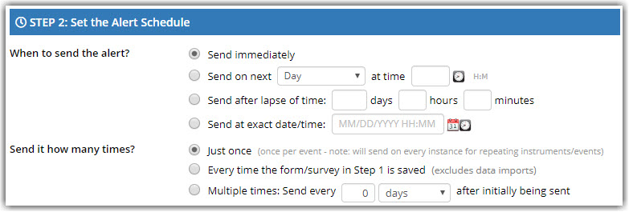
Step 2: Select when to send the alert email after step 1 conditions are met

Step 3:
You will build the message settings that involve choosing the email from, email to*, subject, and message body. The message body does allow for piping and the use of smart variables. You can also add attachments if desired.
**New to REDCap 13.4.10**
File attachments, including PDF's and images, can be embedded in text & emails so that they display inline with the text instead of as a separate attachment.
Tip: Use your own email address in the 'Email To' field to test your alerts first, especially if you've built an alert with real data in Production.
Tip: Keep in mind any email sent from the REDCap system will be sent using the no-reply-redcap@uchc.edu email address regardless of what is selected in the 'Email From' field. Any replies to the initial email will go to the email selected in the 'Email From' field, so still select a member of your team to receive those replies and make sure to include your contact info in the message itself.
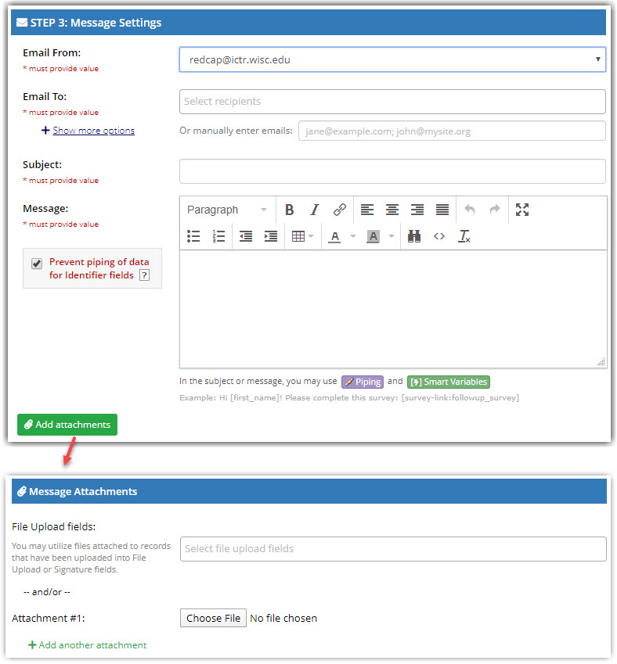
Step 3: Compose email message body and add any attachments to send with the alert
There is also an optional field, which is an alert expiration. This is good to implement if you are using alerts that repeat indefinitely and should stop after a certain deadline (i.e. Study expires on a certain date.)
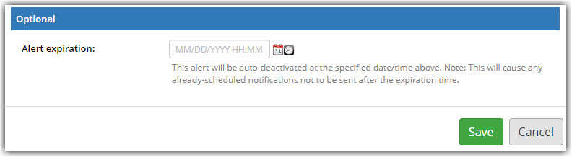
Optional: Set date to stop alert from sending under all conditions (e.g. a study end date).
Once you select “Save”, your alert will immediately become active and may be triggered at any time thereafter.

Deactivating an Email Alert
You can deactivate an alert by selecting “options” for the alert in question and selecting “deactivate alert” from the drop-down. This will stop new alerts from being sent as well as stop repeat alerts.

Alert Management
If you have multiple alerts in a project, you are able to re-order them by choosing "Move alert" from the drop-down "Options" menu.
To manage a large number of alerts or duplicate alerts in a different project, you may now upload/download a CSV with all alert settings from the main Alerts page.
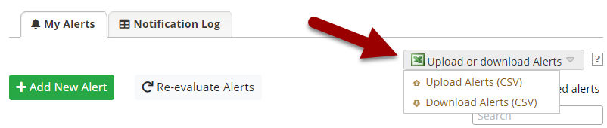Select Upload or download Alerts to manage alerts through a CSV file.
Alerts that were previously created can be copied and modified.
**New to REDCap 13.4.10**
Alerts that have been deactivated can also be copied, edited, and activated as needed.

Re-Evaluating Alerts
If you have made changes to your alerts, you may want to use the "Re-evaluate alerts" button to trigger alerts that should be sent given the new conditions.
Use the "Re-Evaluate Alerts" button with caution! Make sure to test your new alert settings thoroughly first and test re-evaluating them to make sure that you do not unintentionally trigger a large number of outgoing emails. Please contact REDCap support if you would like more guidance on how to safely test modified alerts.

Email Alert Notification Log
The secondary tab in the Alerts and Notification page will be the “Notification Log”. This will allow you to see all past and future email alerts. This will also allow you to apply filters to display specific alerts, specific records, or time limits.
You will also see alerts that were sent if you access the "Email Logging" page.

