REDCap: Moving Your Project to Production

The UCH REDCap system consists of TWO separate environments, Development and Production. These environments have separate web addresses and are not linked to each other in any way.

The Development system is strictly used for project development and testing with mock data. Live data collection and/or storage of real data is strictly prohibited in the Development system. ONLY the Production system can be used for live “real” data collection. REDCap users are allowed to only create a new project in the Development system. The development project then must be moved to the production system so that data collection can begin.

To migrate projects from the Development to the Production system, the PI or their designated project
manager must click the ‘Move Project to Production’ button at the bottom of the Project Setup page. The Move-to-Production Request form will open automatically. The requester must complete all the required information and provide the appropriate IRB documentation. Upon submission, the REDCap Administrator will begin processing the move to production. After it has been approved and moved to the production system by the REDCap Administrator, the PI, and the requestor will be added as users to the project. The REDCap Administrator will then ask the requestor to verify and inspect the project one last time in Production; upon confirmation, the project will be finalized in production status and the PI will be automatically notified. It is then the responsibility of the PI or their designated project manager for adding/removing additional users and assigning privilege access. If the project is using REDCap to collect PHI/PII, the PI must ensure that study personnel either entering or accessing data stored with REDCap have been given the appropriate authority to do so.

Once the project is in Production status, changes cannot be made in real-time to the project as it was in
Development status. However, changes to the project may be made in DRAFT MODE, after which such
changes will be reviewed and approved by a REDCap administrator. Once those changes are approved, you will then receive an email confirmation informing you that those changes have taken effect on your
production project. Edits in Production should only be for minor/simple fixes, such as typos. Making major changes to a project that is in Production should only be done as a last resort. Major changes should be tested in Development. Altering a project that is in Production and has data can cause data loss in some instances. If any critical issues are flagged, you will receive an email from the Administrator to confirm that you want to commit to the changes. The requester should be aware that changes to any variables might affect programmed calculations and/or branching logic. It is the responsibility of the requester to review and test all calculated fields and branching logic before submitting changes. The impact on these fields will NOT be tested by the REDCap Administrator.

Now that we have reviewed the move-to-production process (which is noted in our User Agreement) - Have you finished developing your project in development? Have you tested it thoroughly? Do you have IRB approval? Are you ready for your project to be moved to production? If so, follow the steps outlined below.

Before Moving Your REDCap Project to Production:
If you have created, tested, and finalized your instruments and project set-up, you are ready to move your project to Production status. Once your project moves into Production, you can start entering real data. When you request that your project moves to Production, the REDCap support team will review and complete the move. To make this process easier, please make sure that the following things are done before you move your project to Production:
- Make sure that your project is fully set up and tested!
You should have all of your data collection instruments (for example, all of your surveys and case report forms) and your overall project setup finished. Test your project by entering test data records to make sure everything is functioning correctly before you move your project into production.
- Review the fields in your project for identifiers.
All of the data fields that could be considered a PHI identifier should be marked. This includes names, dates, e-mail addresses, phone numbers, addresses or geographical information more specific than state, etc.
- Double check that the information is correct in your main project settings. In your main project settings, select "Modify project title, purpose, etc." to update the information:
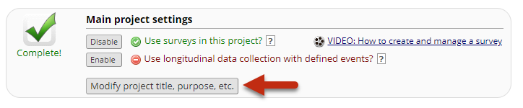
All UCH REDCap projects must be for research only. Make sure the following fields are filled out:
- Project Name
- PI Name
- PI Email
- IRB Number
- Type of research
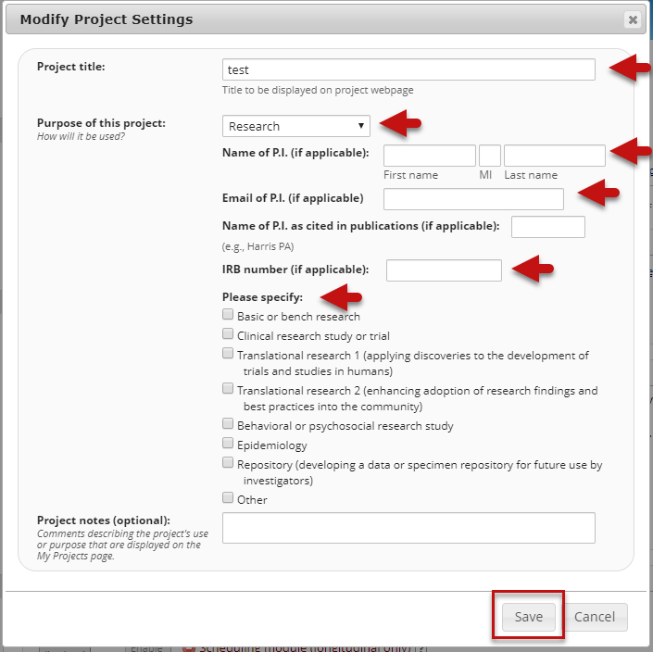

How to Move your project to Production:
If you have completed all of the above checks, you are ready to move your project into Production. To request that a REDCap project be moved to Production, open the project, and select the Project Setup tab. At the bottom of the screen, click the 'Move to Production' button.
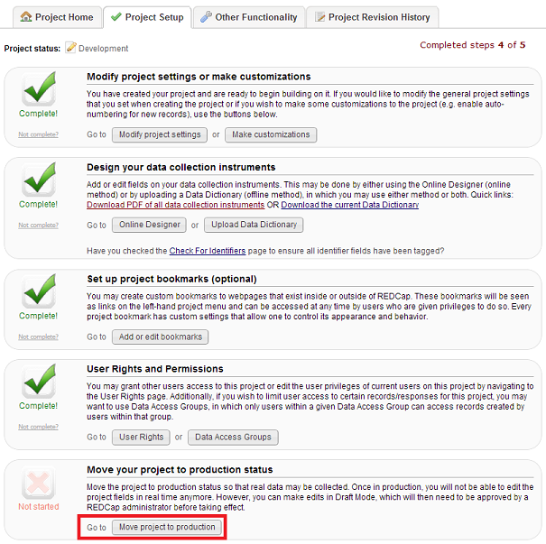
Select "Move project to production" to start the process of moving the project to Production
After you click this button, you may get the option to decide if you wish to Keep ALL or Delete ALL of the data that has been entered. Given that the development is only for testing, and NO real data should have been entered, you will select Delete ALL
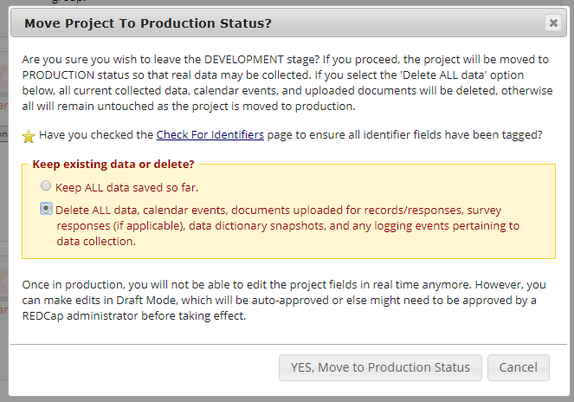

Click 'Yes, Move to Production'

Clicking the ‘Move Project to Production’ button will open automatically. The requester must complete all the required information and provide the appropriate IRB documentation. Upon submission, the REDCap Administrator will begin processing the move to production. After it has been approved and moved to the production system by the REDCap Administrator, the PI, and the requestor will be added as users to the project. The REDCap Administrator will then ask the requestor to verify and inspect the project one last time in Production; upon confirmation, the project will be finalized in production status and the PI will be notified when it is locked in production status. Real data collection cannot begin until the project is locked in production status.
It is the responsibility of the PI or their designated project manager for adding additional users and assigning privilege access. If the project is using REDCap to collect PHI/PII, the PI must ensure that study personnel either entering or accessing data stored with REDCap have been given the appropriate authority to do so.
As a reminder, ONLY the Production system can be used for live “real” data collection. The Development (test/sandbox) system is strictly used for design, development, testing, and training with simulated mock data. Live data collection and/or storage of "real" data is strictly prohibited in the Development system. REDCap users are allowed to only create a new project in the Development system. The development project must be moved to the production system so that data collection can begin.
Additional Information
Usage Eligibility
REDCap usage is limited to non-commercial research purposes only. Federal regulations define research as the systematic investigation, including development, testing, and/or evaluation, designed to develop or contribute to generalizable knowledge.
REDCap may not be used by for-profit entities, for-profit work, or the conduct of clinical care. Forms, questionnaires, or surveys related to commercial research (including industry-sponsored clinical trials) or unrelated to research may be administered using an alternate service (e.g., Qualtrics).

User Eligibility
All REDCap users must complete the Introductory Overviews, Basic Features & Functionality, and Project Types video training modules (approx. 1 hour) before using REDCap. These are the minimum training requirements. All users are encouraged to review additional REDCap training materials REDCap | Clinical Research Center.
If collecting Personal Identifiable Information (PII) or Protected Health Information (PHI), all members of the research project team, including PIs, should complete the CITI Basic Course Requirement before utilizing REDCap.

Project Eligibility
All projects must involve a PI who is a faculty member, employed and paid, by UConn Health or UConn. All projects must show proof of research use by providing the appropriate IRB documentation:
- a UConn/UCHC approval letter or exempt determination letter, or
- a letter from the UConn/UCHC IRB agreeing to rely on another IRB for oversight, or
- a Human Subjects Research Determination form signed by the UConn/UCHC Human Subjects Protections Office indicating that the project is “NOT human subjects research”

The approved IRB documentation must be provided to the REDCap administrator along with the online Move to Production request form. The PI information listed on the request form must match the approved IRB documentation. The PI must have an active REDCap account and be listed as such on the project in REDCap.

Project Fees
The fee for a new project is $150/first year/per project. Every year thereafter while your project is in REDCap, you will be billed $75/year/per project. The cost is per REDCap project, not per study. A research study could use multiple REDCap projects to address the study-specific research data capture needs, however, each project will be charged individually.
Projects are first charged when moved to production – this is considered the project creation date. Annual fees will be billed based on this creation date. Projects will be charged until they are removed completely from the REDCap production system. As a reminder, REDCap cannot be used for the long-term storage of your data. Once data collection has ended, or your IRB has expired, your project needs to be removed from the system. Please see: Managing your Data and Project Statuses and Project Life Cycle.
NOTE: Once you have exported your data, please make sure you adhere to your institution’s data security policies and your approved IRB data collection and storage plan. If you need to request a secure data storage solution or need assistance on securing your data properly, please contact your local IT support.

