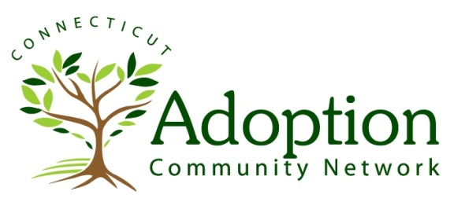
Connecting adoptive families, adoption professionals, and all those interested in adoption
to form a strong, supportive and resourceful adoption community.

Provider Application for Inclusion in the Adoption Community Network’s Directory of Therapy Providers.

(Boxes will expand as you type)
Name
Practice Name
Practice Address
Mailing Address (if different)
Telephone Number
Fax Number
Email Address
Website

Degrees, Licenses, Certifications & Credentials
Professional Affiliations & Memberships
Ages Served
Languages spoken
Handicapped Accessibility
Insurances Accepted
Hourly Rate
Sliding scale? Please describe.
How long have you been practicing?
How long has your practice included work with adoptive/foster families?
On average, how many adoptive families have been treated in your practice over the past 2 years?
Are you a TAC (Training for Adoption Competency) Graduate? If not, please indicate whether you are interested in learning more.

Do you: | Yes or No |  | If yes, please elaborate here
Provide treatment in a family’s home?
Provide crisis management?
Offer evening/weekend appointments?
Attend school meetings?
Participate in treatment meetings?
Offer groups?
Refer for additional assessments?
Have an affiliation with a psychiatrist/prescriber?
Provide Telehealth Services?

Please describe your specific training and experience as it relates to the adoption kinship network and how your skills match with the adoption competent mental health professional competencies:

Please write a 3-4 sentence practice profile that you would like to appear on the web page.

☐ I certify that the above information is true and correct. I hereby authorize UConn Health’s Adoption Assistance Program/Adoption Community Network to release any or all of the above to third parties seeking referrals to or information about mental health service providers and to publish any or all of such information on the ACN website, www.ctadoption.org. In consideration for being listed as a provider, I hereby agree to indemnify and hold harmless the State of Connecticut, the University of Connecticut, UConn Health and their trustees, officers, directors, agents and employees from all liability arising as a result of my inclusion on the website. I understand that UConn Health is not endorsing or evaluating any therapist or kind of treatment. UConn Health is not responsible for any misrepresentation or misuse of this information or for any typographical errors in its reproduction. It is my responsibility to notify the AAP/ACN of any changes to the information provided above.

